Unit 3 Lesson 6: How Much in Each Group? (Part 2)

1 Number Talk: Greater Than 1 or Less Than 1? (Warm up)

Student Task Statement
Decide whether each quotient is greater than 1 or less than 1.
$\frac{1}{2}÷\frac{1}{4}$
$1÷\frac{3}{4}$
$\frac{2}{3}÷\frac{7}{8}$
$2\frac{7}{8}÷2\frac{3}{5}$

2 Two Water Containers

Student Task Statement
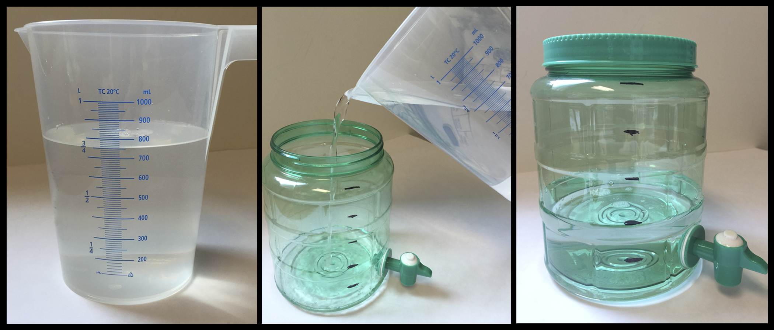
- After looking at these pictures, Lin says, “I see the fraction $\frac{2}{5}$.” Jada says, “I see the fraction $\frac{3}{4}$.” What quantities are Lin and Jada referring to?
- Consider the problem: How many liters of water fit in the water dispenser?
  - Write a multiplication equation and a division equation for the question.
  - Find the answer and explain your reasoning. If you get stuck, consider drawing a diagram.
  - Check your answer using the multiplication equation.

3 Amount in One Group

Student Task Statement
Write a multiplication equation and a division equation and draw a diagram to represent each situation. Then, find the answer and explain your reasoning.
- Jada bought $3\frac{1}{2}$ yards of fabric for $21. How much did each yard cost?
- $\frac{4}{9}$ kilogram of baking soda costs $2. How much does 1 kilogram of baking soda cost?
- Diego can fill $1\frac{1}{5}$ bottles with 3 liters of water. How many liters of water fill 1 bottle?
- $\frac{5}{4}$ gallons of water fill $\frac{5}{6}$ of a bucket. How many gallons of water fill the entire bucket?

4 Inventing Another Situation (Optional)

Student Task Statement
- Think of a situation with a question that can be represented by $\frac{1}{3}÷\frac{1}{4}=?$. Describe the situation and the question.
- Trade descriptions with a partner.
  - Review each other’s description and discuss whether each question matches the equation.
  - Revise your description based on the feedback from your partner.
- Find the answer to your question. Explain or show your reasoning. If you get stuck, consider drawing a diagram.

Activity Synthesis
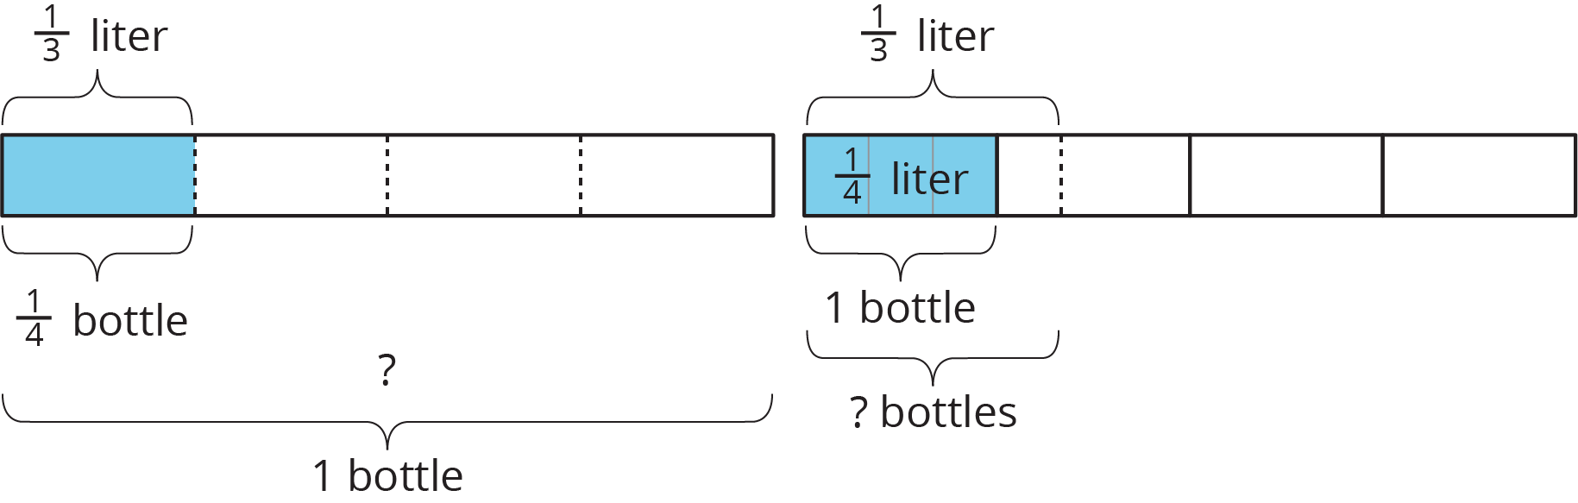
© CC BY Open Up Resources. Adaptations CC BY IM.

