Lesson 1: One of These Things Is Not Like the Others

1.1: Remembering Double Number Lines
- Complete the double number line diagram with the missing numbers.
- 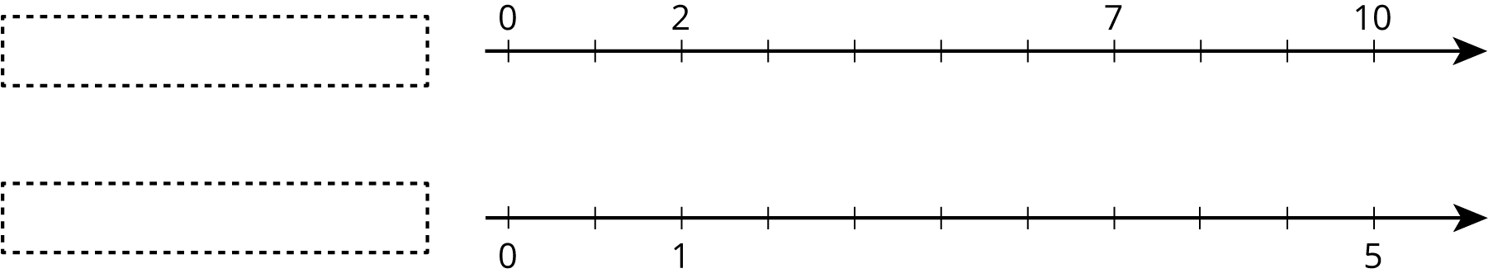
- What could each of the number lines represent? Invent a situation and label the diagram.
- Make sure your labels include appropriate units of measure.

1.2: Mystery Mixtures
Your teacher will show you three mixtures. Two taste the same, and one is different.
- Which mixture tastes different? Describe how it is different.
- Here are the recipes that were used to make the three mixtures:
  - 1 cup of water with $1\frac{1}{2}$ teaspoons of powdered drink mix
  - 2 cups of water with $\frac{1}{2}$ teaspoon of powdered drink mix
  - 1 cup of water with $\frac{1}{4}$ teaspoon of powdered drink mix
- Which of these recipes is for the stronger tasting mixture? Explain how you know.

Are you ready for more?
Salt and sugar give two distinctly different tastes, one salty and the other sweet. In a mixture of salt and sugar, it is possible for the mixture to be salty, sweet or both. Will any of these mixtures taste exactly the same?
- Mixture A: 2 cups water, 4 teaspoons salt, 0.25 cup sugar
- Mixture B: 1.5 cups water, 3 teaspoons salt, 0.2 cup sugar
- Mixture C: 1 cup water, 2 teaspoons salt, 0.125 cup sugar

1.3: Crescent Moons
Here are four different crescent moon shapes.
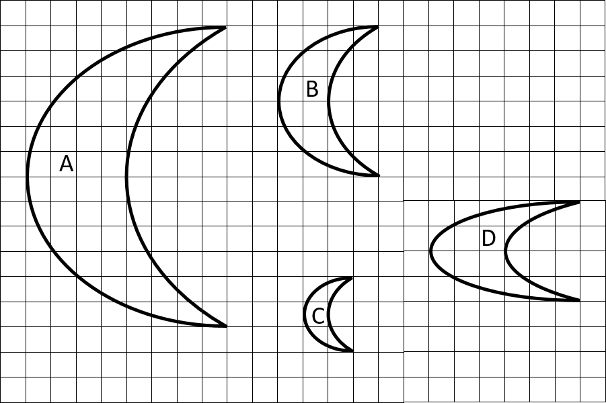
- What do Moons A, B, and C all have in common that Moon D doesn’t?
- Use numbers to describe how Moons A, B, and C are different from Moon D.
- Use a table or a double number line to show how Moons A, B, and C are different from Moon D.

Lesson 1 Summary
When two different situations can be described by equivalent ratios, that means they are alike in some important way.
An example is a recipe. If two people make something to eat or drink, the taste will only be the same as long as the ratios of the ingredients are equivalent. For example, all of the mixtures of water and drink mix in this table taste the same, because the ratios of cups of water to scoops of drink mix are all equivalent ratios.
water (cups) | drink mix (scoops)
3 | 1
12 | 4
1.5 | 0.5
If a mixture were not equivalent to these, for example, if the ratio of cups of water to scoops of drink mix were $6:4$, then the mixture would taste different.
Notice that the ratios of pairs of corresponding side lengths are equivalent in figures A, B, and C. For example, the ratios of the length of the top side to the length of the left side for figures A, B, and C are equivalent ratios. Figures A, B, and C are scaled copies of each other; this is the important way in which they are alike.
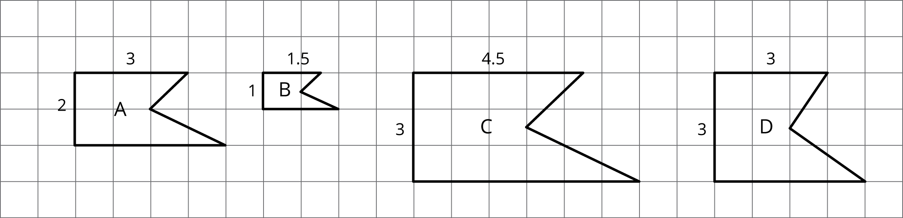
If a figure has corresponding sides that are not in a ratio equivalent to these, like figure D, then it’s not a scaled copy. In this unit, you will study relationships like these that can be described by a set of equivalent ratios.
© CC BY Open Up Resources. Adaptations CC BY IM.

