Unit 8 Lesson 10 Cumulative Practice Problems
- A rare and delicate plant will only produce flowers from 10% of the seeds planted. To see if it is worth planting 5 seeds to see any flowers, the situation is going to be simulated. Which of these options is the best simulation? For the others, explain why it is not a good simulation.
  - Another plant can be genetically modified to produce flowers 10% of the time. Plant 30 groups of 5 seeds each and wait 6 months for the plants to grow and count the fraction of groups that produce flowers.
  - Roll a standard number cube 5 times. Each time a 6 appears, it represents a plant producing flowers. Repeat this process 30 times and count the fraction of times at least one number 6 appears.
  - Have a computer produce 5 random digits (0 through 9). If a 9 appears in the list of digits, it represents a plant producing flowers. Repeat this process 300 times and count the fraction of times at least one number 9 appears.
  - Create a spinner with 10 equal sections and mark one of them “flowers.” Spin the spinner 5 times to represent the 5 seeds. Repeat this process 30 times and count the fraction of times that at least 1 “flower” was spun.
- Jada and Elena learned that 8% of students have asthma. They want to know the probability that in a team of 4 students, at least one of them has asthma. To simulate this, they put 25 slips of paper in a bag. Two of the slips say “asthma.” Next, they take four papers out of the bag and record whether at least one of them says “asthma.” They repeat this process 15 times.
  - Jada says they could improve the accuracy of their simulation by using 100 slips of paper and marking 8 of them.
  - Elena says they could improve the accuracy of their simulation by conducting 30 trials instead of 15.
  - Do you agree with either of them? Explain your reasoning.
  - Describe another method of simulating the same scenario.
- The figure on the left is a trapezoidal prism. The figure on the right represents its base. Find the volume of this prism.
- 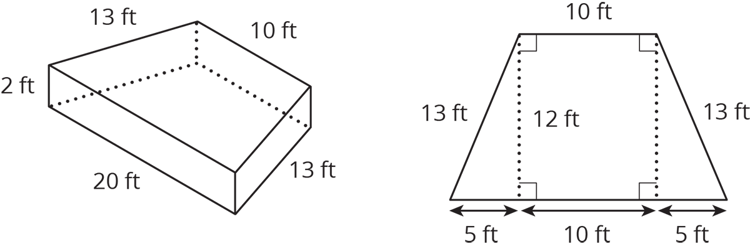

- (From Unit 7, Lesson 13.)
- Match each expression in the first list with an equivalent expression from the second list.
  - $(8x+6y)+(2x+4y)$
  - $(8x+6y)−(2x+4y)$
  - $(8x+6y)−(2x−4y)$
  - $8x−6y−2x+4y$
  - $8x−6y+2x−4y$
  - $8x−(\text{-}6y−2x+4y)$
  - $10(x+y)$
  - $10(x−y)$
  - $6(x−\frac{1}{3}y)$
  - $8x+6y+2x−4y$
  - $8x+6y−2x+4y$
  - $8x−2x+6y−4y$
- (From Unit 6, Lesson 22.)
© CC BY Open Up Resources. Adaptations CC BY IM.

