Lesson 16: Dividing Rational Numbers
Let's divide signed numbers.

16.1: Tell Me Your Sign
Consider the equation: $\text{-}27x=\text{-}35$
Without computing:
- Is the solution to this equation positive or negative?
- Are either of these two numbers solutions to the equation?
- $\frac{35}{27}$
- $\text{-}\frac{35}{27}$

16.2: Multiplication and Division
- Find the missing values in the equations
  - $\text{-}3⋅4=\text{?}$
  - $\text{-}3⋅\text{?}=12$
  - $3⋅\text{?}=12$
  - $\text{?}⋅\text{-}4=12$
  - $\text{?}⋅4=\text{-}12$
- Rewrite the unknown factor problems as division problems.
- Complete the sentences. Be prepared to explain your reasoning.
  - The sign of a positive number divided by a positive number is always:
  - The sign of a positive number divided by a negative number is always:
  - The sign of a negative number divided by a positive number is always:
  - The sign of a negative number divided by a negative number is always:
- Han and Clare walk towards each other at a constant rate, meet up, and then continue past each other in opposite directions. We will call the position where they meet up 0 feet and the time when they meet up 0 seconds.
  - Han's velocity is 4 feet per second.
  - Clare's velocity is -5 feet per second.
  - Where is each person 10 seconds before they meet up?
  - When is each person at the position -10 feet from the meeting place?

Are you ready for more?
It is possible to make a new number system using only the numbers 0, 1, 2, and 3. We will write the symbols for multiplying in this system like this: $1⊗2=2$. The table shows some of the products.
$⊗$ | 0 | 1 | 2 | 3
0 | 0 | 0 | 0 | 0
1 |  | 1 | 2 | 3
2 |  |  | 0 | 2
3
- In this system, $1⊗3=3$ and $2⊗3=2$. How can you see that in the table?
- What do you think $2⊗1$ is?
- What about $3⊗3$?
- What do you think the solution to $3⊗n=2$ is?
- What about $2⊗n=3$?

16.3: Drilling Down
A water well drilling rig has dug to a height of -60 feet after one full day of continuous use.
- Assuming the rig drilled at a constant rate, what was the height of the drill after 15 hours?
- If the rig has been running constantly and is currently at a height of -147.5 feet, for how long has the rig been running?
- Use the coordinate grid to show the drill’s progress.
- 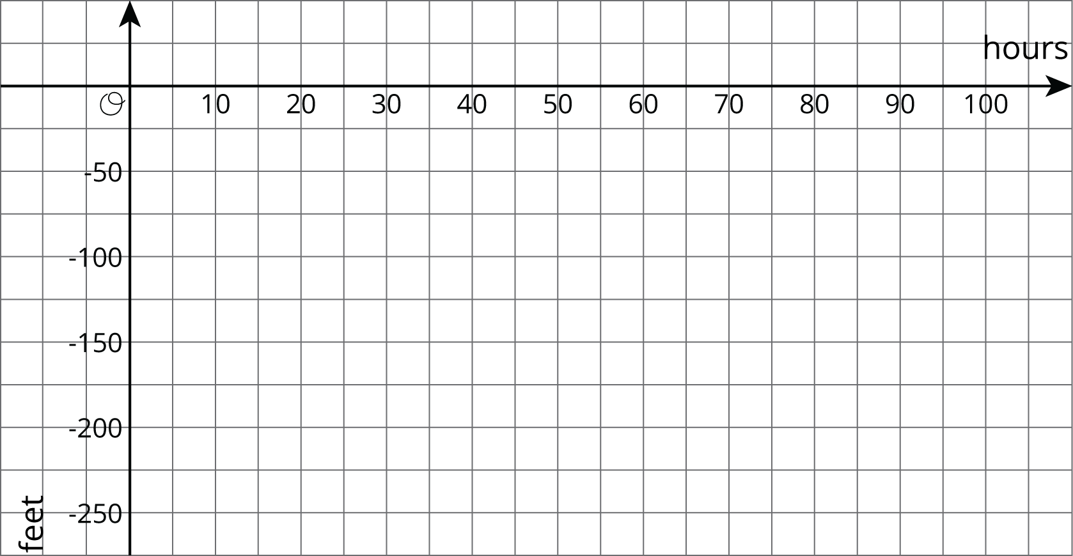
- At this rate, how many hours will it take until the drill reaches -250 feet?
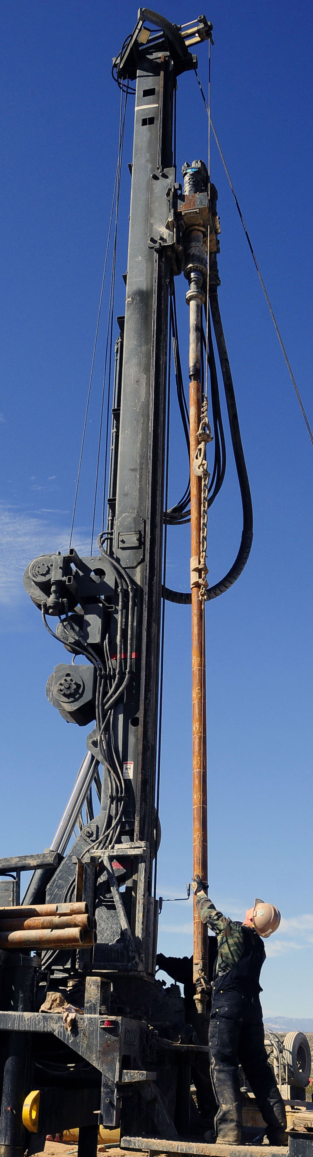

Lesson 16 Summary
Any division problem is actually a multiplication problem:
- $6÷2=3$ because $2⋅3=6$
- $6÷\text{-}2=\text{-}3$ because $\text{-}2⋅\text{-}3=6$
- $\text{-}6÷2=\text{-}3$ because $2⋅\text{-}3=\text{-}6$
- $\text{-}6÷\text{-}2=3$ because $\text{-}2⋅3=\text{-}6$
Because we know how to multiply signed numbers, that means we know how to divide them.
- The sign of a positive number divided by a negative number is always negative.
- The sign of a negative number divided by a positive number is always negative.
- The sign of a negative number divided by a negative number is always positive.
A number that can be used in place of the variable that makes the equation true is called a solution to the equation. For example, for the equation $x÷\text{-}2=5$, the solution is -10, because it is true that $\text{-}10÷\text{-}2=5$.
© CC BY Open Up Resources. Adaptations CC BY IM.

