Lesson 4: The Unit Circle (Part 2)
- Let’s look at angles and points on the unit circle.

4.1: Notice and Wonder: Angles Around the Unit Circle
What do you notice? What do you wonder?
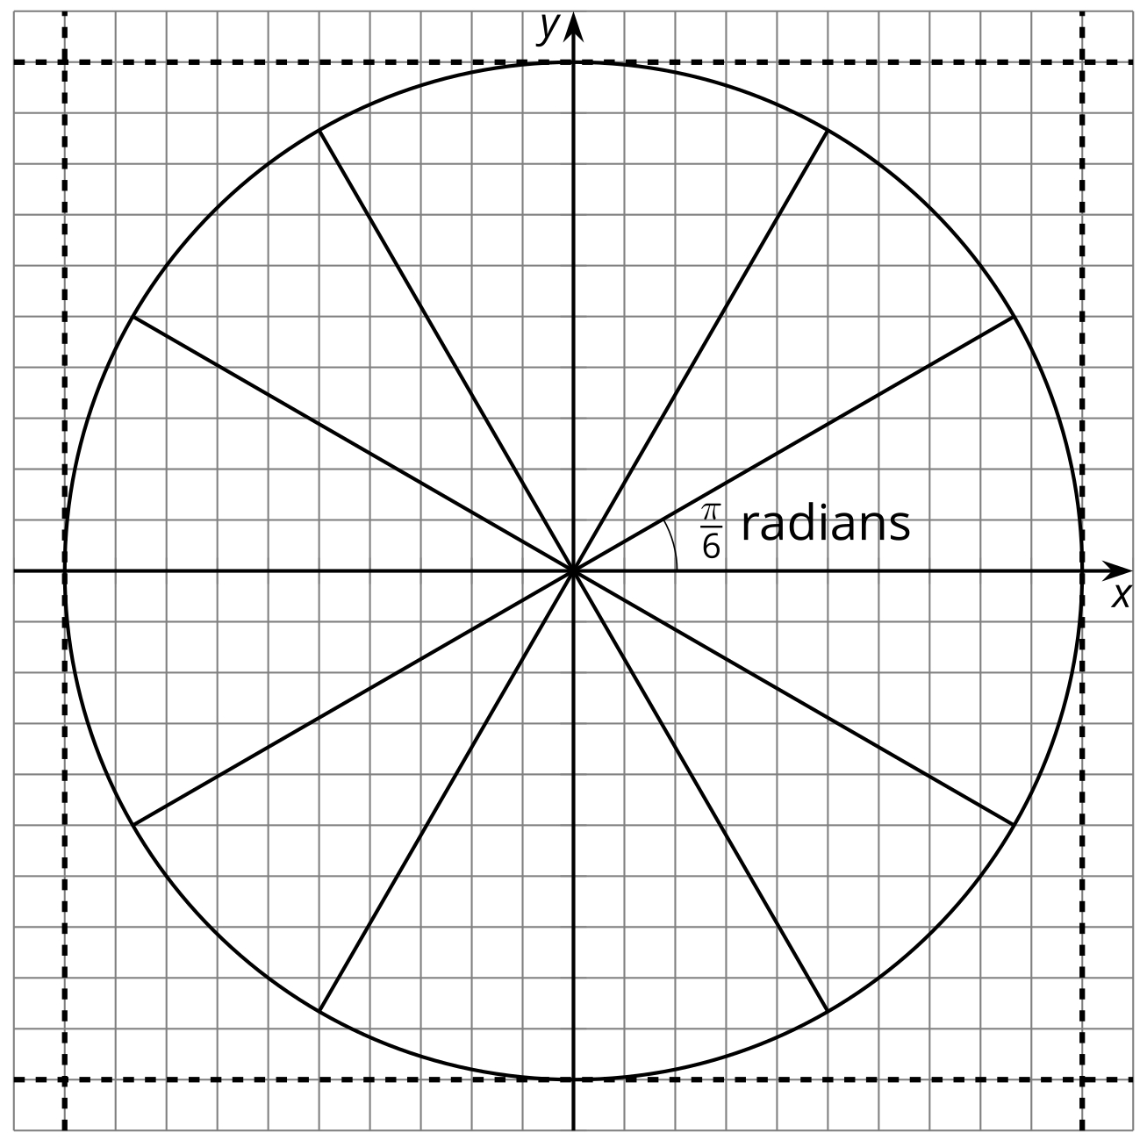

4.2: Angles Everywhere
Here is a circle of radius 1 with some radii drawn.
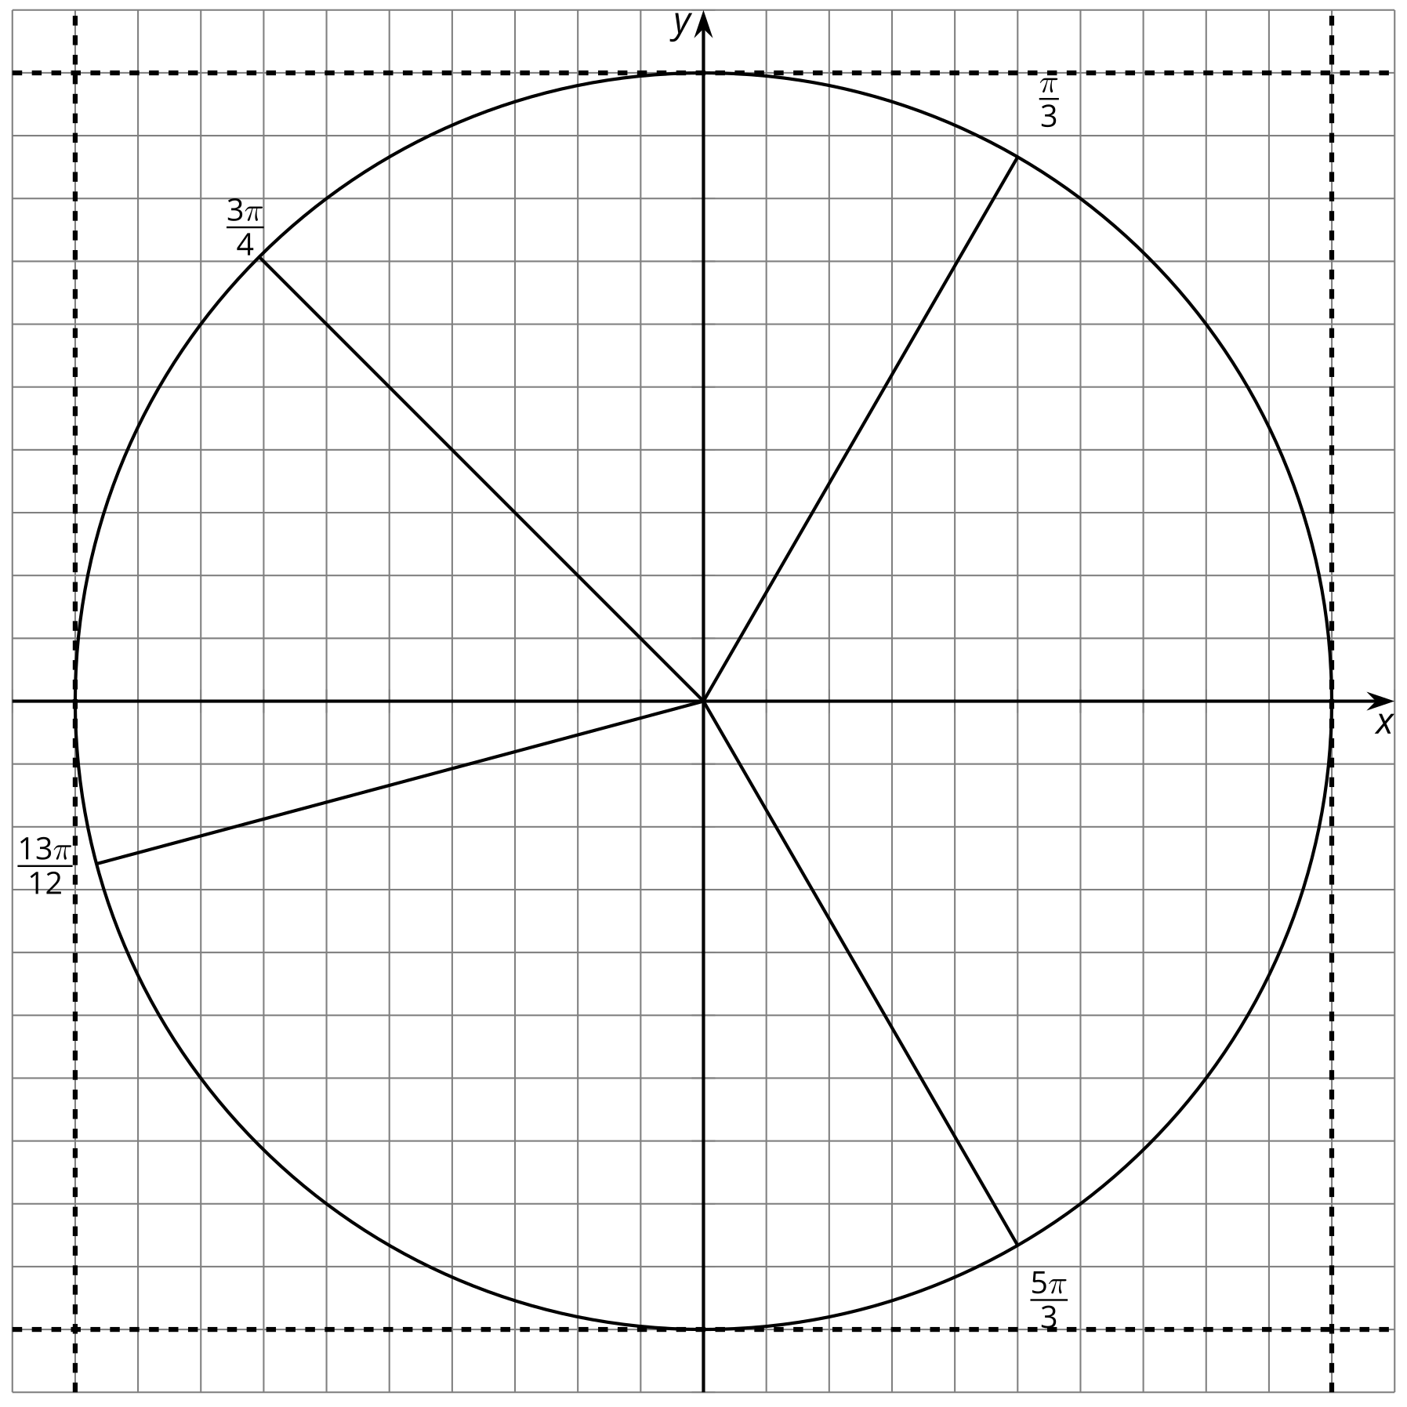
- Draw and label angles, with the positive $x$-axis as the starting ray for each angle, measuring $\frac{π}{12},\frac{π}{6},\frac{π}{4}…,2π$ in the counterclockwise direction. Four of these angles, one in each quadrant, have been drawn for you. There should be a total of 24 angles labeled when you are finished, including those that line up with the axes. Be prepared to share any strategies you used to make the angles.
- Label the points, where the rays meet the unit circle, for which you know the exact coordinate values.

4.3: Angle Coordinates Galore
Your teacher will assign you a section of the unit circle.
- Find and label the coordinates of the points assigned to you where the angles intersect the circle.
- Compare and share your values with your group.
- What relationships or patterns do you notice in the coordinates? Be prepared to share what you notice with the class.

Are you ready for more?
Other than $\left(1,0\right)$, $\left(0,1\right)$, $\left(\text{-}1,0\right)$, and $\left(0,\text{-}1\right)$, the coordinates we used in this activity involved approximations. The point $\left(0.8,0.6\right)$, however, lies exactly on our unit circle.
- Explain why this must be true.
- Find all other points on the unit circle that also lie exactly at the intersection of two grid lines.
- What are the approximate angle measures needed to intersect at $\left(0.8,0.6\right)$ and each of these new points?

Lesson 4 Summary
Given any point in a quadrant on the unit circle and its associated angle, like $R$ shown here, we can make some statements about other points that must also be on the unit circle.
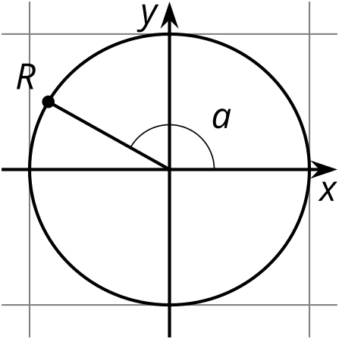
For example, if the coordinates of $R$ are $\left(\text{-}0.87,0.5\right)$ and $a$ is $\frac{5π}{6}$ radians, then there is a point $S$ in quadrant 1 with coordinates $\left(0.87,0.5\right)$. Since $R$ is $\frac{π}{6}$ radians from a half circle, the angle associated with point $S$ must be $\frac{π}{6}$ radians. Similarly, there is a point $T$ at $\left(\text{-}0.87,\text{-}0.5\right)$ with an angle $\frac{π}{6}$ radians greater than a half circle. This means point $T$ is at angle $\frac{7π}{6}$ radians, since $π+\frac{π}{6}=\frac{7π}{6}$.
What is the matching point to $R$ in quadrant 4? (A point at $\left(0.87,\text{-}0.5\right)$ and angle $\frac{11π}{6}$ radians.)
In future lessons, we’ll learn about how to find the coordinates of point $R$ ourselves using its angle $a$ and what we know about right triangles.
© CC BY 2019 by Illustrative Mathematics®

