Lesson 11: Writing Equations for Lines

11.1: Coordinates and Lengths in the Coordinate Plane
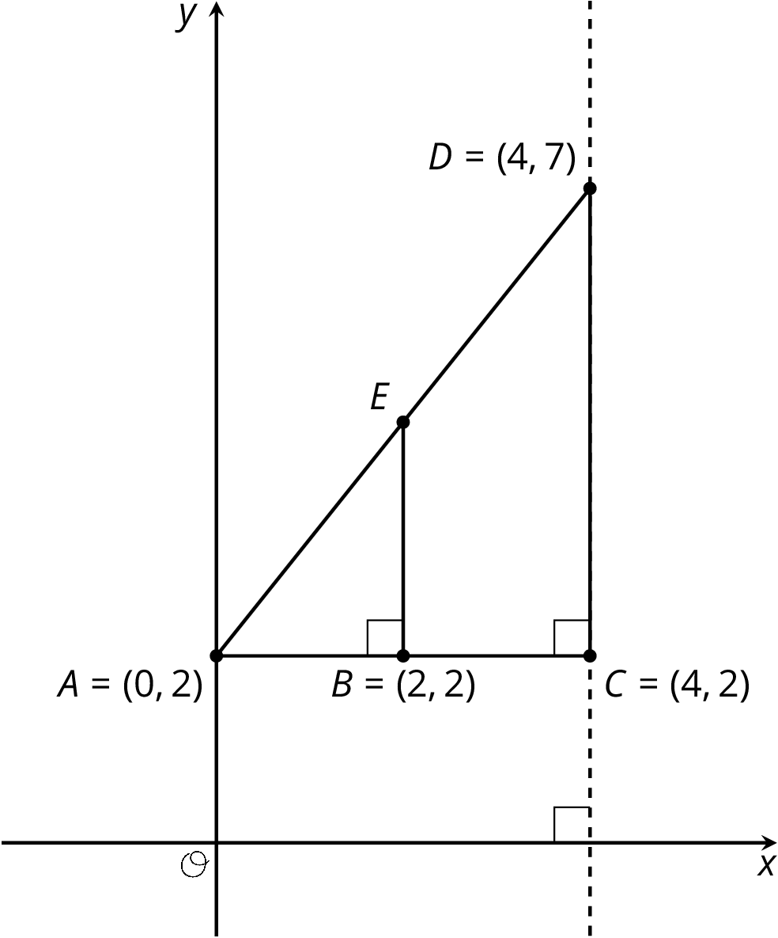
Find each of the following and explain your reasoning:
- The length of segment $BE$.
- The coordinates of $E$.

11.2: What We Mean by an Equation of a Line
Line $j$ is shown in the coordinate plane.
- What are the coordinates of $B$ and $D$?
- Is point $(20,15)$ on line $j$? Explain how you know.
- Is point $(100,75)$ on line $j$? Explain how you know.
- Is point $(90,68)$ on line $j$? Explain how you know.
- Suppose you know the $x$- and $y$-coordinates of a point. Write a rule that would allow you to test whether the point is on line $j$.
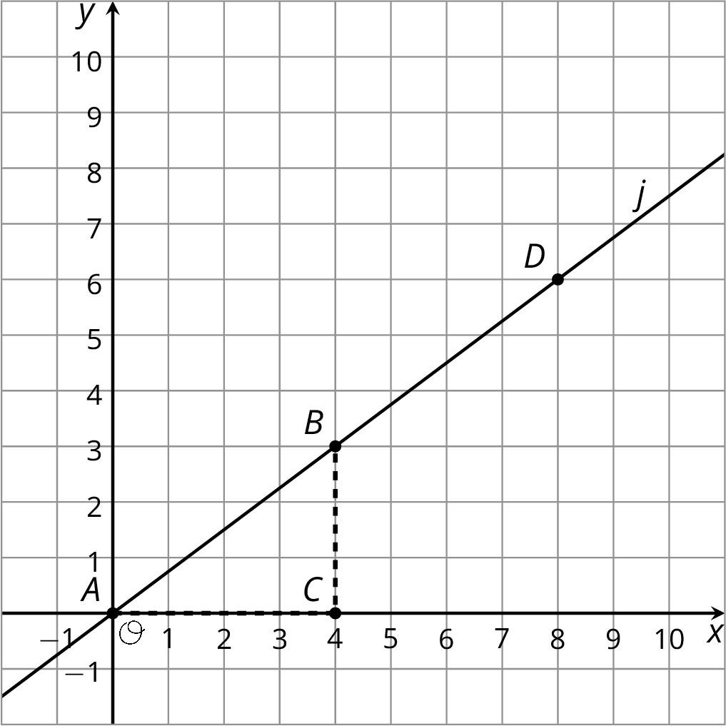

11.3: Writing Relationships from Slope Triangles
Here are two diagrams:
- Complete each diagram so that all vertical and horizontal segments have expressions for their lengths.
- Use what you know about similar triangles to find an equation for the quotient of the vertical and horizontal side lengths of $△DFE$ in each diagram.
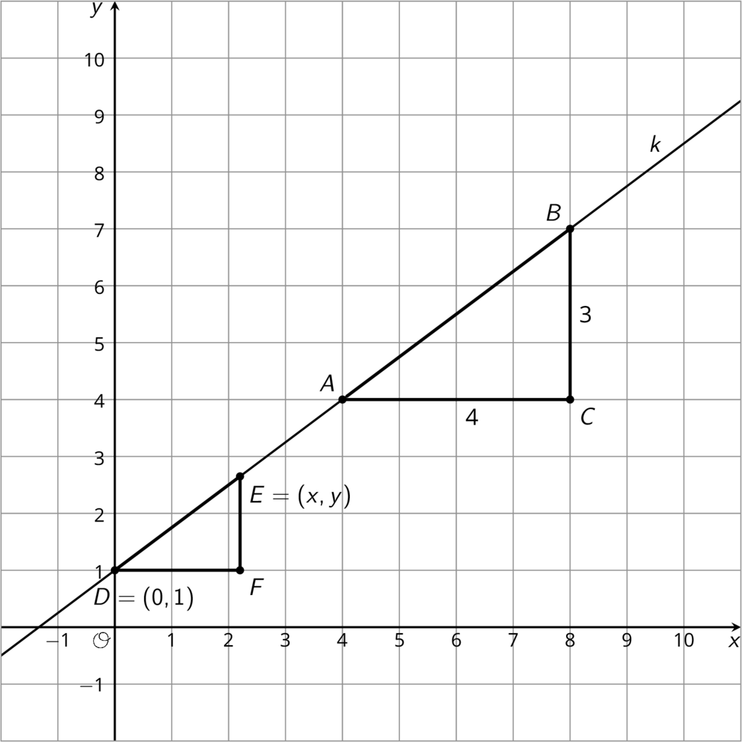
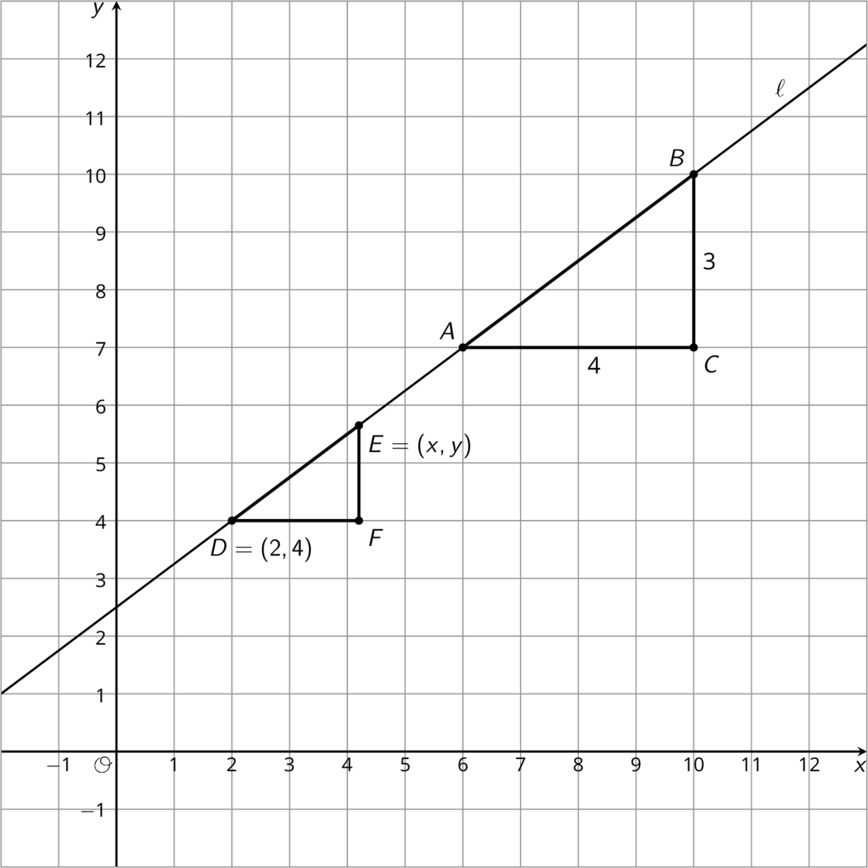

Are you ready for more?
- Find the area of the shaded region by summing the areas of the shaded triangles.
- Find the area of the shaded region by subtracting the area of the unshaded region from the large triangle.
- What is going on here?
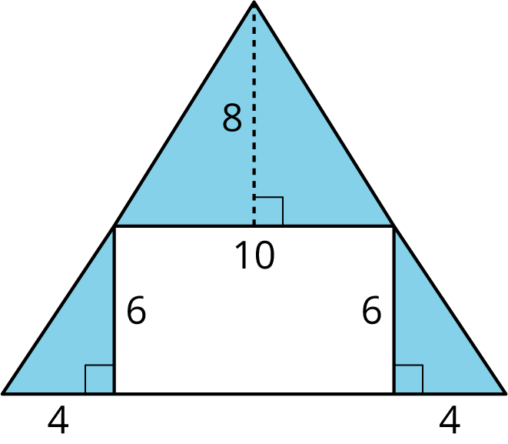

Lesson 11 Summary
Here are the points $A$, $C$, and $E$ on the same line. Triangles $ABC$ and $ADE$ are slope triangles for the line so we know they are similar triangles. Let’s use their similarity to better understand the relationship between $x$ and $y$, which make up the coordinates of point $E$.
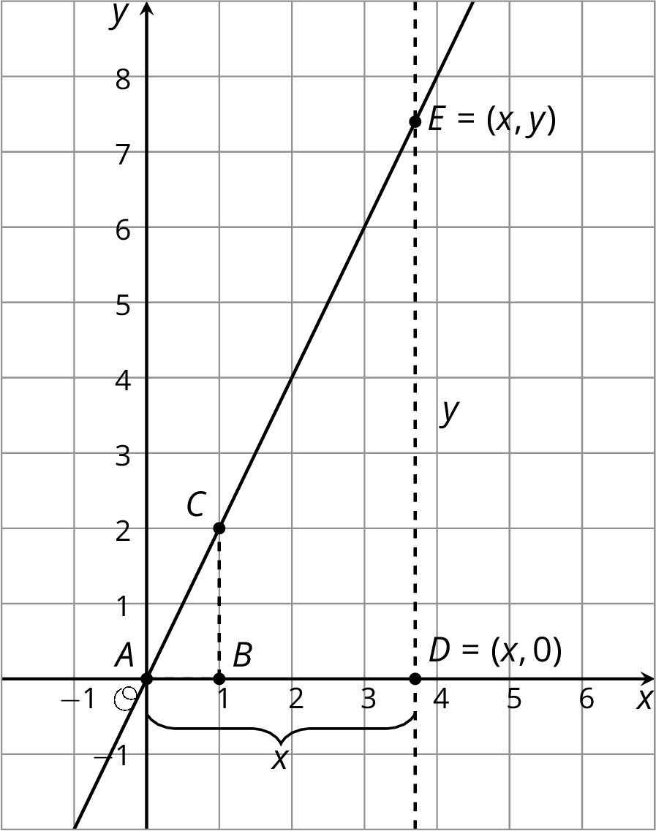
The slope for triangle $ABC$ is $\frac{2}{1}$ since the vertical side has length 2 and the horizontal side has length 1. The slope we find for triangle $ADE$ is $\frac{y}{x}$ because the vertical side has length $y$ and the horizontal side has length $x$. These two slopes must be equal since they are from slope triangles for the same line, and so: $\frac{2}{1}=\frac{y}{x}$.
Since $\frac{2}{1}=2$ this means that the value of $y$ is twice the value of $x$, or that $y=2x$. This equation is true for any point $(x,y)$ on the line!
Here are two different slope triangles. We can use the same reasoning to describe the relationship between $x$ and $y$ for this point $E$.
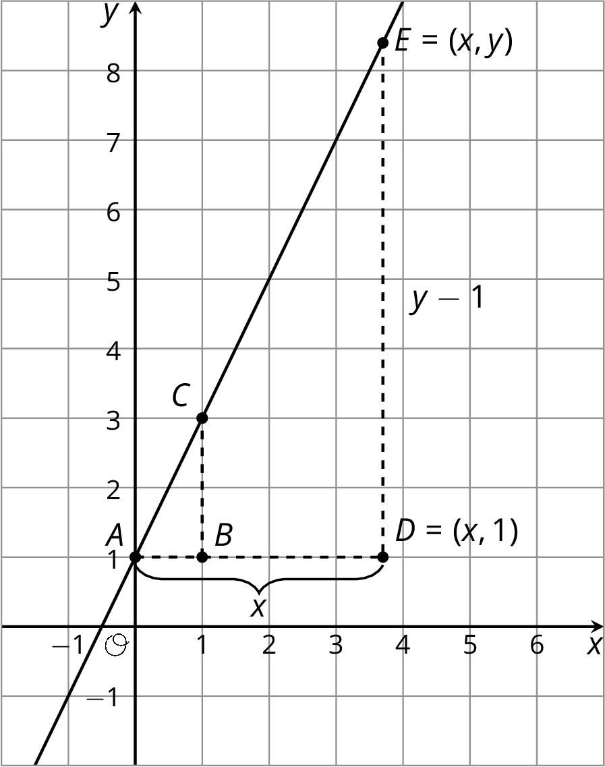
The slope for triangle $ABC$ is $\frac{2}{1}$ since the vertical side has length 2 and the horizontal side has length 1. For triangle $ADE$, the horizontal side has length $x$. The vertical side has length $y−1$ because the distance from $(x,y)$ to the $x$-axis is $y$ but the vertical side of the triangle stops 1 unit short of the $x$-axis. So the slope we find for triangle $ADE$ is $\frac{y−1}{x}$. The slopes for the two slope triangles are equal, meaning: $\frac{2}{1}=\frac{y−1}{x}$
Since $y−1$ is twice $x$, another way to write this equation is $y−1=2x$. This equation is true for any point $(x,y)$ on the line!
© CC BY Open Up Resources. Adaptations CC BY IM.

