Lesson 13: Divide Whole Numbers by Unit Fractions
- Let’s divide a whole number by a unit fraction.

Warm-up: Notice and Wonder: Quilt
What do you notice? What do you wonder?

13.1: Paper Strips
Below are diagrams that show strips of different colored paper. Each strip is 2 feet long. The paper strips will be cut into different sized pieces.
- The red strip will be cut into pieces that are $\frac{1}{2}$ foot long. How many pieces will there be?
- 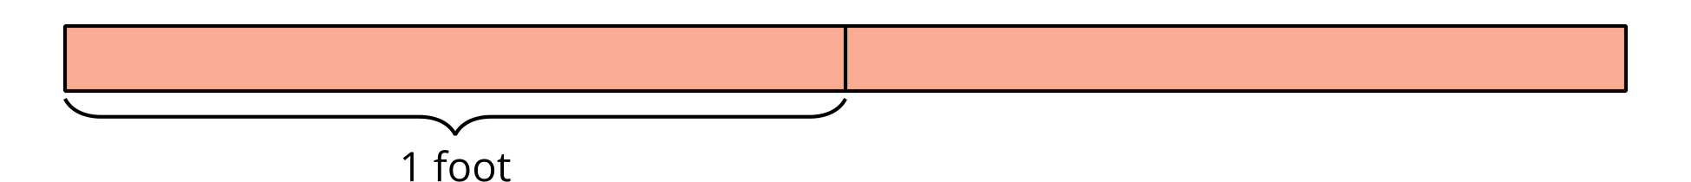
- The green strip will be cut into pieces that are $\frac{1}{3}$ foot long. How many pieces will there be?
- 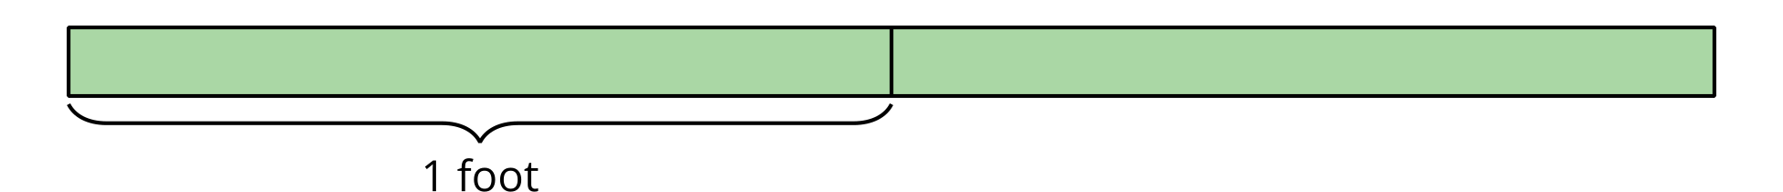
- The yellow strip will be cut into pieces that are $\frac{1}{4}$ foot long. How many pieces will there be?
- 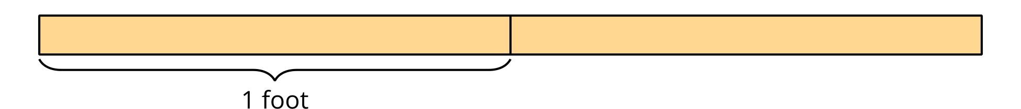
- Describe what was the same about the problems you solved. Describe what was different.

13.2: More Paper Strips
Kiran has a yellow strip of paper that is 2 feet long. He wants to cut the strip into pieces that are $\frac{1}{6}$ foot long.
- How many pieces will Kiran have? Explain or show your reasoning.
- Write a division equation to represent the situation.
- Describe how the equation $3÷\frac{1}{6}=18$ represents a strip of paper that is 3 feet long being cut into equal-sized pieces.
© CC BY 2021 Illustrative Mathematics®

