Lesson 11: Tell Time with Halves and Quarters

Standards Alignments
Building On | 1.MD.B.3
Addressing | 2.MD.C.7
Building Towards | 2.MD.C.7

Teacher-facing Learning Goals
- Tell time from an analog clock using the words half past, quarter past, and quarter till.

Student-facing Learning Goals
- Let’s tell time with halves and quarters.

Lesson Purpose
The purpose of this lesson is for students to tell time with an analog clock using the words half past, quarter past, and quarter till.
In grade 1, students learned to tell and write time to the hour and half-hour. They related representations of time to the half-hour on analog clocks to circles partitioned into halves. In previous lessons, students partitioned shapes, including circles, into halves and quarters.
In this lesson, students connect their understanding of partitioning a circle into equal pieces to using the words “half past,” “quarter past,” and “quarter till” to tell time (MP2). Some students may already be familiar with telling time to the nearest 5-minute increments. If they read a clock as 4:15 rather than quarter past 4, ask if they can find another way to state the time using these phrases.

Access for:

Students with Disabilities
- Representation (Activity 1)

English Learners
- MLR8 (Activity 2)

Instructional Routines
Card Sort (Activity 2), What Do You Know About _____? (Warm-up)

Materials to Gather
- Chart paper: Warm-up

Materials to Copy
- Halves and Quarters Clock Sort (groups of 2): Activity 2

Lesson Timeline
Warm-up | 10 min
Activity 1 | 15 min
Activity 2 | 20 min
Lesson Synthesis | 10 min
Cool-down | 5 min

Teacher Reflection Question
What connections did students make between partitioning circles into halves and quarters and identifying halves and quarters of the clock? How did these connections allow students to more easily tell time using “half past,” “quarter after,” and “quarter till?”

Cool-down
(to be completed at the end of the lesson) 5min
Tell Time with Halves and Quarters

Standards Alignments
Addressing | 2.MD.C.7

Student-facing Task Statement
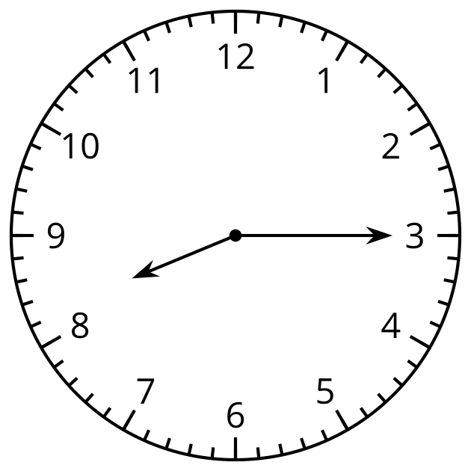
Circle the time shown on the clock.
half past 8
quarter past 8
quarter till 8

Student Responses
quarter past 8

