Lesson 9: Solve Number Riddles
- Let’s solve number riddles.

Warm-up: True or False: Comparison Statements
Decide if each statement is true or false.
Be prepared to explain your reasoning.
- $65>35$
- $65=75−10$
- $65>35+30$

9.1: A Number Riddle
My number is less than 60.
My number has 4 ones.
My number is more than 30.
What numbers fit these clues?
Secret number: ___________

9.2: More Number Riddles
Secret Numbers
A: __________
B: __________
C: __________
D: __________
E: __________
F: __________
G: __________
H: __________
I: __________
J: __________
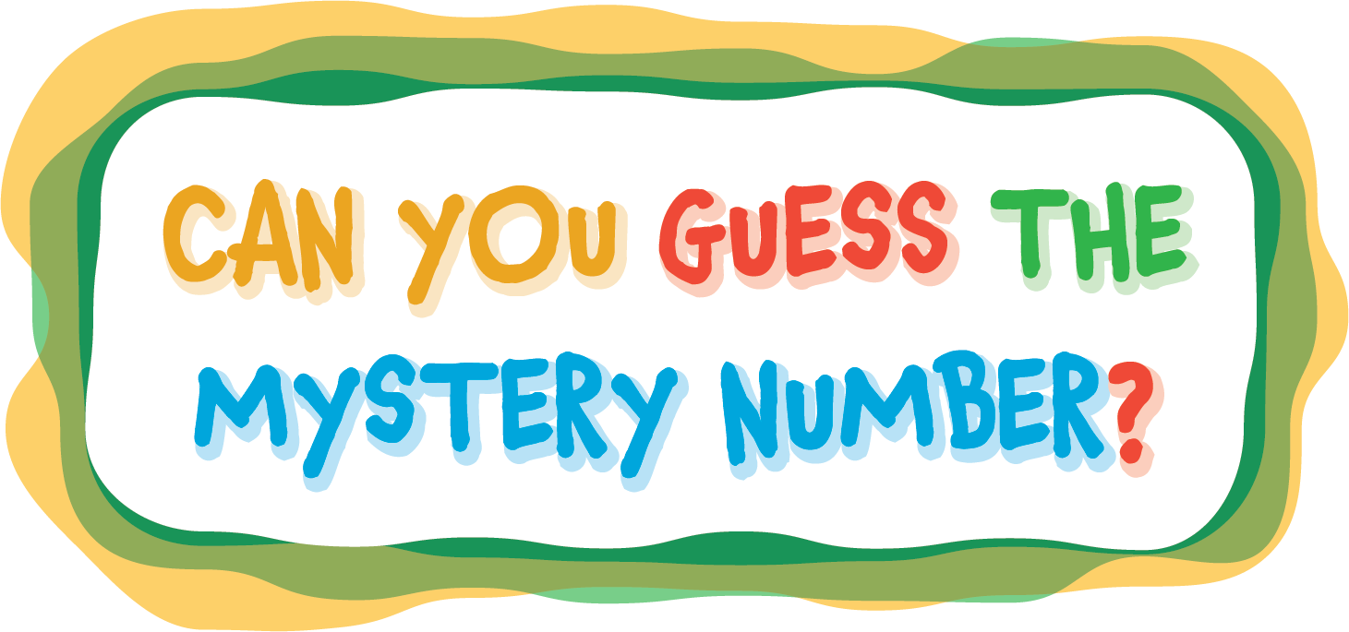
© CC BY 2021 Illustrative Mathematics®

