Lesson 15: Irrational Numbers
- Let’s explore irrational numbers

15.1: Finding a Home for Irrational Numbers
Use the number line to place these values in their approximate location.
- $\sqrt{5}$
- $\text{-}\sqrt{13}$
- $3+\sqrt{2}$
- $3−\sqrt{2}$

15.2: Solving for Missing Sides
For each triangle, use the Pythagorean Theorem to find the length of the missing side.
- 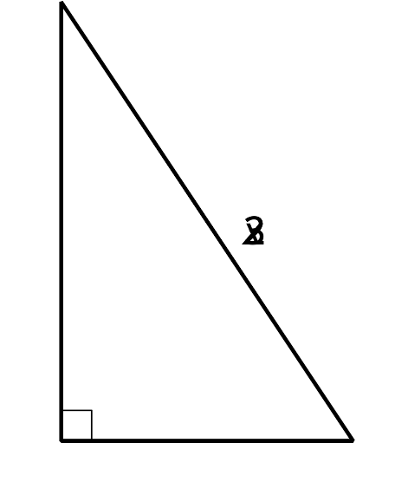
- 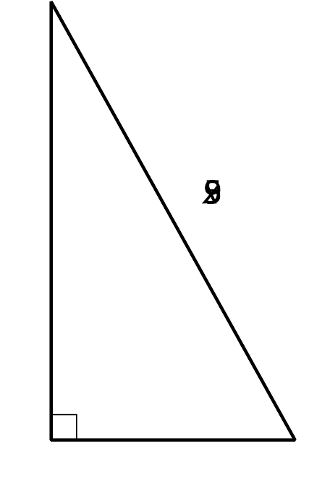
- 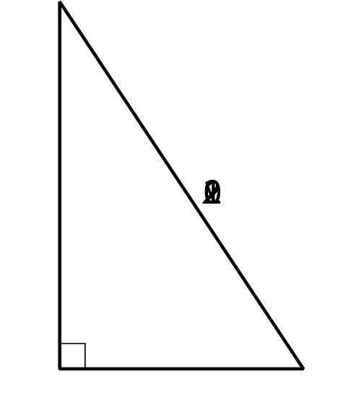
- 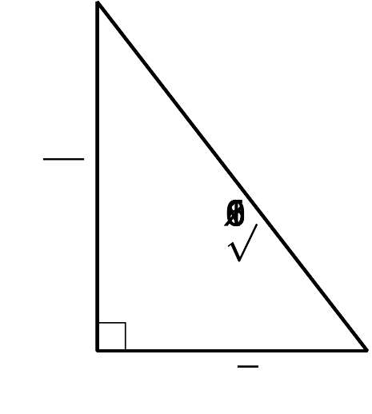
- 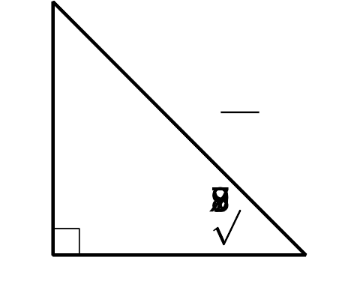

15.3: Solving with Square Roots
Solve each of these equations. Represent the solutions exactly. If the solution is not a whole number, what 2 whole numbers does each solution lie between? Be prepared to explain your reasoning.
- $(x+1)^{2}=64$
- $(x−3)^{2}−4=0$
- $x^{2}=10$
- $(x−2)^{2}=12$
- $(x+3)^{2}=24+4$
© CC BY 2019 by Illustrative Mathematics®

