Unit 1 Lesson 4: Create Scaled Picture Graphs

WU How Many Do You See: More Groups of Dots (Warm up)

Student Task Statement
How many do you see? How do you see them?
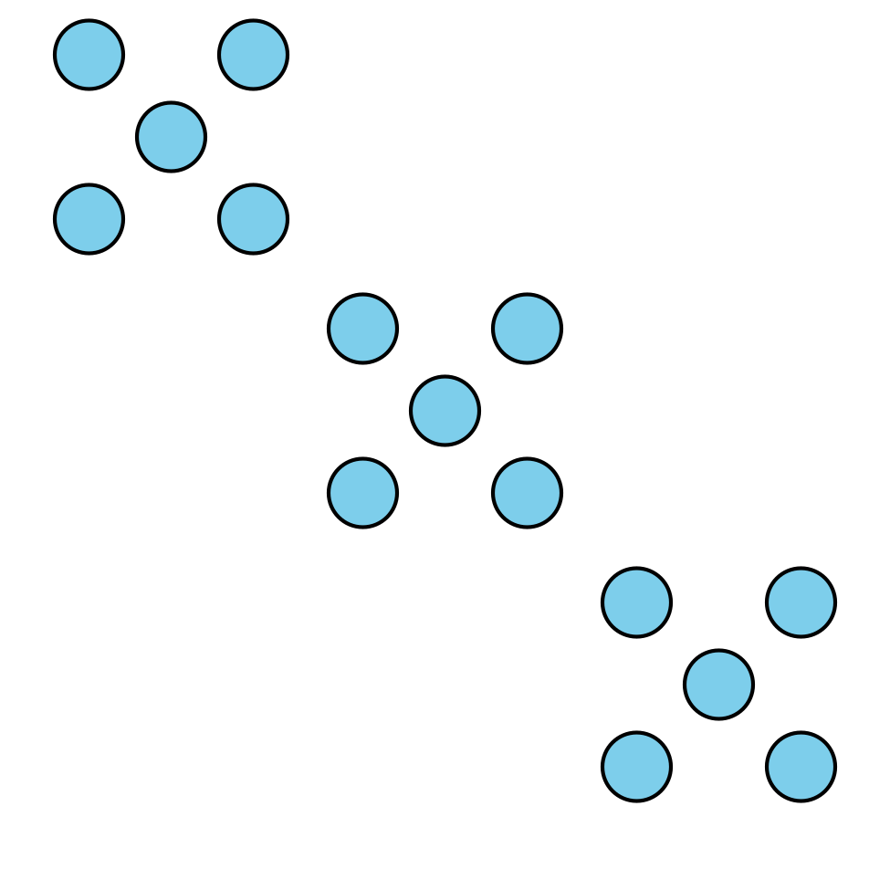
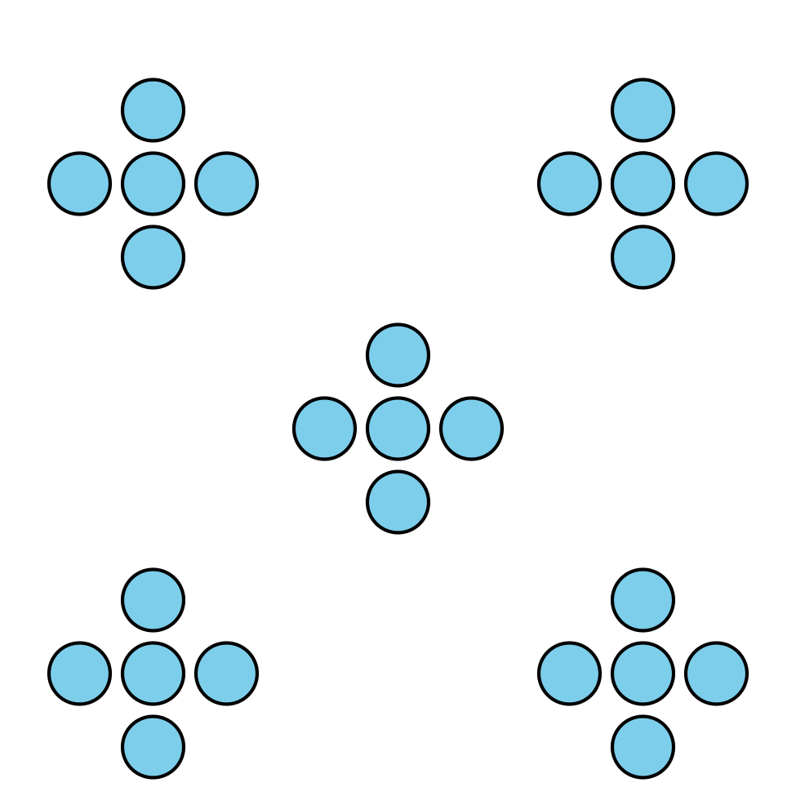

1 Ways to Travel

Student Task Statement
How would you like to travel?
- car (C)
- train (T)
- boat (B)
- balloon (Bal)
- plane (P)
- helicopter (H)
student's name | way of traveling

2 Create a Scaled Picture Graph

Student Task Statement
Represent our survey data in a scaled picture graph where each picture represents 2 students.
© CC BY 2021 Illustrative Mathematics®

