Lesson 24: Assess the Reasonableness of Solutions
- Let’s solve problems and assess the reasonableness of solutions.

Warm-up: Notice and Wonder: Native American Languages
What do you notice and what do you wonder?
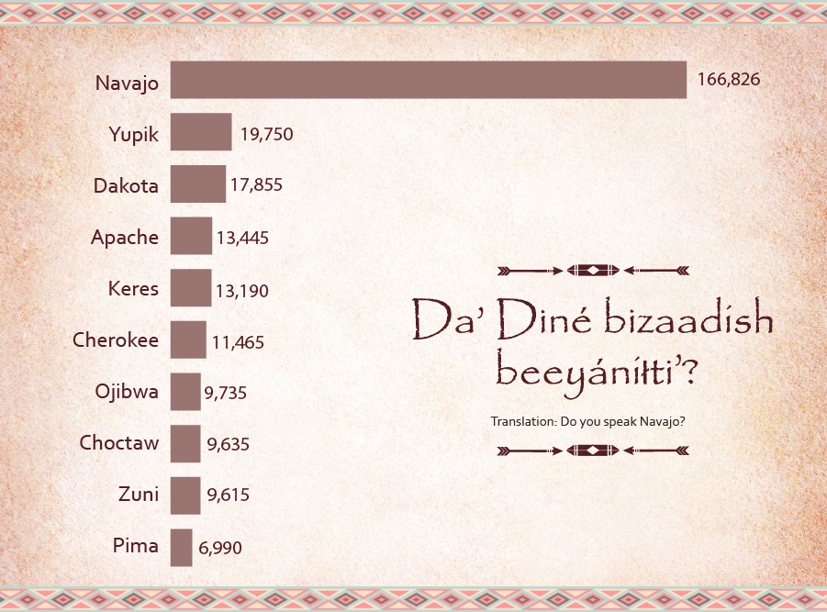

24.1: Do You Speak Navajo?
- In the list of the ten most widely spoken Native American languages in the U.S., Navajo and Yupik are the most widely spoken.
  - How many more Navajo speakers are there than Yupik speakers? Show your reasoning.
- language | - number of speakers
- Navajo | - 166,826
- Yupik | - 19,750
- Dakota | - 17,855
- Apache | - 13,445
- Keres | - 13,190
- Cherokee | - 11,465
- Ojibwa | - 9,735
- Choctaw | - 9,635
- Zuni | - 9,615
- Pima | - 6,990
  - About how many times as many Navajo speakers as there are Yupik speakers? Show your reasoning.
- Navajo, Apache, and Cherokee languages have been used during wartime to help the U.S. military keep its communications secure and incomprehensible to their enemies.
  - Based on the data here, how many people might have been able to understand the communications? Show your reasoning.
  - How do you know that your answer is reasonable?
- Are there more Navajo speakers than the speakers of all the other nine languages combined? Explain or show how you know.

24.2: Languages in Philadelphia and Chicago
Philadelphia, the birthplace of the United States, is a diverse city and home to people of different backgrounds.
The table shows 2017 data on some types of languages spoken in Philadelphia and the numbers of people who speak them.
language | number of speakers in Philadelphia
English only | 1,224,539
Spanish | 127,352
Other Indo-European | 6,750
Asian | 364
- Based on the data, are there more people in Philadelphia who only speak English or more people who speak a language other than English? Show how you know.
- What is the difference between the number of people who speak only English and those who speak another language? Show how you know.
- Chicago is a city with a similar population to Philadelphia.
- This table shows data on some types of languages spoken by people in Chicago.
- language | - number of speakers in Chicago
- English only | - 1,731,836
- Spanish | - 422,568
- Other Indo-European | - 25,777
- Asian | - 1,005
  - How many more speakers of Spanish and other Indo-European languages are in Chicago than in Philadelphia? Show your reasoning.
  - How do you know your answer is reasonable?

Section Summary
Section Summary
In this section, we encountered problems that involve large numbers from different contexts and that could be solved with different strategies.
In the beginning, we saw at least five ways to find the product of 45 and 18: by multiplying and dividing in parts, using a series of equations, drawing diagrams, and more.
Later, we explored problems about measurements, with numbers up to four digits. We found that, often, the same problem could be solved using different operations.
For example, in the fitness challenge activity, Han took 32,550 steps in 7 days. We can find the number of steps he took each day by thinking in terms of multiplication (what number times 7 is 32,550?) or in terms of division (what is 32,550 divided by 7?).
We can also write different equations.
$7×n=32,​550$
$32,​550÷7=n$
To find out how many steps Han had to take to reach a goal of 120,000 steps if he had 96,897 steps, we can think in terms of addition (what number must be added to 96,897 to make 120,000?) or subtraction (what is the difference between 120,000 and 96,897?).
$96,​897+n=120,​000$
$120,​000−96,​897=n$
© CC BY 2021 Illustrative Mathematics®

