Lesson 3: Same Denominator or Numerator
- Let’s compare fractions with the same numerator or the same denominator.

Warm-up: Number Talk: Hundreds More
Find the value of each expression mentally.
- $136+100$
- $136+300$
- $136+370$
- $136+378$

3.1: Fractions with the Same Denominator
- This diagram shows a set of fraction strips. Label each rectangle with the fraction it represents.
- 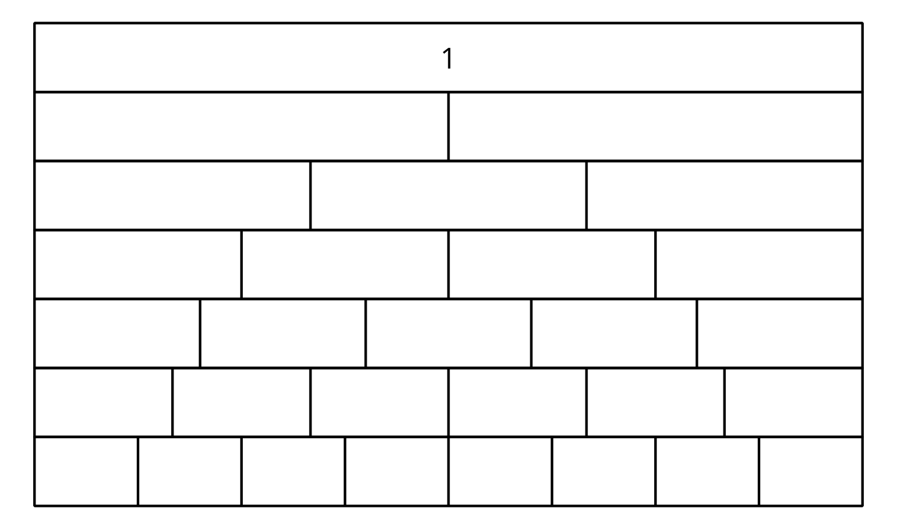
- Circle the greater fraction in each of the following pairs. If helpful, use the diagram of fraction strips.
  - $\frac{3}{4}$ or $\frac{5}{4}$
  - $\frac{3}{5}$ or $\frac{5}{5}$
  - $\frac{3}{6}$ or $\frac{5}{6}$
  - $\frac{3}{8}$ or $\frac{5}{8}$
  - $\frac{3}{10}$ or $\frac{5}{10}$
- What pattern do you notice about the circled fractions? How can you explain the pattern?
- Which one is greater: $\frac{7}{3}$ or $\frac{10}{3}$? Explain your reasoning.

3.2: Fractions with the Same Numerator
- Circle the greater fraction in each of the following pairs. If helpful, use the diagram of fraction strips.
  - $\frac{1}{3}$ or $\frac{1}{5}$
  - $\frac{2}{3}$ or $\frac{2}{5}$
  - $\frac{3}{3}$ or $\frac{3}{5}$
  - $\frac{4}{3}$ or $\frac{4}{5}$
  - $\frac{9}{3}$ or $\frac{9}{5}$
- What pattern do you notice about the circled fractions? How can you explain the pattern?
- Which one is greater: $\frac{70}{100}$ or $\frac{70}{20}$? Explain your reasoning.
- Tyler is comparing $\frac{4}{10}$ and $\frac{4}{6}$. He says, “Ten is greater than 6, so $\frac{4}{10}$ is greater than $\frac{4}{6}$.” Explain or show why Tyler’s conclusion is incorrect.
© CC BY 2021 Illustrative Mathematics®

