Lesson 7: Finding Unknown Coordinates on a Circle
- Let’s find coordinates on a circle.

7.1: Notice and Wonder: Big and Small
What do you notice? What do you wonder?
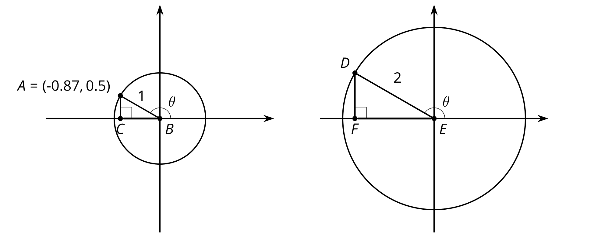

7.2: Clock Coordinates
Here is a clock face.
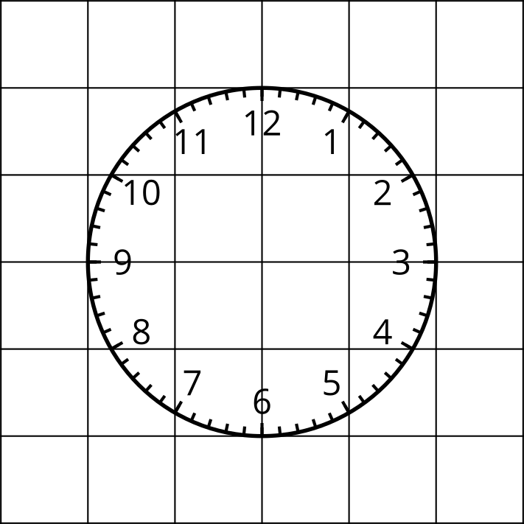
- The length of the minute hand on a clock is 5 inches and the center of the clock is at $\left(0,0\right)$ on a coordinate plane. Determine the coordinates of the end of the minute hand at the following times. Explain or show your reasoning.
  - 45 minutes after the hour
  - 10 minutes after the hour
  - 40 minutes after the hour
- The minute hand on another clock, also centered at $\left(0,0\right)$, has a length of 15 inches. Determine the coordinates of the end of the minute hand at the following times. Explain or show your reasoning.
  - 45 minutes after the hour
  - 10 minutes after the hour
  - 40 minutes after the hour
- At a certain time, the end of the minute hand of a third clock centered at $\left(0,0\right)$ has coordinates approximately $\left(7.5,7.5\right)$. How long is the minute hand of the clock if each grid square is one inch by one inch? Explain or show your reasoning.

Are you ready for more?
The center of a clock is $\left(0,0\right)$ on a coordinate grid. Its hour hand is half the length of its minute hand. The coordinates of the end of the hour hand are about $\left(3,0.5\right)$. What are the approximate coordinates of the end of the minute hand? Explain how you know.

7.3: Around a Ferris Wheel
The center of a Ferris wheel is 40 feet off of the ground, and the radius of the Ferris wheel is 30 feet. Point $P$ is shown at 0 radians.
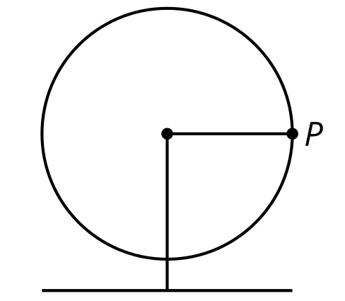
- Calculate how high off the ground point $P$ is as the Ferris wheel rotates counterclockwise starting from 0 radians.
  - $\frac{π}{12}$ radians
  - $\frac{π}{2}$radians
  - $\frac{5π}{6}$ radians
  - $\frac{5π}{3}$ radians
- As $P$ goes around on the Ferris wheel, estimate which angle(s) of rotation put $P$ 60 feet off the ground. Explain your reasoning.

Lesson 7 Summary
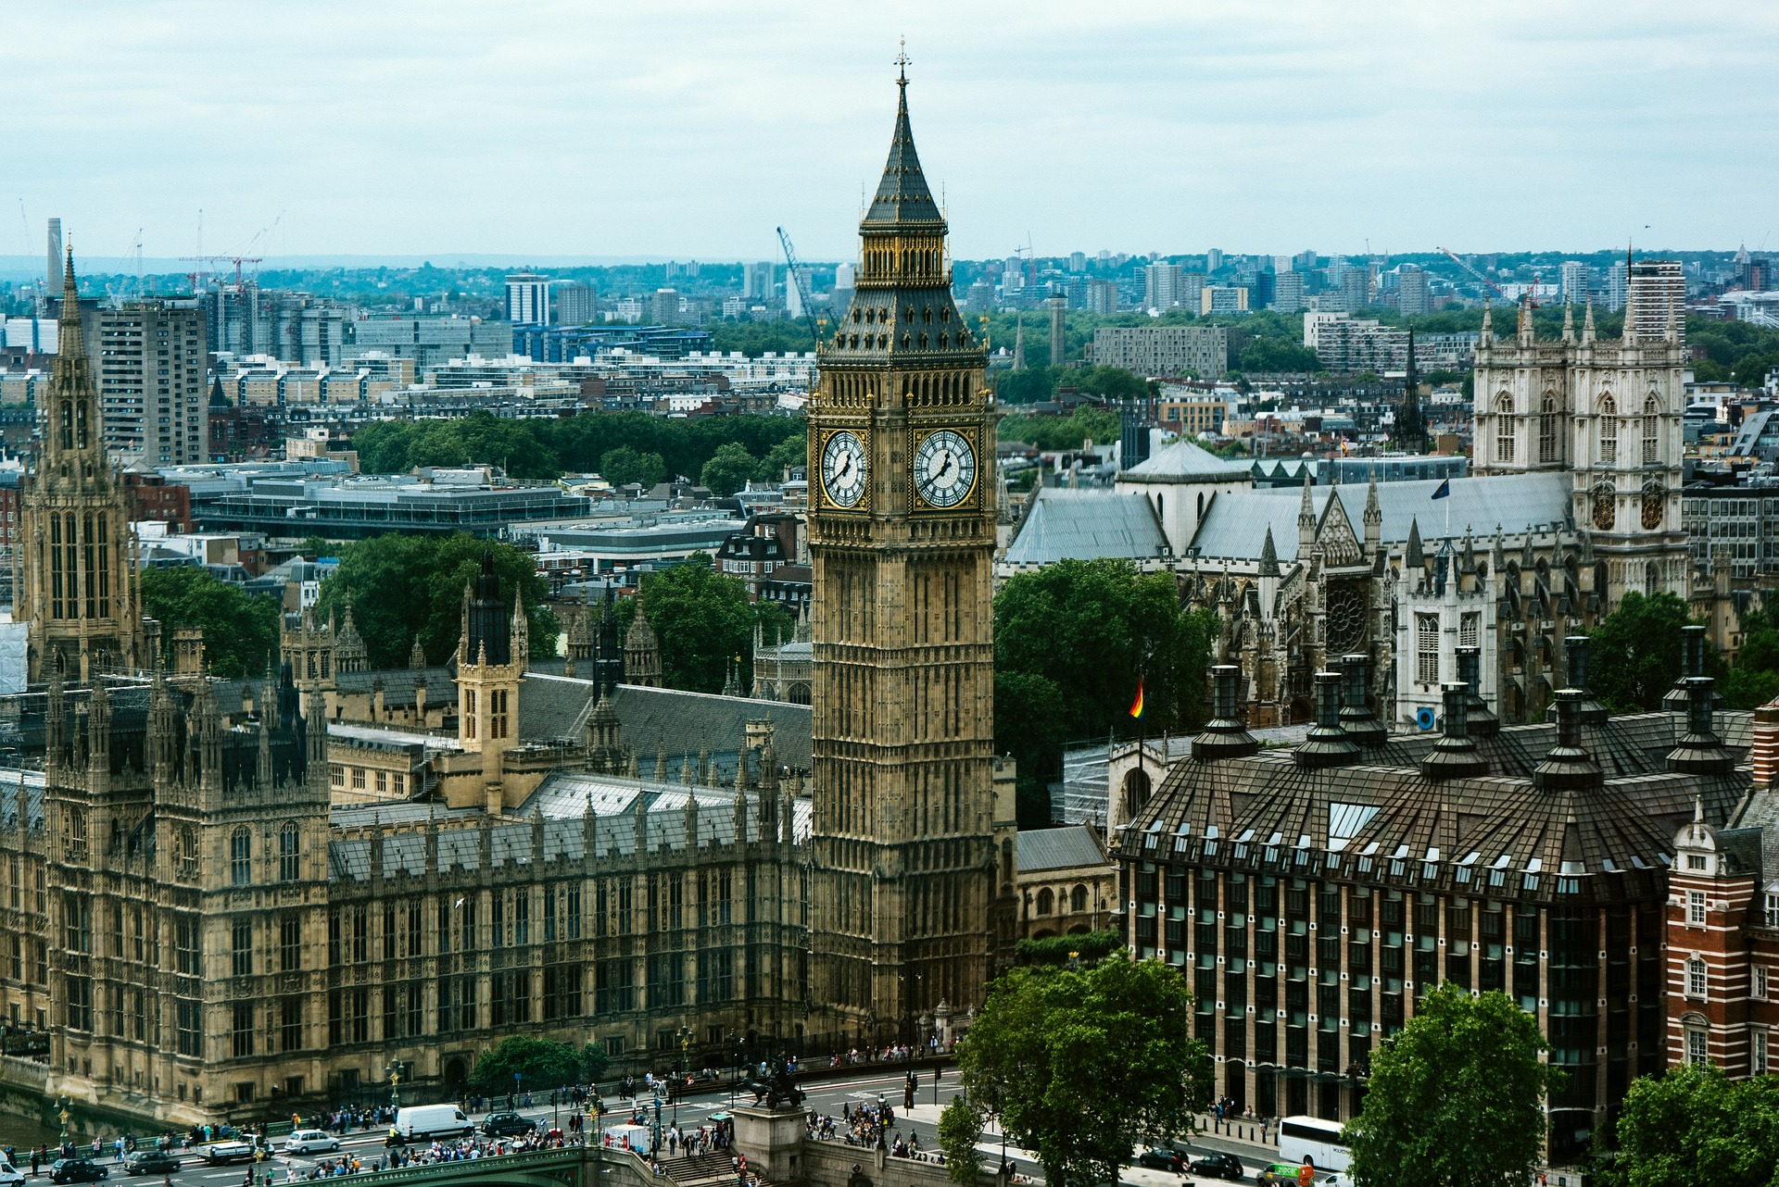
Sine is helpful for finding heights of things moving in a circular motion. The minute hand on the Elizabeth Tower, a famous clock in London whose bell is nicknamed Big Ben, extends 11.5 feet to the edge of the 23 foot diameter clock face. The center of the clock is 180 feet above the ground. At 12:00 the height of the end of the minute hand above the ground is 191.5 feet ($180+11.5$) while at 12:30 it is 168.5 feet high ($180−11.5$). At 12:15 and 12:45 the end of the minute hand is 180 feet high.
What can we say about the height of the end of the minute hand at other times? Let’s start by imagining a unit circle centered on the clock.
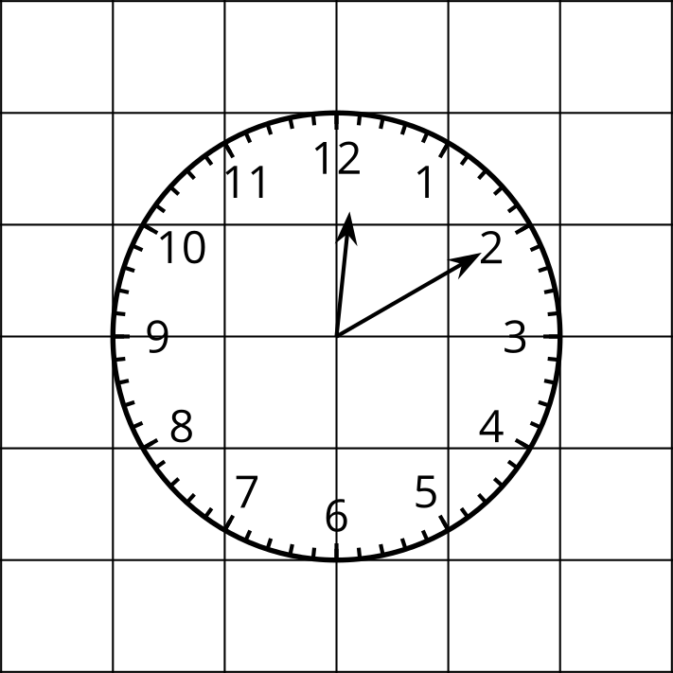
At 12:10 the minute hand makes a $\frac{π}{6}$ radian angle together with the ray through the 3 on the clock. Using our unit circle, we know $sin\left(\frac{π}{6}\right)=0.5$. For a clock that has a radius of 1, the height of the end of the minute hand above the middle of the circle would be 0.5 feet. But this clock has a radius of 11.5, so the end of the minute hand is 5.75 feet above the center of the clock, since $5.75=0.5⋅11.5$. Taken together with the center of the clock being 180 feet off the ground, the end of the minute hand is 185.75 feet above ground.
Another question we can ask is: when is the end of the minute hand 174.25 feet above the ground? Since $174.25=180−5.75$, this means that the tip of the minute hand is 5.75 feet below the center of the clock, and this is $\frac{5.75}{11.5}$ or $\frac{1}{2}$ times its length. Using our unit circle again, the two angles where $sin\left(θ\right)=\text{-}\frac{1}{2}$ are $\frac{7π}{6}$ and $\frac{11π}{6}$. This means the end of the minute hand is 174.25 feet off the ground at 40 and 20 minutes after the hour.
© CC BY 2019 by Illustrative Mathematics®

