Unit 2 Lesson 15: Solving Systems by Elimination (Part 2)

1 Is It Still True? (Warm up)

Student Task Statement
Here is an equation: $50+1=51$.
- Perform each of the following operations and answer these questions: What does each resulting equation look like? Is it still a true equation?
  - Add 12 to each side of the equation.
  - Add $10+2$ to the left side of the equation and 12 to the right side.
  - Add the equation $4+3=7$ to the equation $50+1=51$.
- Write a new equation that, when added to $50+1=51$, gives a sum that is also a true equation.
- Write a new equation that, when added to $50+1=51$, gives a sum that is a false equation.

2 Classroom Supplies

Student Task Statement
A teacher purchased 20 calculators and 10 measuring tapes for her class and paid $495. Later, she realized that she didn’t order enough supplies. She placed another order of 8 of the same calculators and 1 more of the same measuring tape and paid $178.50.
This system represents the constraints in this situation:
$\left\{\begin{matrix}\begin{matrix}20c+10m & =495 \\ 8c+ m & =178.50\end{matrix}\end{matrix}\right.$
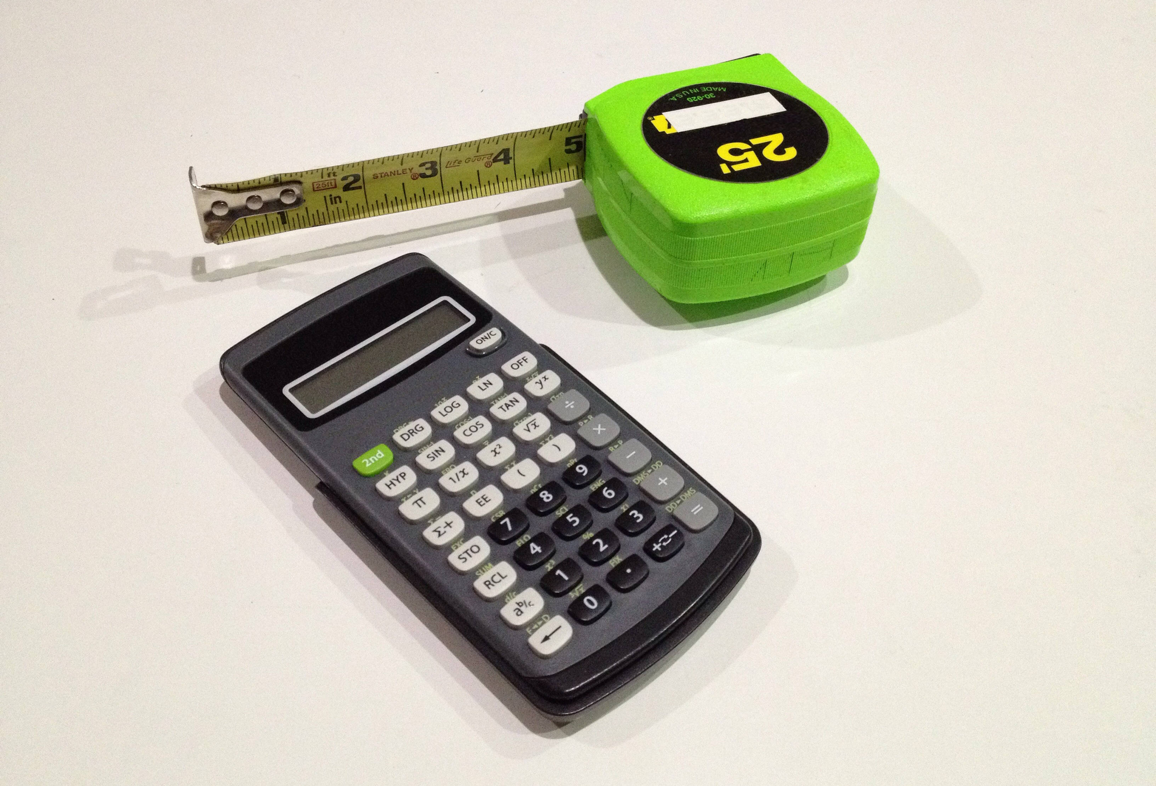
- Discuss with a partner:
  - In this situation, what do the solutions to the first equation mean?
  - What do the solutions to the second equation mean?
  - For each equation, how many possible solutions are there? Explain how you know.
  - In this situation, what does the solution to the system mean?
- Find the solution to the system. Explain or show your reasoning.
- To be reimbursed for the cost of the supplies, the teacher recorded: “Items purchased: 28 calculators and 11 measuring tapes. Amount: $673.50.”
  - Write an equation to represent the relationship between the numbers of calculators and measuring tapes, the prices of those supplies, and the total amount spent.
  - How is this equation related to the first two equations?
  - In this situation, what do the solutions of this equation mean?
  - How many possible solutions does this equation have? How many solutions make sense in this situation? Explain your reasoning.

Activity Synthesis

3 A Bunch of Systems

Student Task Statement
Solve each system of equations without graphing and show your reasoning. Then, check your solutions.
A$\left\{\begin{matrix}\begin{matrix}2x+3y & = 7 \\ \text{-}2x+4y & =14\end{matrix}\end{matrix}\right.$
B$\left\{\begin{matrix}\begin{matrix}2x+3y & = 7 \\ 3x−3y & =3\end{matrix}\end{matrix}\right.$
C$\left\{\begin{matrix}\begin{matrix}2x+3y & =5 \\ 2x+4y & =9\end{matrix}\end{matrix}\right.$
D$\left\{\begin{matrix}\begin{matrix}2x+3y & =16 \\ 6x−5y & =20\end{matrix}\end{matrix}\right.$

© CC BY 2019 by Illustrative Mathematics®

