Unit 4 Lesson 5: Say It with Decimals

1 Notice and Wonder: Fractions to Decimals (Warm up)

Student Task Statement
A calculator gives the following decimal representations for some unit fractions:
$\frac{1}{2}=0.5$
$\frac{1}{3}=0.3333333$
$\frac{1}{4}=0.25$
$\frac{1}{5}=0.2$
$\frac{1}{6}=0.1666667$
$\frac{1}{7}=0.142857143$
$\frac{1}{8}=0.125$
$\frac{1}{9}=0.1111111$
$\frac{1}{10}=0.1$
$\frac{1}{11}=0.0909091$
What do you notice? What do you wonder?

2 Repeating Decimals

Student Task Statement
- Use long division to express each fraction as a decimal.
- $\frac{9}{25}$
- $\frac{11}{30}$
- $\frac{4}{11}$
- What is similar about your answers to the previous question? What is different?
- Use the decimal representations to decide which of these fractions has the greatest value. Explain your reasoning.

3 More and Less with Decimals

Student Task Statement
- Match each diagram with a description and an equation.
- Diagrams:
- 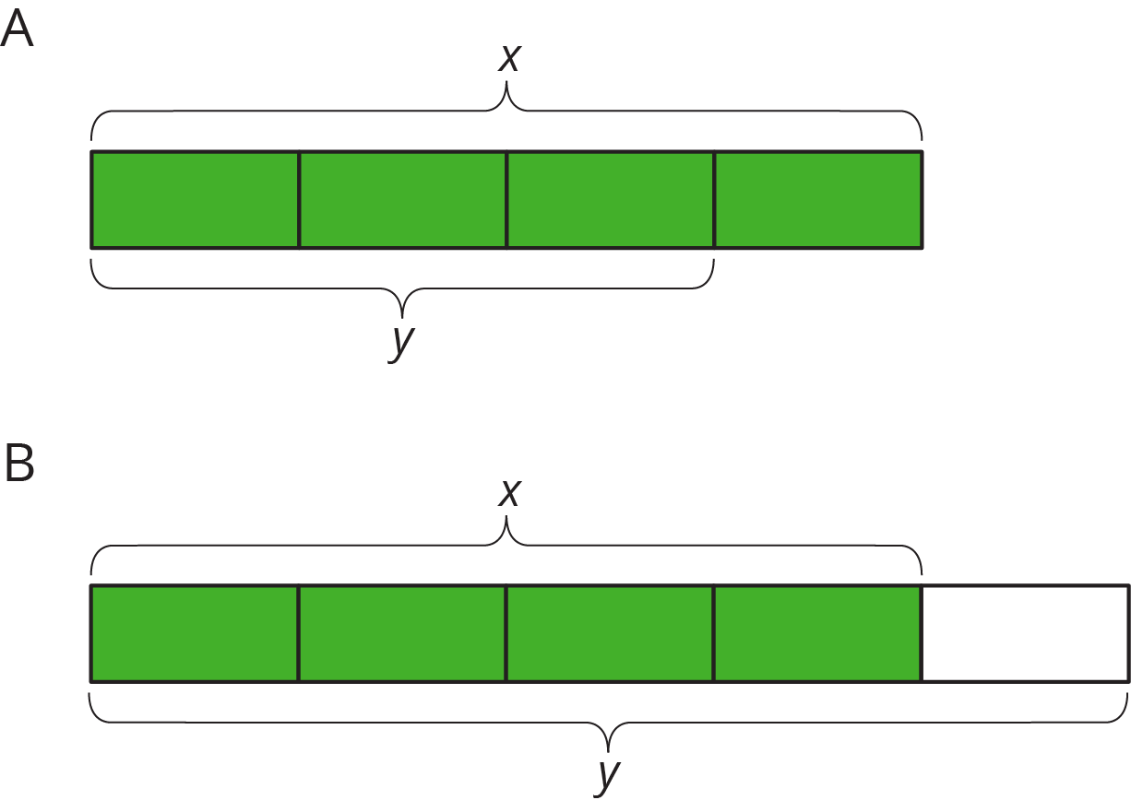
- Descriptions:
- An increase by $\frac{1}{4}$
- An increase by $\frac{1}{3}$
- An increase by $\frac{2}{3}$
- A decrease by $\frac{1}{5}$
- A decrease by $\frac{1}{4}$
- Equations:
- $y=1.\overset{¯}{6}x$
- $y=1.\overset{¯}{3}x$
- $y=0.75x$
- $y=0.4x$
- $y=1.25x$
- Draw a diagram for one of the unmatched equations.

4 Card Sort: More Representations (Optional)

Student Task Statement
Your teacher will give you a set of cards that have proportional relationships represented 2 different ways: as descriptions and equations. Mix up the cards and place them all face-up.
Take turns with a partner to match a description with an equation.
- For each match you find, explain to your partner how you know it’s a match.
- For each match your partner finds, listen carefully to their explanation, and if you disagree, explain your thinking.
- When you have agreed on all of the matches, check your answers with the answer key. If there are any errors, discuss why and revise your matches.
© CC BY Open Up Resources. Adaptations CC BY IM.

