Unit 8 Lesson 11 Cumulative Practice Problems
- Compare the weights of the backpacks for the students in these three classes.
- 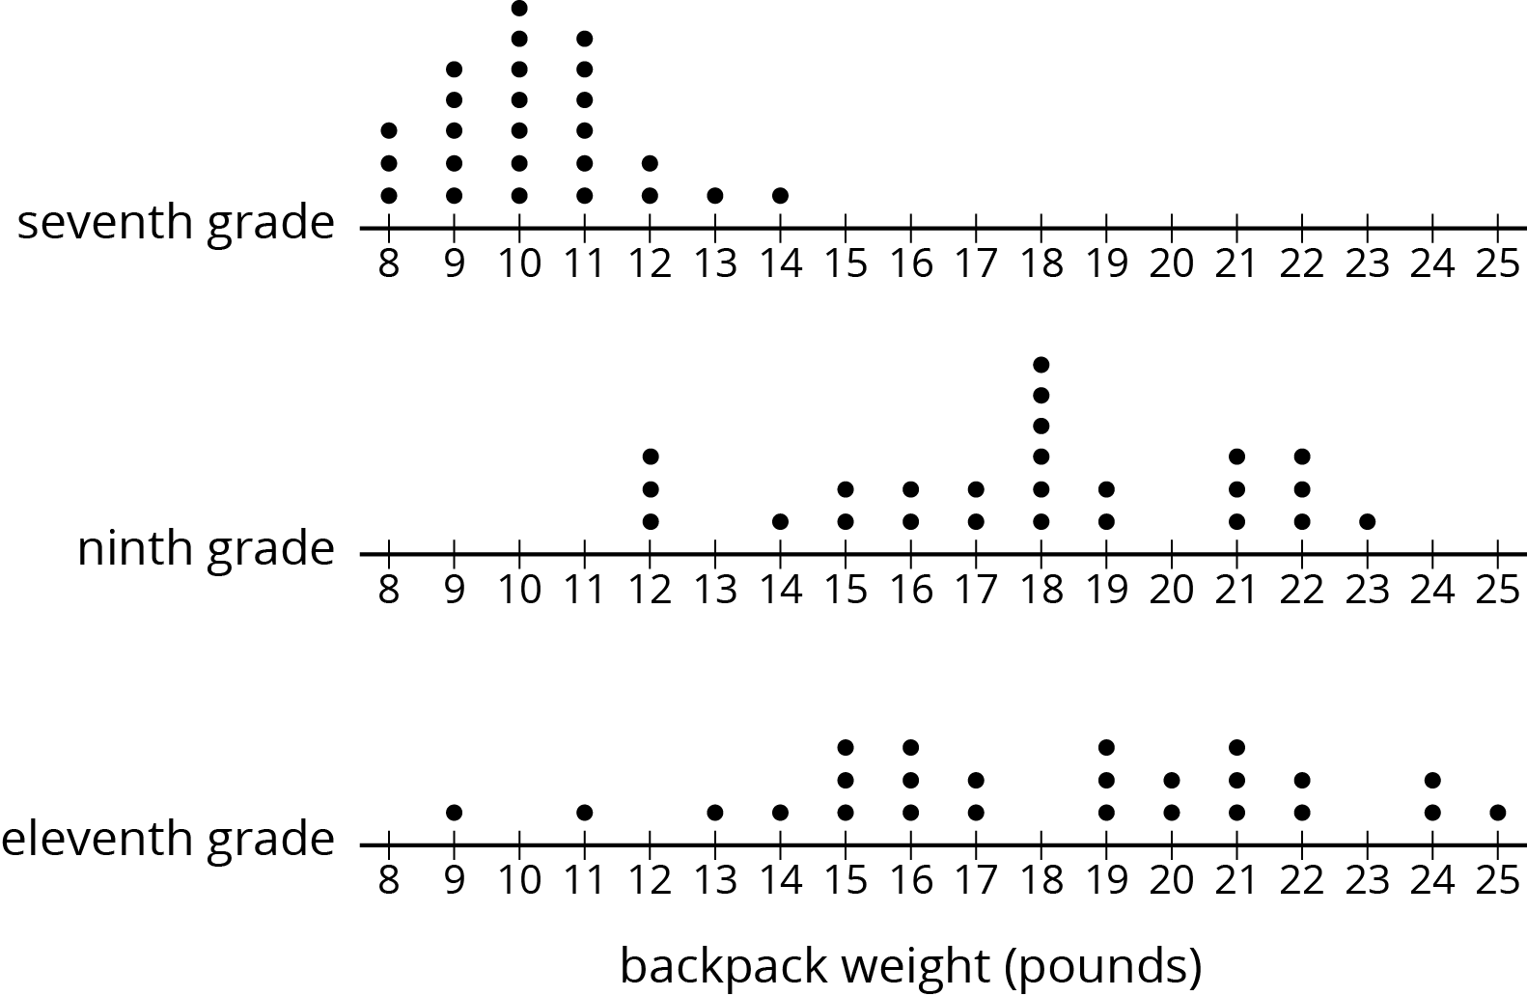

- A bookstore has marked down the price for all the books in a certain series by 15%.
  - How much is the discount on a book that normally costs $18.00?
  - After the discount, how much would the book cost?
- (From Unit 4, Lesson 11.)
- Match each expression in the first list with an equivalent expression from the second list.
  - $6(x+2y)−2(y−2x)$
  - $2.5(2x+4y)−5(4y−x)$
  - $4(5x−3y)−10x+6y$
  - $5.5(x+y)−2(x+y)+6.5(x+y)$
  - $7.9(5x+3y)−4.2(5x+3y)−1.7(5x+3y)$
  - $10(x−y)$
  - $10(x+y)$
  - $10x+6y$
  - $10x−6y$
- (From Unit 6, Lesson 22.)
- Angles $C$ and $D$ are complementary. The ratio of the measure of Angle $C$ to the measure of Angle $D$ is $2:3$. Find the measure of each angle. Explain or show your reasoning.
- (From Unit 7, Lesson 2.)
© CC BY Open Up Resources. Adaptations CC BY IM.

