Lesson 2: Representemos la multiplicación de fracciones unitarias

Standards Alignments
Addressing | 5.NF.B.4.a

Teacher-facing Learning Goals
- Represent multiplication of unit fractions with diagrams and expressions

Student-facing Learning Goals
- Escribamos expresiones para representar la multiplicación de fracciones unitarias.

Lesson Purpose
The purpose of this lesson is for students to write and evaluate expressions given a diagram that represents the product of two unit fractions.
In the previous lesson, students drew diagrams to represent a unit fraction of another unit fraction in context. The purpose of this lesson is for students to draw diagrams representing products of unit fractions and to examine the relationship between expressions and diagrams in greater depth. Students examine different methods for representing unit fraction products with a diagram and they interpret how a diagram represents a given expression.
This diagram represents both $\frac{1}{4}×\frac{1}{3}$ and $\frac{1}{3}×\frac{1}{4}$. In future lessons, this diagram will be used to represent multiplication expressions and equations because of its flexibility.
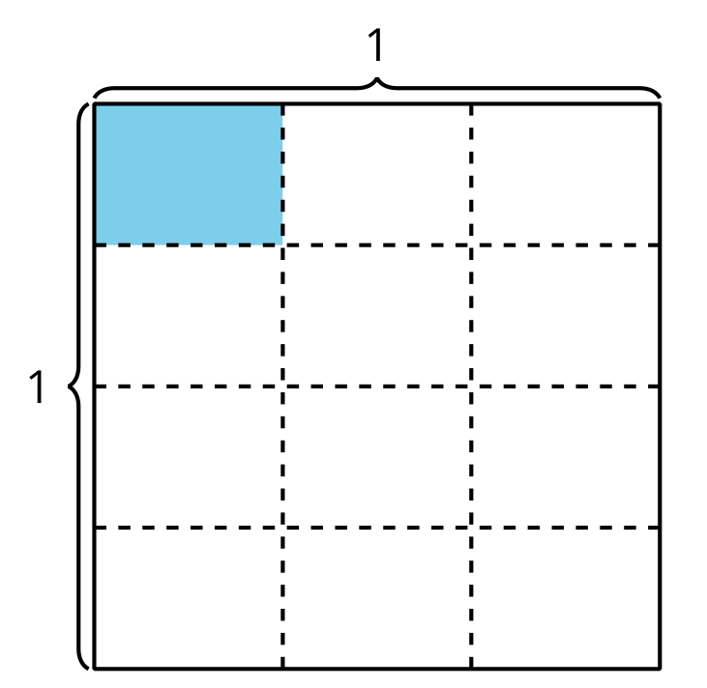
Student generated diagrams may be different.
In this diagram, we see $\frac{1}{4}×\frac{1}{3}$. We would need to adapt the diagram to show $\frac{1}{3}×\frac{1}{4}$ more clearly. We could do this by extending the partition lines all the way across.
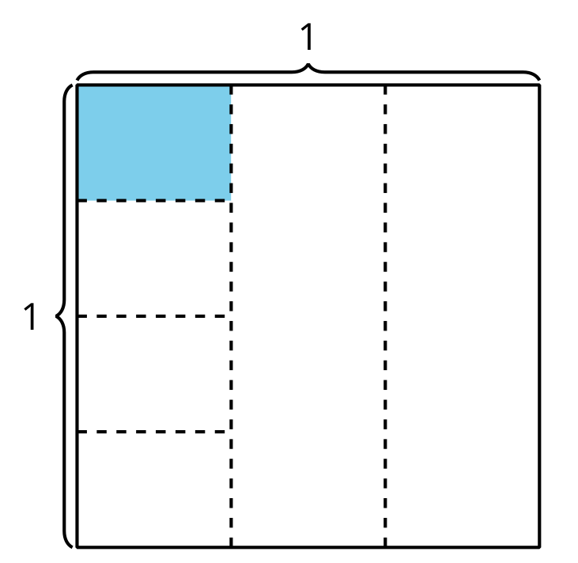

Access for:

Students with Disabilities
- Representation (Activity 2)

Instructional Routines
MLR2 Collect and Display (Activity 2), Which One Doesn’t Belong? (Warm-up)

Lesson Timeline
Warm-up | 10 min
Activity 1 | 20 min
Activity 2 | 15 min
Lesson Synthesis | 10 min
Cool-down | 5 min

Teacher Reflection Question
What did you say, do, or ask during the lesson synthesis that helped students be clear on the learning of the day? How did understanding the cool-down of the lesson before you started teaching today help you synthesize that learning?

Cool-down
(to be completed at the end of the lesson) 5min
¿Cuánto está coloreado?

Standards Alignments
Addressing | 5.NF.B.4.a

Student-facing Task Statement
Escribe una expresión de multiplicación que represente el área de la región coloreada.
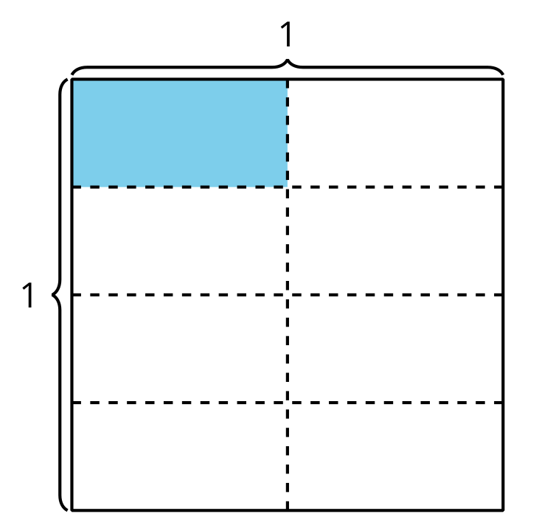

Student Responses
$\frac{1}{4}×\frac{1}{2}$ or $\frac{1}{2}×\frac{1}{4}$

