Lesson 12 Practice Problems
- Put the following expressions in order from least to greatest.
  - $e^{3}$
  - $2^{2}$
  - $e^{2}$
  - $2e$
  - $e^{e}$
- Here are graphs of three functions: $f\left(x\right)=2^{x}$, $g\left(x\right)=e^{x}$, and $h\left(x\right)=3^{x}$.
- 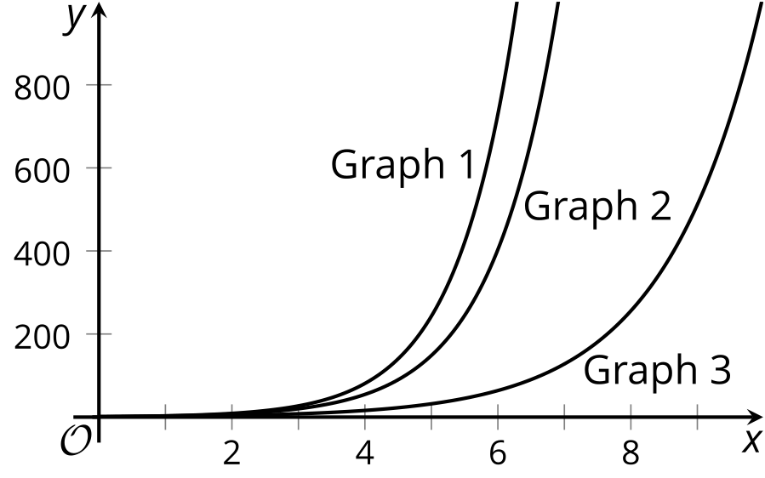
- Which graph corresponds to each function? Explain how you know.
- Which of the statements are true about the function $f$ given by $f\left(x\right)=100⋅e^{\text{-}x}$? Select all that apply.
  - The $y$-intercept of the graph of $f$ is at $\left(0,100\right)$.
  - The values of $f$ increase when $x$ increases.
  - The value of $f$ when $x=\text{-}1$ is a little less than 40.
  - The value of $f$ when $x=5$ is less than 1.
  - The value of $f$ is never 0.
- Suppose you have $1 to put in an interest-bearing account for 1 year and are offered different options for interest rates and compounding frequencies (how often interest is calculated), as shown in the table. The highest interest rate is 100%, calculated once a year. The lower the interest rate, the more often it gets calculated.
  - Complete the table with expressions that represent the amount you will have after one year, and then evaluate each expression to find its value in dollars (round to 5 decimal places).
- interest rate | - frequency  per year | - expression | - value in dollars  after 1 year
- 100% | - 1 | - $1⋅{\left(1+1\right)}^{1}$
- 10% | - 10 | - $1⋅{\left(1+0.1\right)}^{10}$
- 5% | - 20 | - $1⋅{\left(1+0.05\right)}^{20}$
- 1% | - 100
- 0.5% | - 200
- 0.1% | - 1,000
- 0.01% | - 10,000
- 0.001% | - 100,000
  - Predict whether the account value will be greater than $3 if there is an option for a 0.0001% interest rate calculated 1 million times a year. Check your prediction.
  - What do you notice about the values of the account as the interest rate gets smaller and the frequency of compounding gets larger?
- The function $f$ is given by $f\left(x\right)={\left(1+x\right)}^{\frac{1}{x}}$. How do the values of $f$ behave for small positive and large positive values of $x$?
- Since 1992, the value of homes in a neighborhood has doubled every 16 years. The value of one home in the neighborhood was $136,500 in 1992.
  - What is the value of this home, in dollars, in the year 2000? Explain your reasoning.
  - Write an equation that represents the growth in housing value as a function of time in $t$ years since 1992.
  - Write an equation that represents the growth in housing value as a function of time in $d$ decades since 1992.
  - Use one of your equations to find the value of the home, in dollars, 1.5 decades after 1992.
- (From Unit 4, Lesson 4.)
- Write two equations—one in exponential form and one in logarithmic form—to represent each question. Use “?” for the unknown value.
  - “To what exponent do we raise the number 5 to get 625?”
  - “What is the log, base 3, of 27?”
- (From Unit 4, Lesson 10.)
- Clare says that $log0.1=\text{-}1$. Kiran says that $log\left(\text{-}10\right)=\text{-}1$. Do you agree with either one of them? Explain your reasoning.
- (From Unit 4, Lesson 11.)
© CC BY 2019 by Illustrative Mathematics®

