## Lesson 14: Recalling Percent Change

Let's find the result of changing a number by a percentage.

### 14.1: Wheels

A scooter costs $160.

For each question, show your reasoning.

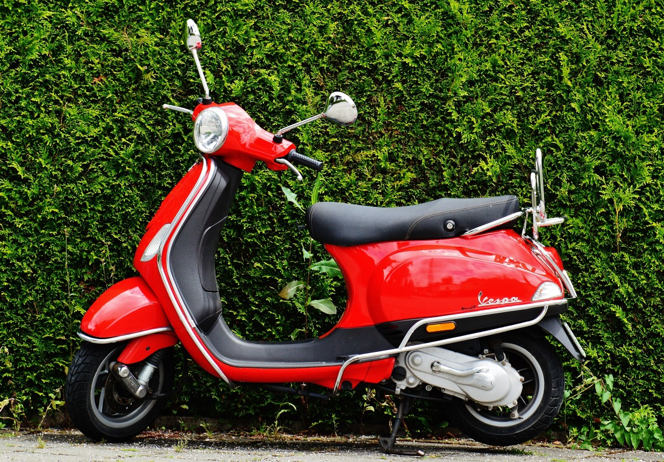

1. The cost of a pair of roller skates is 20% of the cost of the scooter. How much do the roller skates cost?
2. A bicycle costs 20% more than the scooter. How much does the bicycle cost?
3. A skateboard costs 25% less than the bicycle. How much does the skateboard cost?

### 14.2: Taxes and Sales

1. You need to pay 8% tax on a car that costs $12,000. What will you end up paying in total? Show your reasoning.
2. Burritos are on sale for 30% off. Your favorite burrito normally costs $8.50. How much does it cost now? Show your reasoning.
3. A pair of shoes that originally cost $79 are on sale for 35% off. Does the expression represent the sale price of the shoes (in dollars)? Explain your reasoning.

#### Are you ready for more?

Come up with some strategies for mentally adding 15% to the total cost of an item.

### 14.3: Expressing Percent Increase and Decrease

Complete the table so that each row has a description and two different expressions that answer the question asked in the description. The second expression should use only multiplication. Be prepared to explain how the two expressions are equivalent.

|  |  |  |
| --- | --- | --- |
| description and question | expression 1 | expression 2 (using only multiplication) |
| A one-night stay at a hotel in Anaheim, CA costs $160. Hotel room occupancy tax is 15%. What is the total cost of a one-night stay? |  |  |
| Teachers receive 30% educators discount at a museum. An adult ticket costs $24. How much would a teacher pay for admission into the museum? |  |  |
| The population of a city was 842,000 ten years ago. The city now has 2% more people than it had then. What is the population of the city now? |  |  |
| After a major hurricane, 46% of the 90,500 households on an island lost their access to electricity. How many households still have electricity? |  |  |
|  |  |  |
| Two years ago, the number of students in a school was 150. Last year, the student population increased 8%. This year, it increased about 8% again. What is the number of students this year? |  |  |

### Lesson 14 Summary

We can write different expressions to calculate percent increase and decrease.

Suppose a new phone costs $360 and is on sale at 25% off the regular price. One way to calculate this is to first find 25% of 360, which is 90, and then subtract $90 from $360 to get a sale price of $270. These calculations can be recorded in this way:

Another way to represent this calculation is to notice that subtracting 25% of the cost is equivalent to finding 75% of the cost. Using the distributive property, we know that can be rewritten as , which is equal to .



© CC BY 2019 by Illustrative Mathematics®