Lesson 21 Practice Problems
- Here is a graph of the equation $2y−x=1$.
- 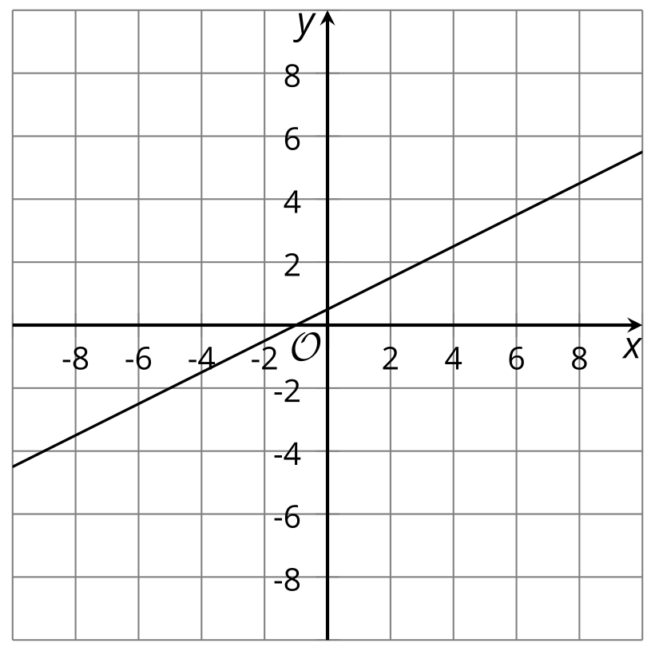
- ​​​​​​
  - Are the points $\left(0,\frac{1}{2}\right)$ and $\left(\text{-}7,\text{-}3\right)$ solutions to the equation? Explain or show how you know.
  - Check if each of these points is a solution to the inequality $2y−x>1$:
- $\left(0,2\right)$ | - $\left(8,\frac{1}{2}\right)$ | - $\left(\text{-}6,3\right)$ | - $\left(\text{-}7,\text{-}3\right)$

  - Shade the region that represents the solution set to the inequality $2y−x>1$.
  - Are the points on the line included in the solution set? Explain how you know.
- Select all coordinate pairs that are solutions to the inequality $5x+9y<45$.
  - $\left(0,0\right)$
  - $\left(5,0\right)$
  - $\left(9,0\right)$
  - $\left(0,5\right)$
  - $\left(0,9\right)$
  - $\left(5,9\right)$
  - $\left(\text{-}5,\text{-}9\right)$
- Consider the linear equation $2y−3x=5$.
  - The pair $\left(\text{-}1,1\right)$ is a solution to the equation. Find another $\left(x,y\right)$ pair that is a solution to the equation.
  - Are $\left(\text{-}1,1\right)$ and $\left(4,1\right)$ solutions to the inequality $2y−3x<5$? Explain how you know.
  - Explain how to use the answers to the previous questions to graph the solution set to the inequality $2y−3x<5$.
- The boundary line on the graph represents the equation $5x+2y=6$. Write an inequality that is represented by the graph.
- 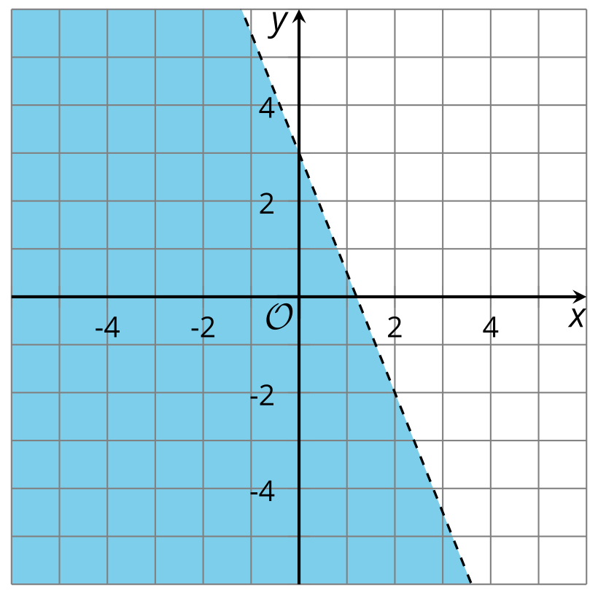

- Choose the inequality whose solution set is represented by this graph.
- 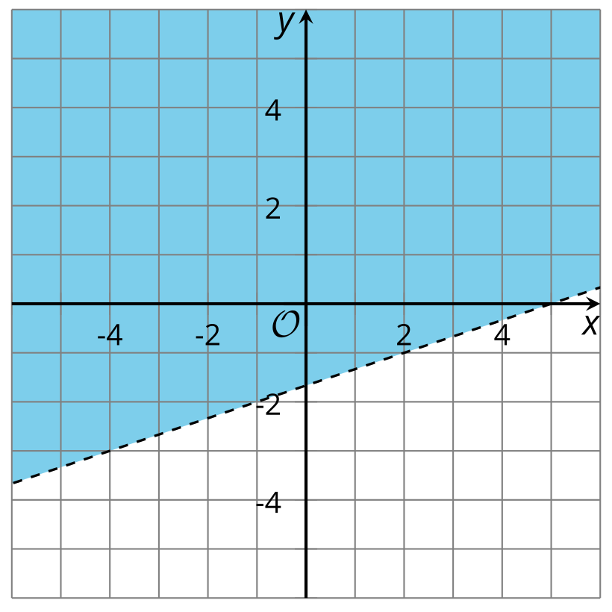

  - $x−3y<5$
  - $x−3y≤5$
  - $x−3y>5$
  - $x−3y≥5$
- Solve each system of equations without graphing.
  - $\left\{\begin{matrix}4d+7e=68 \\ \text{-}4d−6e=\text{-}72\end{matrix}\right.$
  - $\left\{\begin{matrix}\frac{1}{4}x+y=1 \\ \frac{3}{2}x−y=\frac{4}{3}\end{matrix}\right.$
- (From Unit 2, Lesson 14.)
- Mai and Tyler are selling items to earn money for their elementary school. The school earns $w$ dollars for every wreath sold and $p$ dollars for every potted plant sold. Mai sells 14 wreaths and 3 potted plants and the school earns $70.50. Tyler sells 10 wreaths and 7 potted plants and the school earns $62.50.
- This situation is represented by this system of equations: $\left\{\begin{matrix}14w+3p=70.50 \\ 10w+7p=62.50\end{matrix}\right.$
- Explain why it makes sense in this situation that the solution of this system is also a solution to $4w+\left(\text{-}4p\right)=8.00$.
- (From Unit 2, Lesson 15.)
- Elena is planning to go camping for the weekend and has already spent $40 on supplies. She goes to the store and buys more supplies.
- Which inequality represents $d$, the total amount in dollars that Elena spends on supplies?
  - $d>40$
  - $d≥40$
  - $d<40$
  - $d≤40$
- (From Unit 2, Lesson 18.)
- Solve this inequality: $\frac{x−4}{3}≥\frac{x+3}{2}$
- (From Unit 2, Lesson 19.)
- Which graph represents the solution to $\frac{4x−8}{3}≤2x−5$ ?
- (From Unit 2, Lesson 19.)
- Solve $\text{-}x<3$. Explain how to find the solution set.
- (From Unit 2, Lesson 20.)
© CC BY 2019 by Illustrative Mathematics®

