Unit 6 Lesson 14: Representing Fractions on a Line Plot

WU Which One Doesn’t Belong: Line Plot (Warm up)

Student Task Statement
Which one doesn’t belong?
A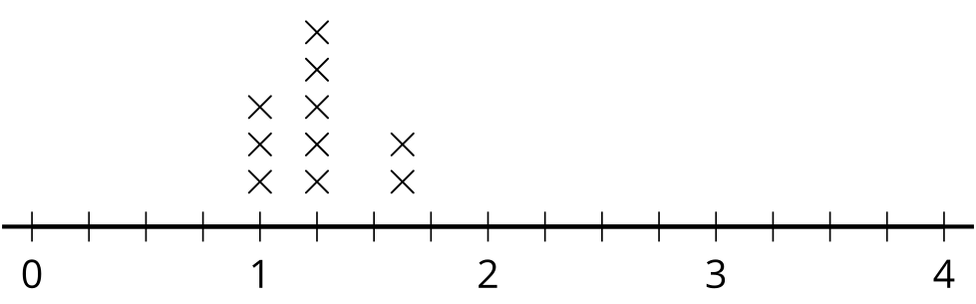
B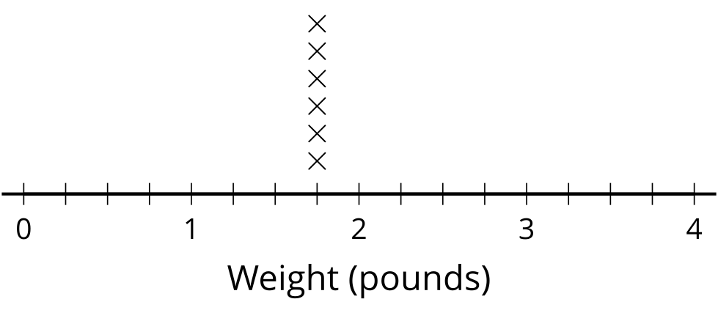
C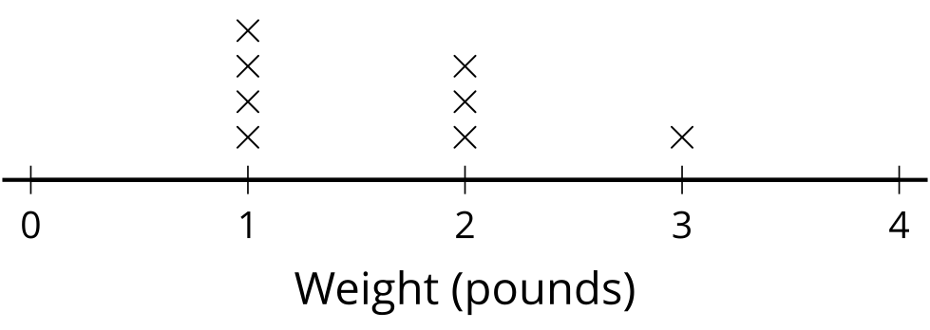

D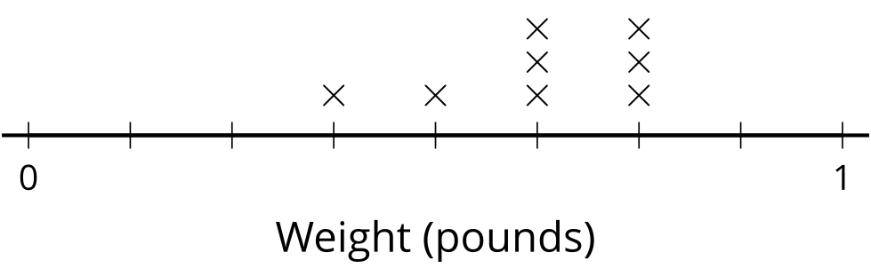

1 Sums of Fractions

Student Task Statement
- Play Sums of Fractions with your partner.
  - Take turns with your partner.
  - Spin the spinner twice.
  - Add the two fractions.
  - Record the sum on the line plot.
  - Play the game until you and your partner together have 12 data points.
- 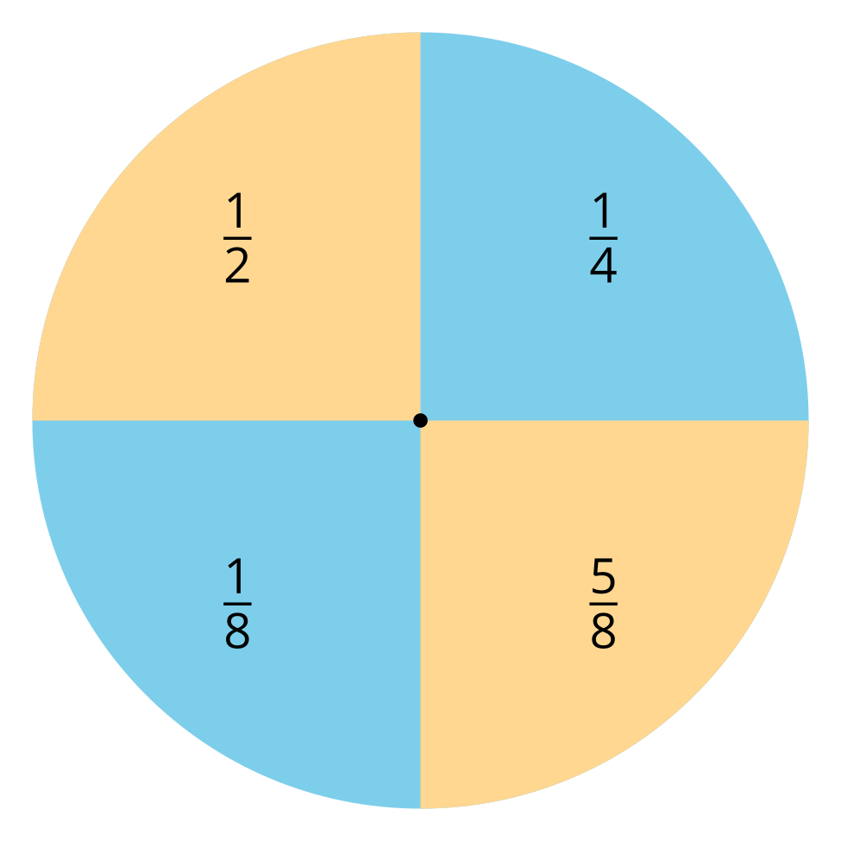
- How did you know where to plot the sums of eighths?
- What is the difference between your highest and lowest number?
- What do you notice about the data you collected?

2 Lots of Eggs

Student Task Statement
- Here are the weights of some eggs, in ounces. Use them to make a line plot.
- $1\frac{7}{8}$, $2\frac{1}{2}$, $2\frac{3}{8}$, $1\frac{3}{4}$, $2\frac{1}{4}$, $2\frac{4}{8}$, $2\frac{1}{8}$, $1\frac{7}{8}$, $2\frac{1}{4}$, $1\frac{6}{8}$, $2\frac{1}{8}$, $1\frac{7}{8}$
- 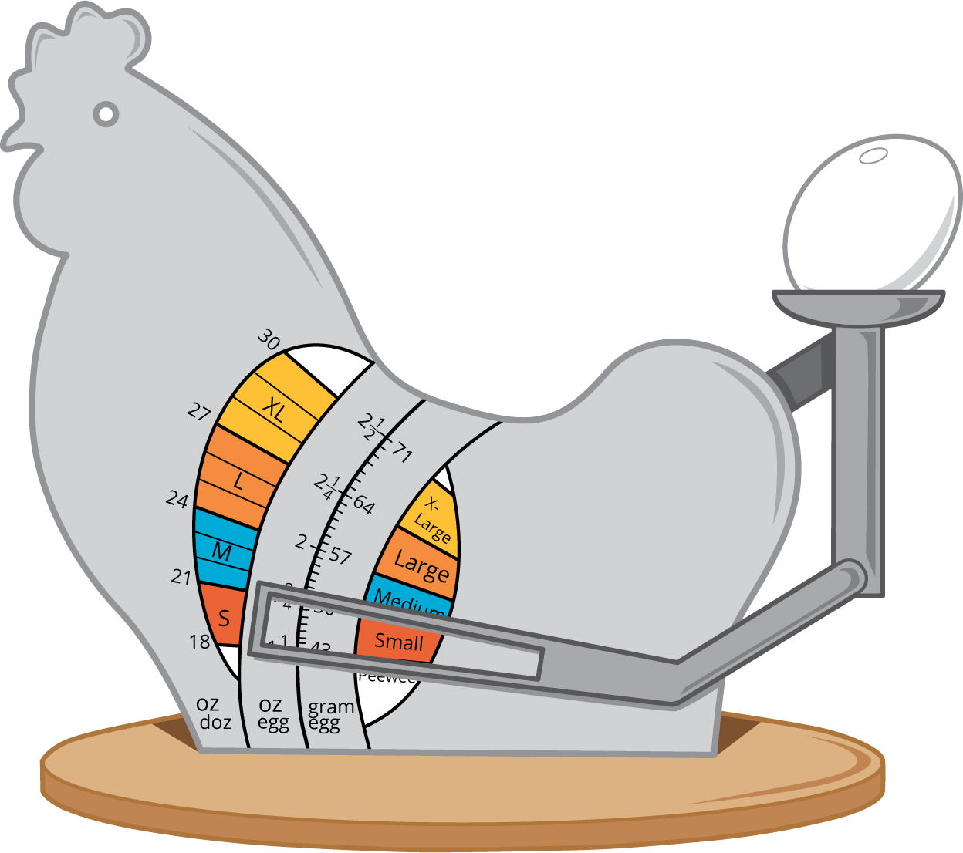
- Jada said that $\frac{1}{4}$ of the eggs weigh $1\frac{7}{8}$ ounces. Do you agree? Explain or show your reasoning.
- How much heavier is the heaviest egg than the lightest egg? Explain or show your reasoning.
© CC BY 2021 Illustrative Mathematics®

