Lesson 14: Represent Division of Whole Numbers by Unit Fractions
- Let's solve problems involving division of a unit fraction by a whole number.

Warm-up: Number Talk: Increasing Quotients
Find the value of each expression mentally.
- $6÷1$
- $6÷\frac{1}{2}$
- $6÷\frac{1}{3}$
- $6÷\frac{1}{6}$

14.1: Notice Patterns
Set A: Find the value that makes each equation true. Draw a diagram if it is helpful. What patterns do you notice?
- $3÷\frac{1}{4}=\underset{_}{}$
- $4÷\frac{1}{4}=\underset{_}{}$
- $5÷\frac{1}{4}=\underset{_}{}$
- $6÷\frac{1}{4}=\underset{_}{}$
Set B: Find the value that makes each equation true. Draw a diagram if it is helpful. What patterns do you notice?
- $3÷\frac{1}{2}=\underset{_}{}$
- $3÷\frac{1}{3}=\underset{_}{}$
- $3÷\frac{1}{4}=\underset{_}{}$
- $3÷\frac{1}{5}=\underset{_}{}$
What is the same about problem set A and B? What is different?

14.2: Match the Situation to the Expression
- Match each problem to an expression that represents the problem. Some expressions will not have a match. Be prepared to explain your reasoning.
  - One serving of popcorn is $\frac{1}{4}$ cup of kernels. There are 3 cups of kernels in the bowl. How many servings are in the bowl?
  - 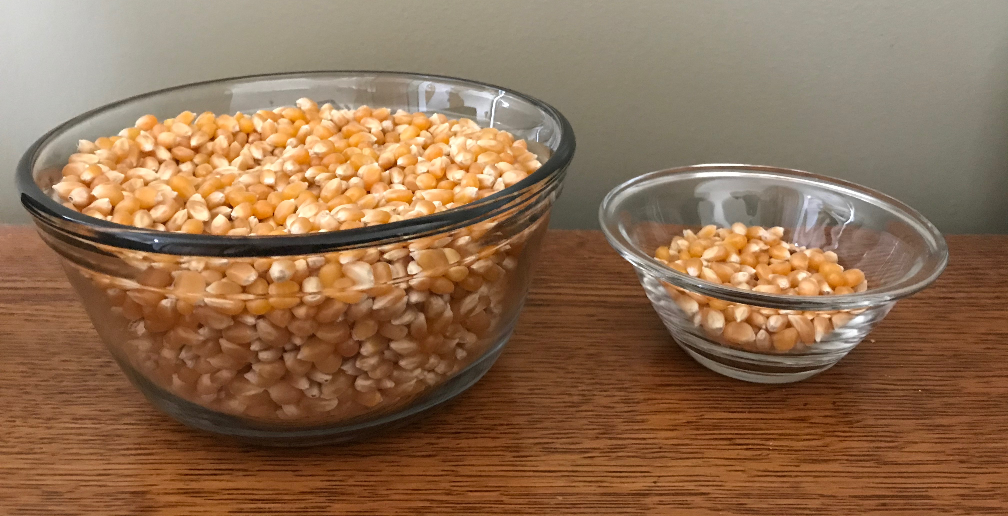
  - One serving of orange juice is $\frac{1}{4}$ liter. The container of juice holds 2 liters. How many servings are in the container?
  - One serving of granola is $\frac{1}{2}$ cup. The bag of granola holds 5 cups. How many servings are in the bag?
- $\frac{1}{4}÷3$
- $\frac{1}{2}÷5$
- $3÷\frac{1}{4}$
- $\frac{1}{4}÷2$
- $5÷\frac{1}{2}$
- $2÷\frac{1}{4}$
- Find the value of each expression.
© CC BY 2021 Illustrative Mathematics®

