Lesson 12: Count by 5 to Tell Time

Standards Alignments
Addressing | 2.MD.C.7, 2.NBT.A.2
Building Towards | 2.MD.C.7

Teacher-facing Learning Goals
- Tell time on analog clocks.
- Understand that the numbers on an analog clock represent 5-minute intervals.

Student-facing Learning Goals
- Let’s tell time.

Lesson Purpose
The purpose of this lesson is for students to tell time to the nearest 5 minutes on an analog clock.
In grade 1, students learned to tell time to the hour and half-hour. In a previous lesson, students learned to tell time using the phrases “half past,” “quarter past,” and “quarter till,” and described the relative position of the hour hand.
In this lesson, students make connections between a number line with intervals of 5 and the distance between the numbers on the clock, which represents 5 minute intervals. Students skip count by 5 in order to tell time.

Access for:

Students with Disabilities
- Representation (Activity 1)

English Learners
- MLR8 (Activity 2)

Instructional Routines
Notice and Wonder (Warm-up)

Materials to Copy
- Count on the Clock Card Sort (groups of 2): Activity 1

Lesson Timeline
Warm-up | 10 min
Activity 1 | 20 min
Activity 2 | 15 min
Lesson Synthesis | 10 min
Cool-down | 5 min

Teacher Reflection Question
What unfinished learning or misunderstandings do your students have about telling time? How did you leverage those misconceptions in a positive way to further understanding of the class?

Cool-down
(to be completed at the end of the lesson) 5min
Which Time Is It?

Standards Alignments
Addressing | 2.MD.C.7

Student-facing Task Statement
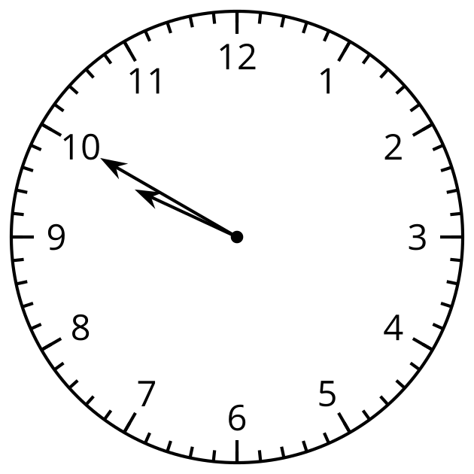
Does the clock show 9:50 or 10:50? Explain.

Student Responses
9:50. Sample response: The hour hand looks like it is pointing to the 10, but it is really just very close but not there yet. If the time was 10:50 the hour hand would have to be past the 10 and closer to the 11.

