Unit 1 Lesson 5: Represent Data in Scaled Bar Graphs

WU Number Talk: Twos and Fives (Warm up)

Student Task Statement
Find the value of each expression mentally.
- $2+2+2+2$
- $2+2+2+2+2+2+2+2$
- $5+5+5+5$
- $5+5+5+5+5+5+5+5$

1 Compare Bar Graphs

Student Task Statement
A class was asked, “How do you get home from school?” Their responses are shown in these two bar graphs:
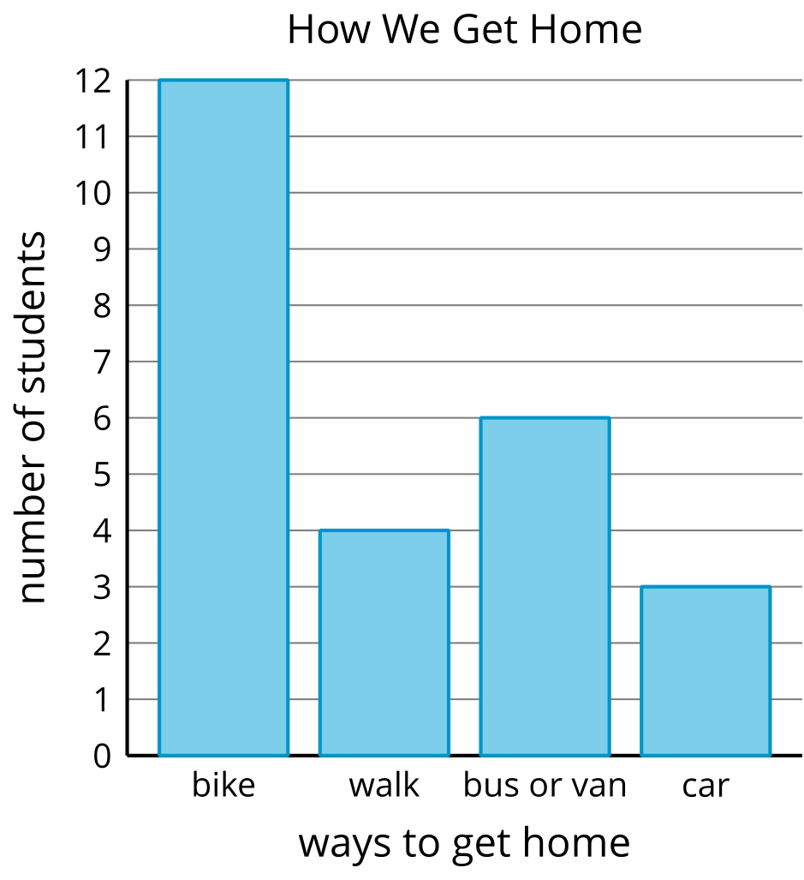
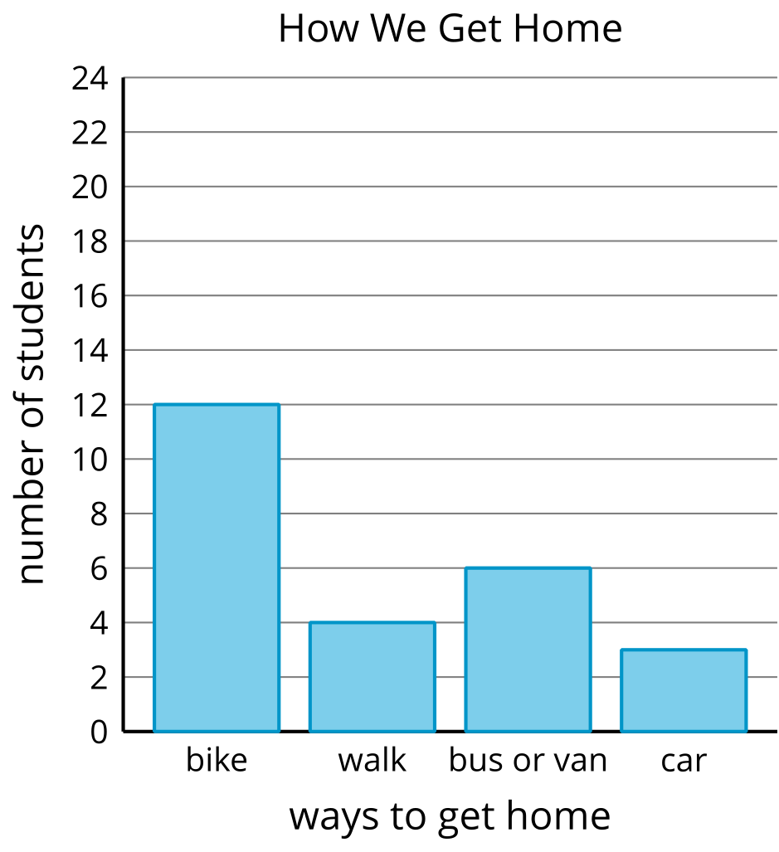
Discuss with your partner: How are the two graphs alike? How are they different?

2 Create a Scaled Bar Graph

Student Task Statement
Represent the data we collected earlier in a scaled bar graph.
Use the graph with a scale of 2 or the graph with a scale of 5. If you have time, you can make 2 graphs. Be sure to label your title and categories.
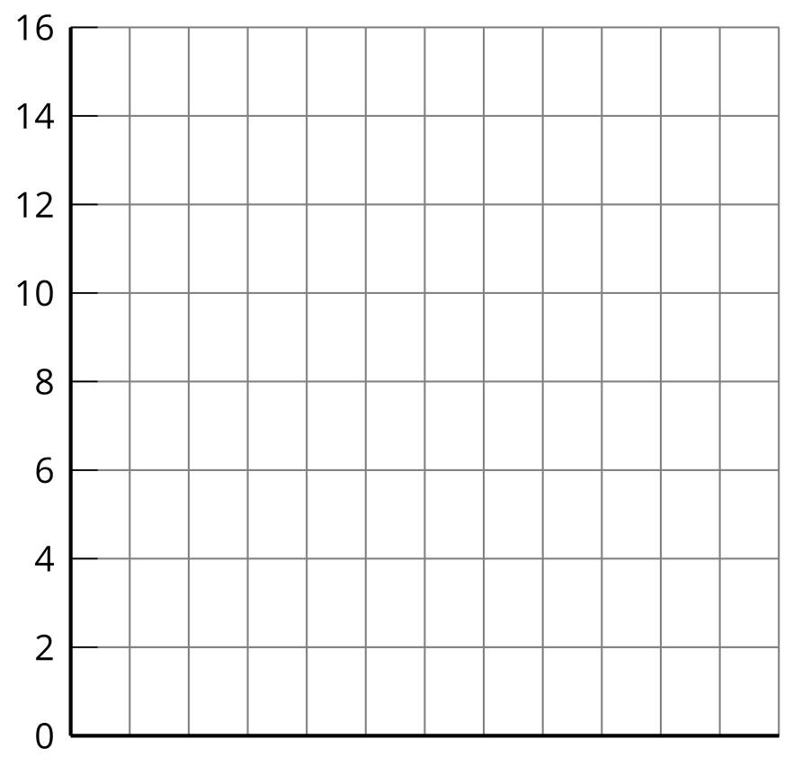
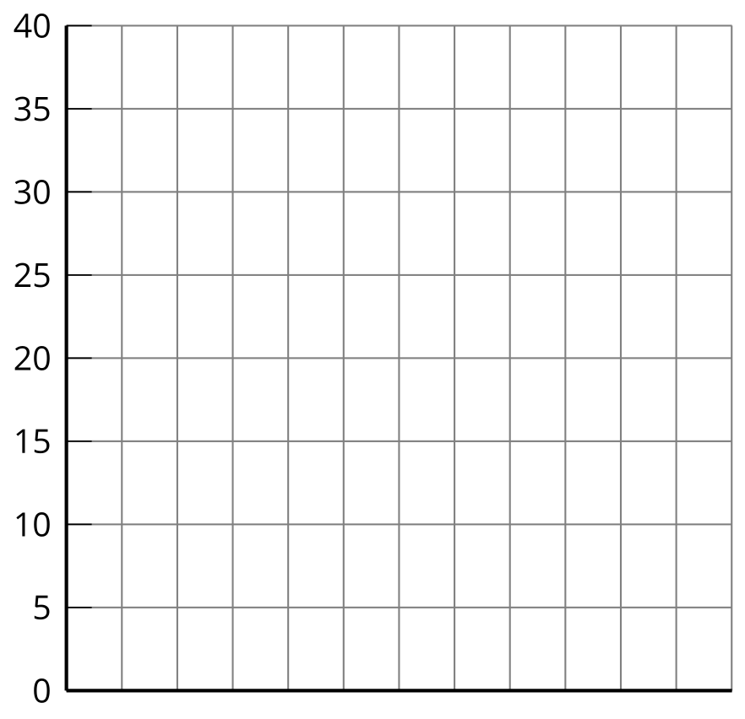
© CC BY 2021 Illustrative Mathematics®

