Unit 4 Lesson 12: Compare Multi-digit Numbers

WU Which One Doesn’t Belong: Friendly Numbers (Warm up)

Student Task Statement
Which one doesn’t belong?
- 1,395
- 3,095
- 9,530
- 30,195

1 Which is Greater?

Student Task Statement
Your teacher will give you a set of cards, each with a single digit, 0–9.
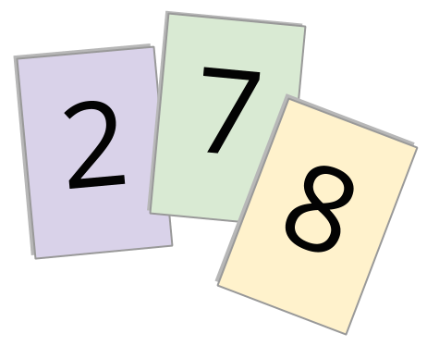
- Use the cards for 2, 7, and 8 to make two different three-digit numbers. Use < or > to compare them.
- 0000 0000 0000 _ 0000 0000 0000
- Now include the digit 1 to make two different four-digit numbers. Compare the numbers.
- 0000 , 0000 0000 0000 _ 0000 , 0000 0000 0000
- Shuffle the cards. Repeat what you did earlier with new cards.
  - Four-digit numbers
  - 0000 , 0000 0000 0000 _ 0000 , 0000 0000 0000
  - Five-digit numbers
  - 0000 0000 , 0000 0000 0000 _ 0000 0000 , 0000 0000 0000
  - Six-digit numbers
  - 0000 0000 0000 , 0000 0000 0000 _ 0000 0000 0000 , 0000 0000 0000
- For each pair you compared, how did you decide which number is greater?

2 Incomplete Numbers

Student Task Statement
- Here are two numbers. In both, the missing digit is the same number.
- 0 1 7 0 6 2
  - Han says the numbers can’t be compared because they are incomplete.
  - Clare says the second number is greater, no matter what the missing digit is.
- Do you agree with either one of them? Explain your reasoning.
- Here are some pairs of numbers. The numbers in each pair are missing the same digit. Can you tell which number is greater? Be prepared to explain your reasoning.
  - 4 9 0
3 0 9
  - 1 ,0 7 2
1 ,0 8 5
  - 8 ,0 1 6
5 ,8 0 2
  - 2 7 ,0 9 5
2 0 , 7 4 5
  - 0 9 0 ,1 6 5
9 0 0 ,0 6 4

3 Is It Possible? (Optional)

Student Task Statement
- Each of the following pairs of numbers is missing the same digit but in different places.
- Your teacher will assign a digit to you. Use it as the missing digit and decide if each comparison statement is true.
  - 0 ,9 9 9>0 ,5 0 0
  - 1 5 ,2 0 0>1 5 ,0 0 2
  - 4 0 ,7 0 0<7 0 ,4 0 0
  - 1 0 5 ,0 0 0>5 0 1 ,0 0 0
- Here are two numbers, each with the same missing digit.
- 4 0 ,3 0 0 3 0 ,4 0 0
- Choose a digit to complete the numbers and show where they would be on the number line.
- Is it possible to fill in the two blanks with the same digit to make each statement true? If you think so, give at least one example of what the digits could be. If not, explain why it is not possible.
  - 4 0 ,3 0 0 is less than 3 0 ,4 0 0 .
  - 0 4 ,3 0 0 is less than 0 3 ,4 0 0 .
© CC BY 2021 Illustrative Mathematics®

