Lesson 2: Introducing Proportional Relationships with Tables

2.1: Notice and Wonder: Paper Towels by the Case
Here is a table that shows how many rolls of paper towels a store receives when they order different numbers of cases.
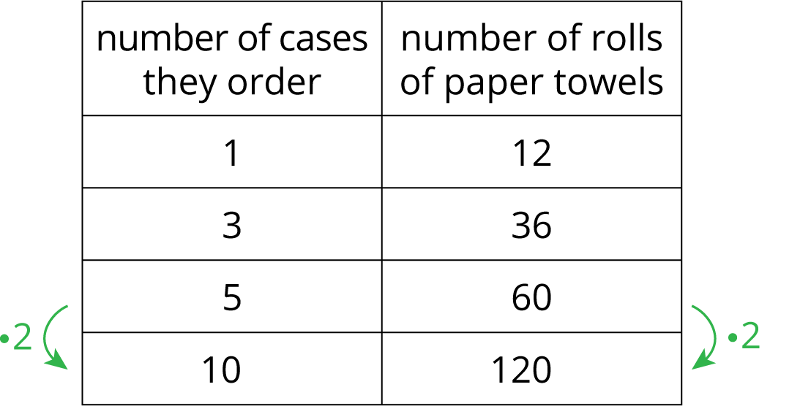
What do you notice about the table? What do you wonder?

2.2: Feeding a Crowd
- A recipe says that 2 cups of dry rice will serve 6 people. Complete the table as you answer the questions. Be prepared to explain your reasoning.
  - How many people will 10 cups of rice serve?
  - How many cups of rice are needed to serve 45 people?
- cups of rice | - number of people
- 2 | - 6
- 3 | - 9
- 10
 | - 45
- A recipe says that 6 spring rolls will serve 3 people. Complete the table.
- number of spring rolls | - number of people
- 6 | - 3
- 30
- 40
 | - 28

2.3: Making Bread Dough
A bakery uses 8 tablespoons of honey for every 10 cups of flour to make bread dough. Some days they bake bigger batches and some days they bake smaller batches, but they always use the same ratio of honey to flour. Complete the table as you answer the questions. Be prepared to explain your reasoning.
- How many cups of flour do they use with 20 tablespoons of honey?
- How many cups of flour do they use with 13 tablespoons of honey?
- How many tablespoons of honey do they use with 20 cups of flour?
- What is the proportional relationship represented by this table?
honey (tbsp) | flour (c)
8 | 10
20
13
 | 20

2.4: Quarters and Dimes
4 quarters are equal in value to 10 dimes.
- How many dimes equal the value of 6 quarters?
- How many dimes equal the value of 14 quarters?
- What value belongs next to the 1 in the table? What does it mean in this context?
number of  quarters | number of  dimes
1
4 | 10
6
14

Are you ready for more?
Pennies made before 1982 are 95% copper and weigh about 3.11 grams each. (Pennies made after that date are primarily made of zinc). Some people claim that the value of the copper in one of these pennies is greater than the face value of the penny. Find out how much copper is worth right now, and decide if this claim is true.

Lesson 2 Summary
If the ratios between two corresponding quantities are always equivalent, the relationship between the quantities is called a proportional relationship.
This table shows different amounts of milk and chocolate syrup. The ingredients in each row, when mixed together, would make a different total amount of chocolate milk, but these mixtures would all taste the same.
Notice that each row in the table shows a ratio of tablespoons of chocolate syrup to cups of milk that is equivalent to $4:1$.
About the relationship between these quantities, we could say:
tablespoons of  chocolate syrup | cups of  milk
4 | 1
6 | $1\frac{1}{2}$
8 | 2
$\frac{1}{2}$ | $\frac{1}{8}$
12 | 3
1 | $\frac{1}{4}$
- The relationship between amount of chocolate syrup and amount of milk is proportional.
- The relationship between the amount of chocolate syrup and the amount of milk is a proportional relationship.
- The table represents a proportional relationship between the amount of chocolate syrup and amount of milk.
- The amount of milk is proportional to the amount of chocolate syrup.
We could multiply any value in the chocolate syrup column by $\frac{1}{4}$ to get the value in the milk column. We might call $\frac{1}{4}$ a unit rate, because $\frac{1}{4}$ cup of milk is needed for 1 tablespoon of chocolate syrup. We also say that $\frac{1}{4}$ is the constant of proportionality for this relationship. It tells us how many cups of milk we would need to mix with 1 tablespoon of chocolate syrup.
© CC BY Open Up Resources. Adaptations CC BY IM.

