Lesson 2 Practice Problems
- The tortoise and the hare are having a race. After the hare runs 16 miles the tortoise has only run 4 miles.
- The relationship between the distance $x$ the tortoise “runs” in miles for every $y$ miles the hare runs is $y=4x$. Graph this relationship.
- 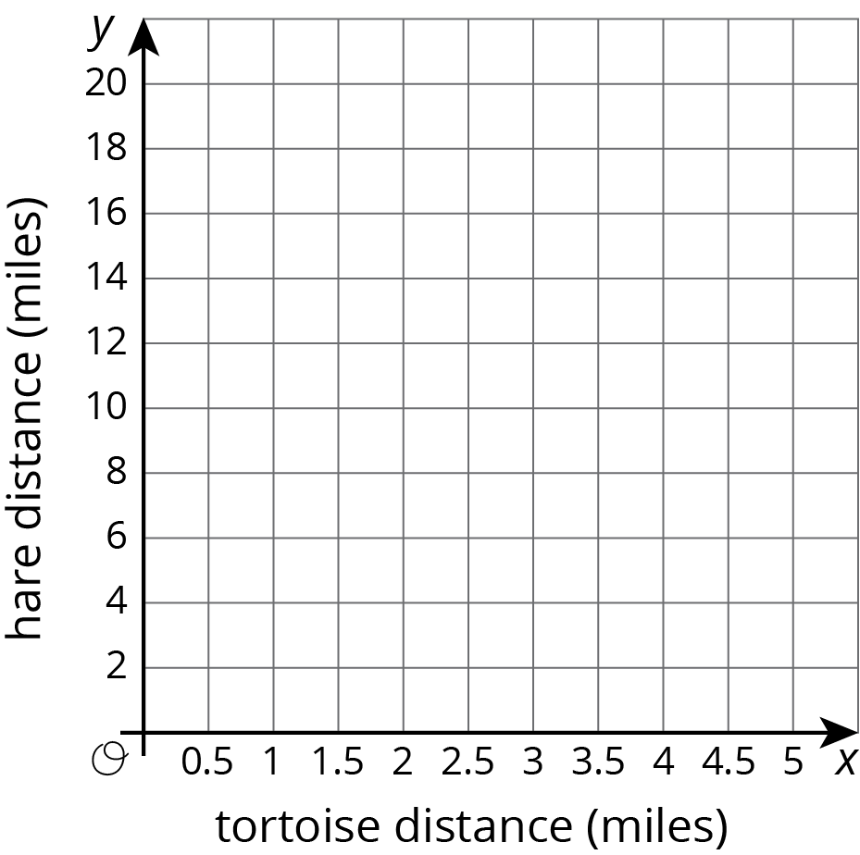
- The table shows a proportional relationship between the weight on a spring scale and the distance the spring has stretched.
  - Complete the table.
  - Describe the scales you could use on the $x$ and $y$ axes of a coordinate grid that would show all the distances and weights in the table.
- distance (cm) | - weight (newtons)
- 20 | - 28
- 55
 | - 140
- 1
- Find a sequence of rotations, reflections, translations, and dilations showing that one figure is similar to the other. Be specific: give the amount and direction of a translation, a line of reflection, the center and angle of a rotation, and the center and scale factor of a dilation.
- 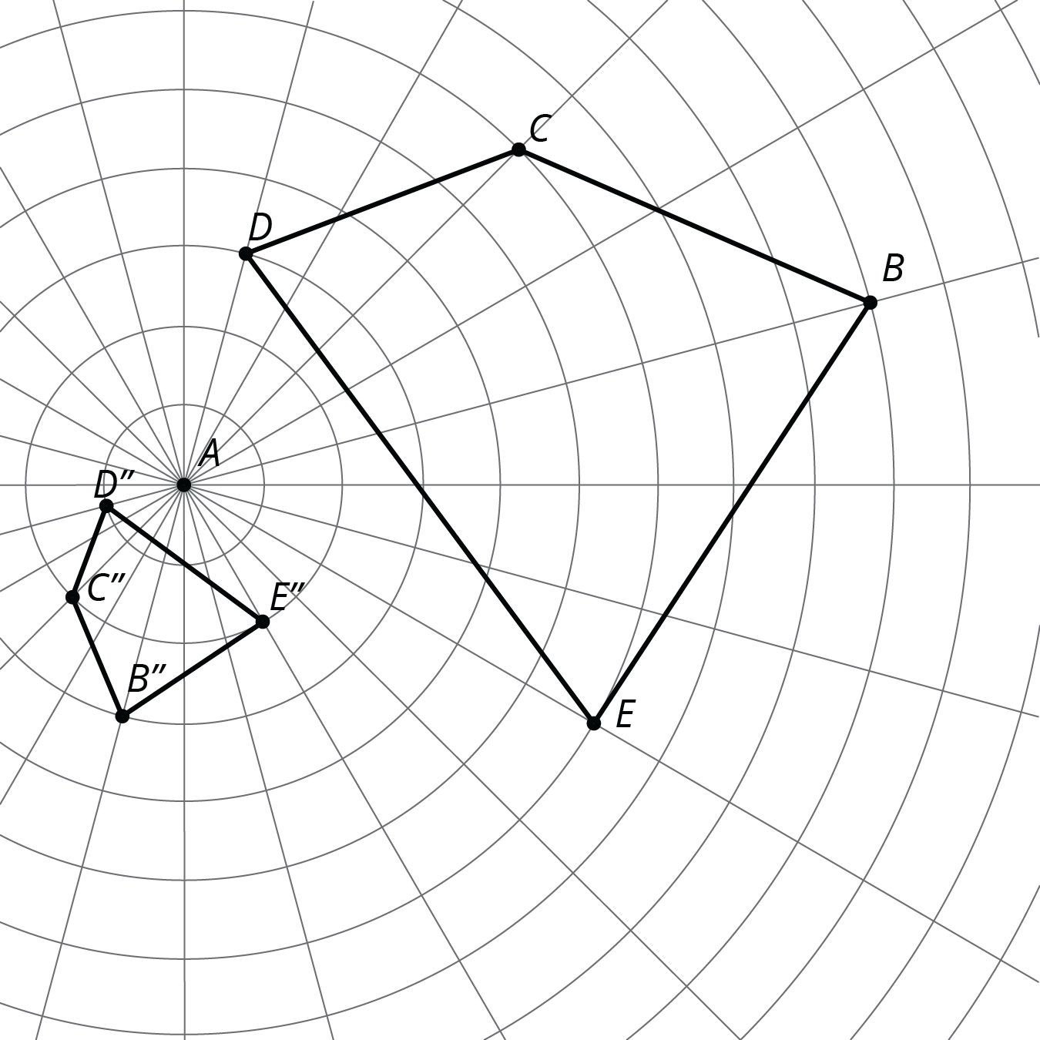

- (From Unit 2, Lesson 6.)
- Andre said, “I found two figures that are congruent, so they can’t be similar.”
- Diego said, “No, they are similar! The scale factor is 1.”
- Do you agree with either of them? Use the definition of similarity to explain your answer.
- (From Unit 2, Lesson 6.)
© CC BY Open Up Resources. Adaptations CC BY IM.

