Lesson 11 Practice Problems
- What is the volume of this cube?
- 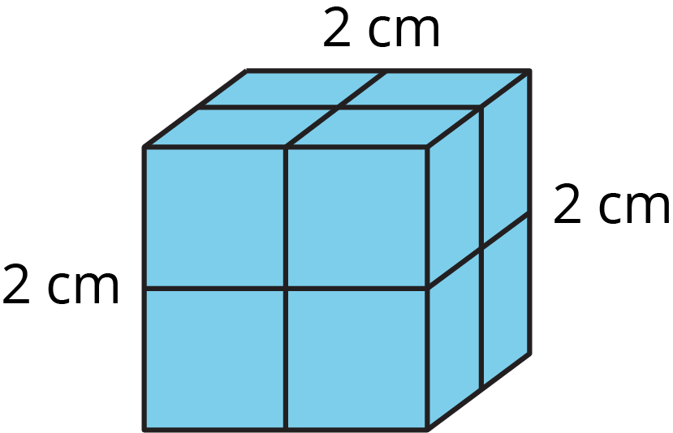

  - Decide if each number on the list is a perfect square.
  - 16
  - 20
  - 25
  - 100
  - 125
  - 144
  - 225
  - 10,000
  - Write a sentence that explains your reasoning.

  - Decide if each number on the list is a perfect cube.
  - 1
  - 3
  - 8
  - 9
  - 27
  - 64
  - 100
  - 125
  - Explain what a perfect cube is.

  - A square has side length 4 cm. What is its area?
  - The area of a square is 49 m². What is its side length?
  - A cube has edge length 3 in. What is its volume?
- Prism A and Prism B are rectangular prisms.
  - Prism A is 3 inches by 2 inches by 1 inch.
  - Prism B is 1 inch by 1 inch by 6 inches.
- Select all statements that are true about the two prisms.
  - They have the same volume.
  - They have the same number of faces.
  - More inch cubes can be packed into Prism A than into Prism B.
  - The two prisms have the same surface area.
  - The surface area of Prism B is greater than that of Prism A.
- (From Unit 1, Lesson 12.)

  - What polyhedron can be assembled from this net?
  - 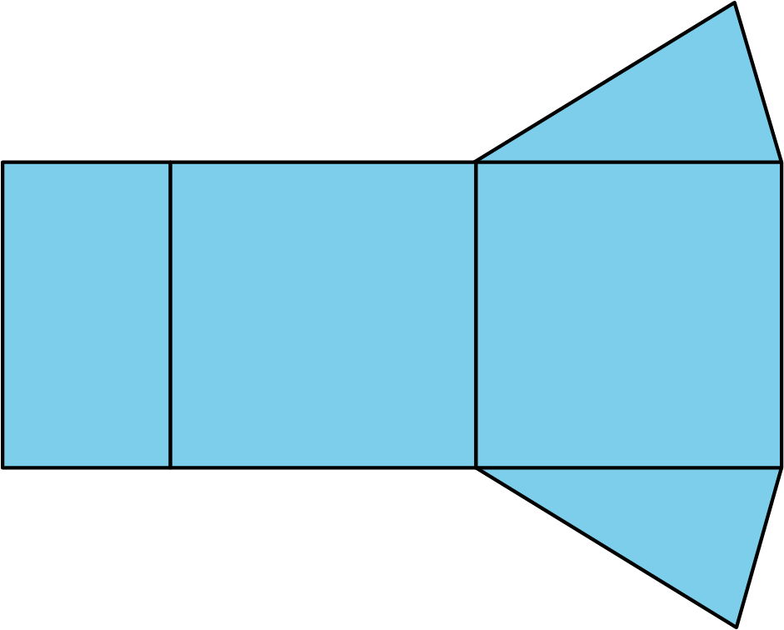
  - What information would you need to find its surface area? Be specific, and label the diagram as needed.
- (From Unit 1, Lesson 11.)
- Find the surface area of this triangular prism. All measurements are in meters.
- 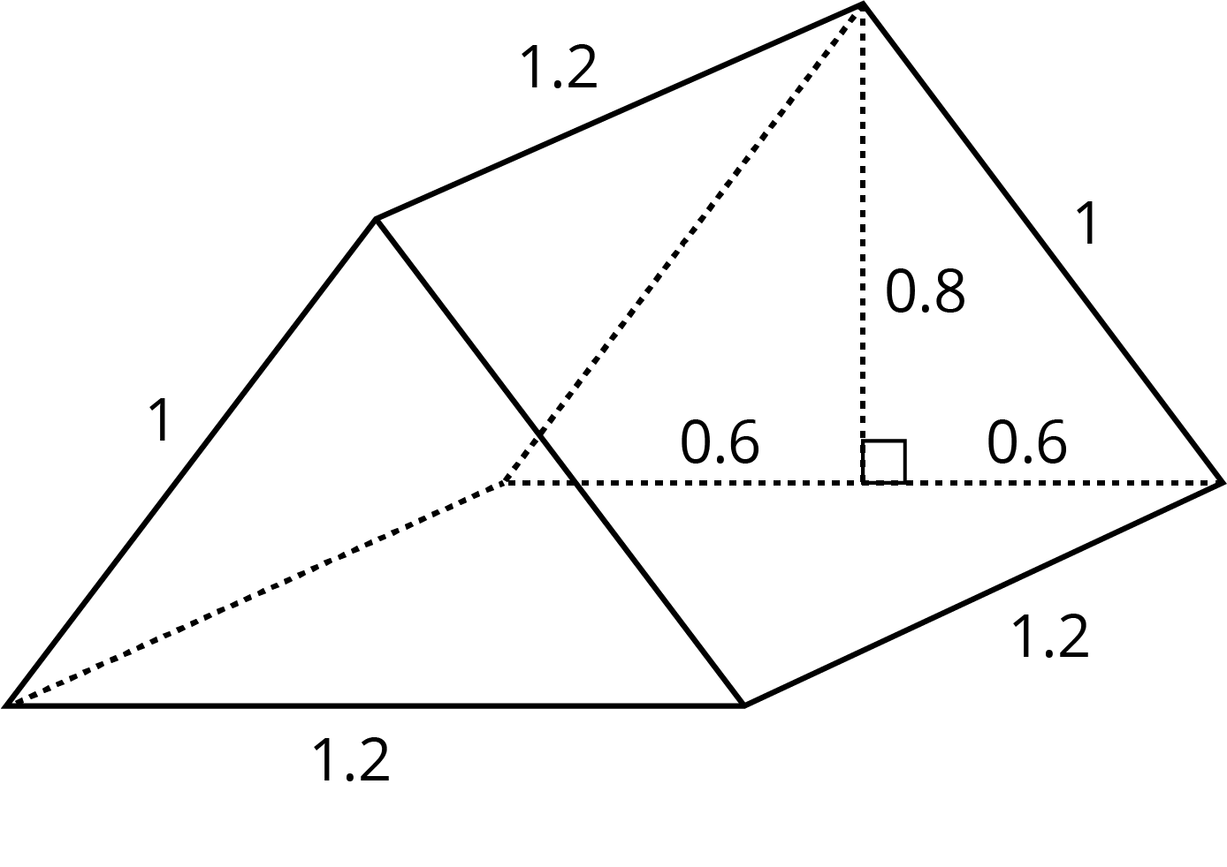
- (From Unit 1, Lesson 12.)
© CC BY Open Up Resources. Adaptations CC BY IM.

