Lesson 3: Multipliquemos fracciones unitarias

Standards Alignments
Addressing | 5.NF.B.4.a

Teacher-facing Learning Goals
- Find the product of 2 unit fractions.

Student-facing Learning Goals
- Resolvamos ecuaciones.

Lesson Purpose
The purpose of this lesson is for students to represent products of unit fractions using diagrams and equations.
In previous lessons students represented products of unit fractions with diagrams and expressions. In this lesson students connect the diagrams and expressions, using the structure of the diagram to calculate the value of the expression. Students use the diagrams to find the value of many expressions and, toward the end of the lesson, they find the value of an expression, representing a product of unit fractions, without being given a diagram.

Access for:

Students with Disabilities
- Engagement (Activity 2)

Instructional Routines
Estimation Exploration (Warm-up), MLR1 Stronger and Clearer Each Time (Activity 2)

Lesson Timeline
Warm-up | 10 min
Activity 1 | 20 min
Activity 2 | 15 min
Lesson Synthesis | 10 min
Cool-down | 5 min

Teacher Reflection Question
Some students may be multiplying the numerators and denominators without considering why this strategy works. Why is it important for students to understand how the diagrams represent products of fractions? What questions can you ask to help students connect the diagrams to the procedures they are using?

Cool-down
(to be completed at the end of the lesson) 5min
Ecuaciones de multiplicación

Standards Alignments
Addressing | 5.NF.B.4.a

Student-facing Task Statement
- Escribe una ecuación de multiplicación que represente la parte coloreada de la figura. Explica o muestra tu razonamiento.
- 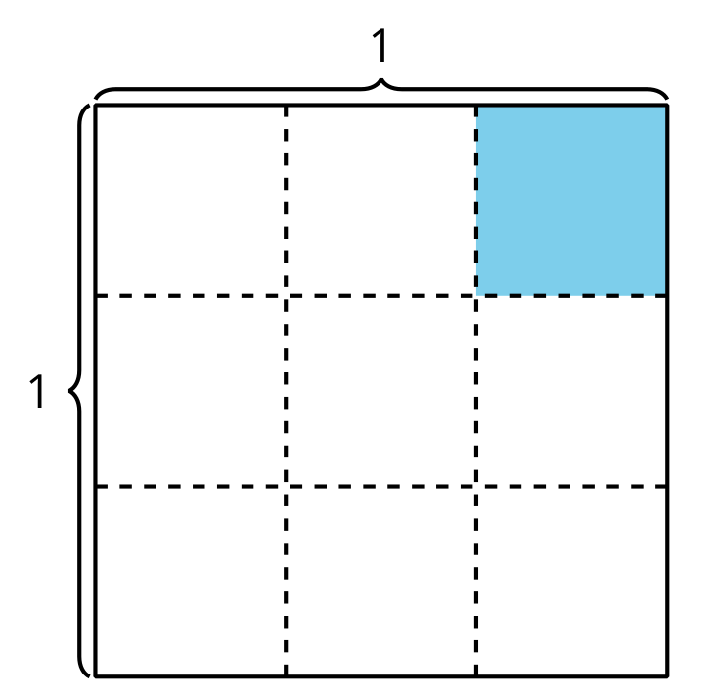
- Completa cada ecuación. Si te ayuda, dibuja un diagrama.
  - $\frac{1}{5}×\frac{1}{4}=\underset{_}{}$
  - $\frac{1}{2}×\frac{1}{6}=\underset{_}{}$

Student Responses
- $\frac{1}{3}×\frac{1}{3}=\frac{1}{9}$ since there is $\frac{1}{3}$ of a column shaded and that column is $\frac{1}{3}$ of the square. The shaded piece is $\frac{1}{9}$ of the square.

  - $\frac{1}{5}×\frac{1}{4}=\frac{1}{20}$
  - $\frac{1}{2}×\frac{1}{6}=\frac{1}{12}$

