Unit 6 Lesson 15: Problem Solving with Line Plots

WU Number Talk: Multiply by 18 (Warm up)

Student Task Statement
Find the value of each expression mentally.
- $\frac{1}{3}×18$
- $\frac{2}{3}×18$
- $\frac{4}{3}×18$
- $\frac{5}{3}×18$

1 Info Gap: Picking Fruit

Student Task Statement
Your teacher will give you either a problem card or a data card. Do not show or read your card to your partner.
Pause here so your teacher can review your work.
Ask your teacher for a new set of cards and repeat the activity, trading roles with your partner.

2 Mathematical Questions (Optional)

Student Task Statement
This line plot shows the weights of some apricots that Mai picked.
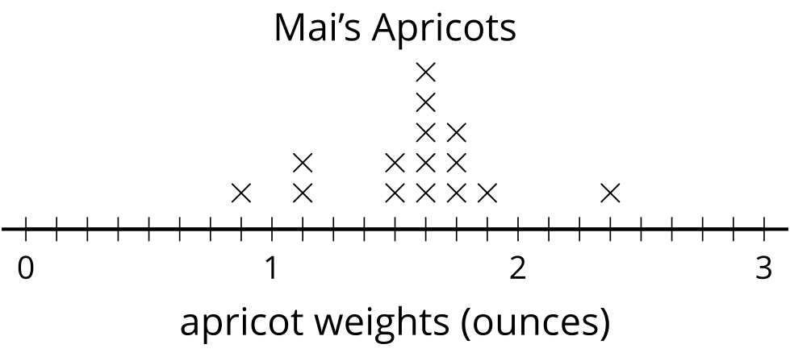
- What fraction of the apricots weigh less than $1\frac{1}{2}$ ounces? Explain or show your reasoning.
- Write a multiplication equation that represents the total weight of the apricots that each weigh $1\frac{5}{8}$ ounces.
- Do all of Mai’s apricots together weigh more or less than a pound? Explain or show your reasoning.
© CC BY 2021 Illustrative Mathematics®

