Lesson 13: Is It a.m. or p.m.?

Standards Alignments
Addressing | 2.MD.C.7

Teacher-facing Learning Goals
- Label times using a.m. and p.m.
- Read and write time to the nearest 5-minute interval on analog and digital clocks.

Student-facing Learning Goals
- Let’s read and write times using a.m. or p.m.

Lesson Purpose
The purpose of this lesson is for students to read and write time with analog and digital clocks, using a.m. and p.m.
In previous lessons, students learned to tell time to the nearest 5 minutes using analog clocks.
In this lesson, students practice telling time to the nearest 5 minutes. Students recognize that the hour hand goes around the clock twice each day, so a.m. and p.m. are used to distinguish between morning and night. Students relate a.m. and p.m. to specific times and activities during the day.
This lesson has a Student Section Summary.

Access for:

Students with Disabilities
- Representation (Activity 2)

Instructional Routines
Choral Count (Warm-up), MLR8 Discussion Supports (Activity 1)

Materials to Gather
- Glue: Activity 1
- Scissors: Activity 1

Materials to Copy
- Hours in a Day Timeline (groups of 1): Activity 1

Lesson Timeline
Warm-up | 10 min
Activity 1 | 20 min
Activity 2 | 15 min
Lesson Synthesis | 10 min
Cool-down | 5 min

Teacher Reflection Question
How helpful is the linear representation of 1 day for developing an understanding of the repeating 12-hour cycle? What more do students need to build an understanding of the hours that make up a.m. versus the hours that make up p.m.?

Cool-down
(to be completed at the end of the lesson) 5min
Represent the Time

Standards Alignments
Addressing | 2.MD.C.7

Student-facing Task Statement
Draw the hands on the clock to show the time and circle a.m. or p.m.
- The alarm clock wakes me up at 6:20.
- 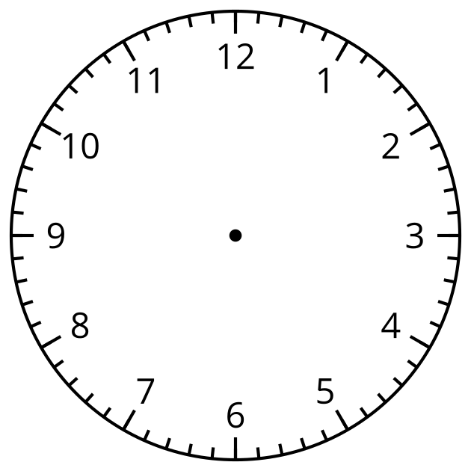
- a.m. or p.m.
- I watch TV at 4:45.
- a.m. or p.m.

Student Responses
1.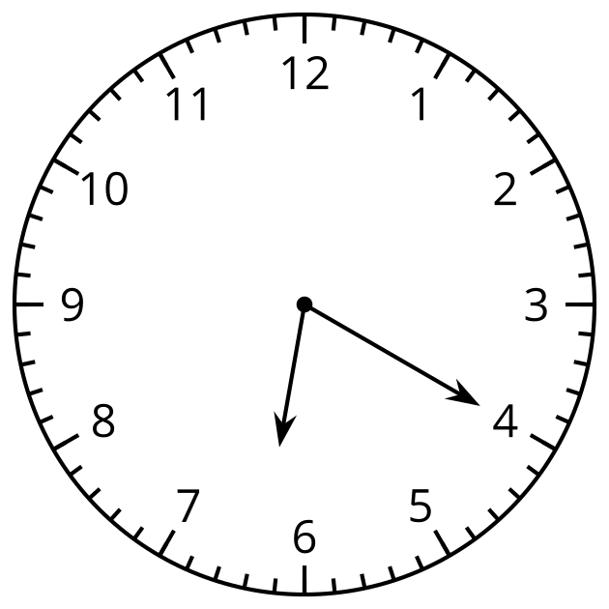
a.m.
2.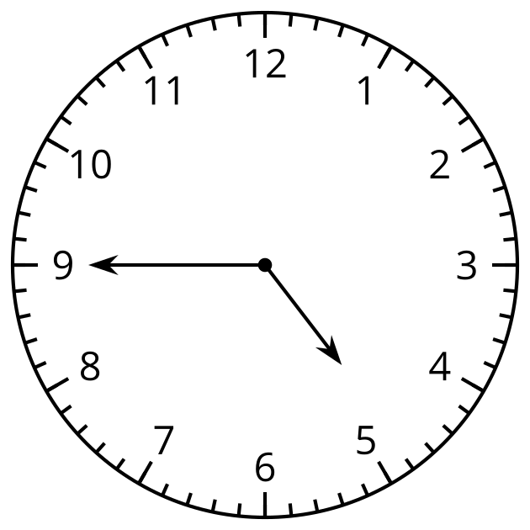
p.m.

