Unit 1 Lesson 6: Choose a Scale

WU Notice and Wonder: Bar Graph Scales (Warm up)

Student Task Statement
What do you notice? What do you wonder?
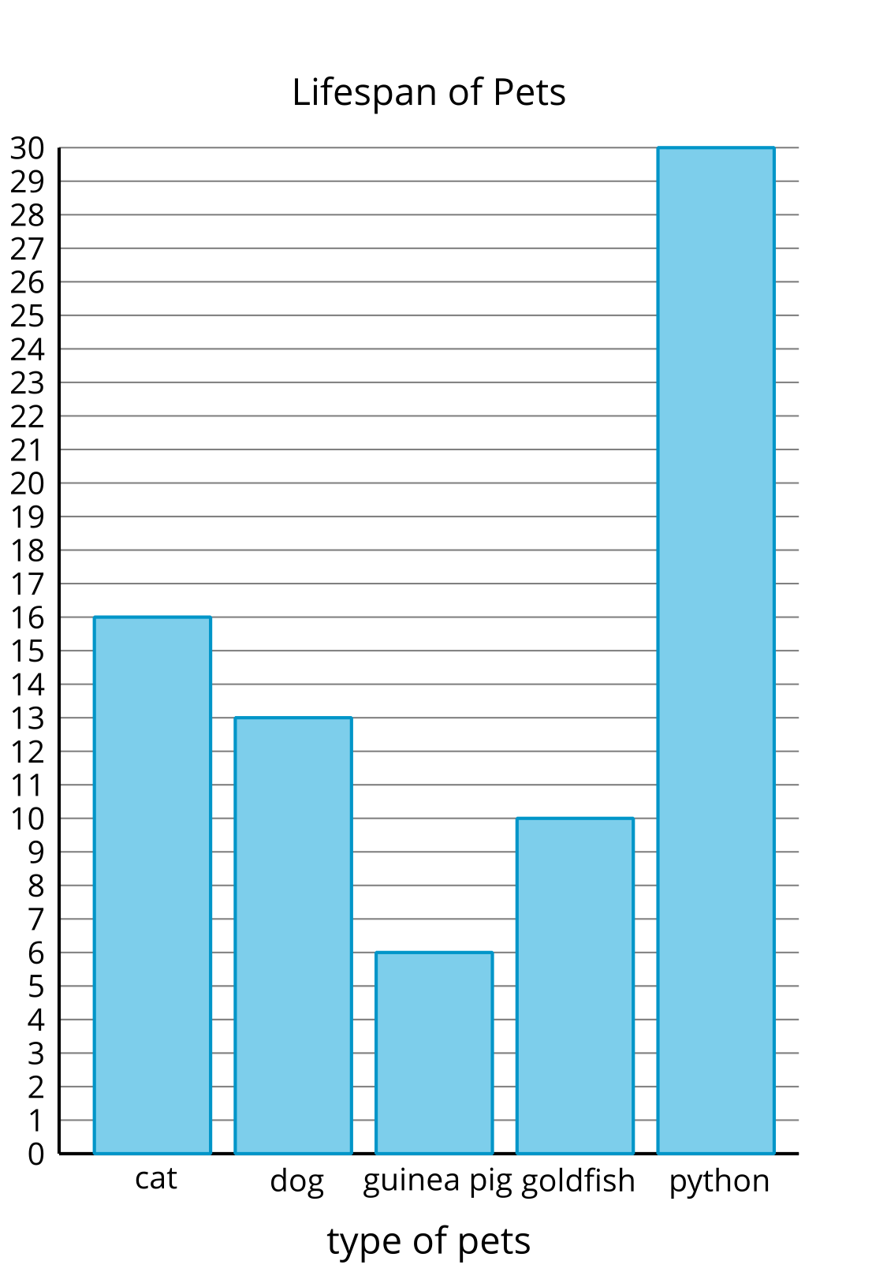
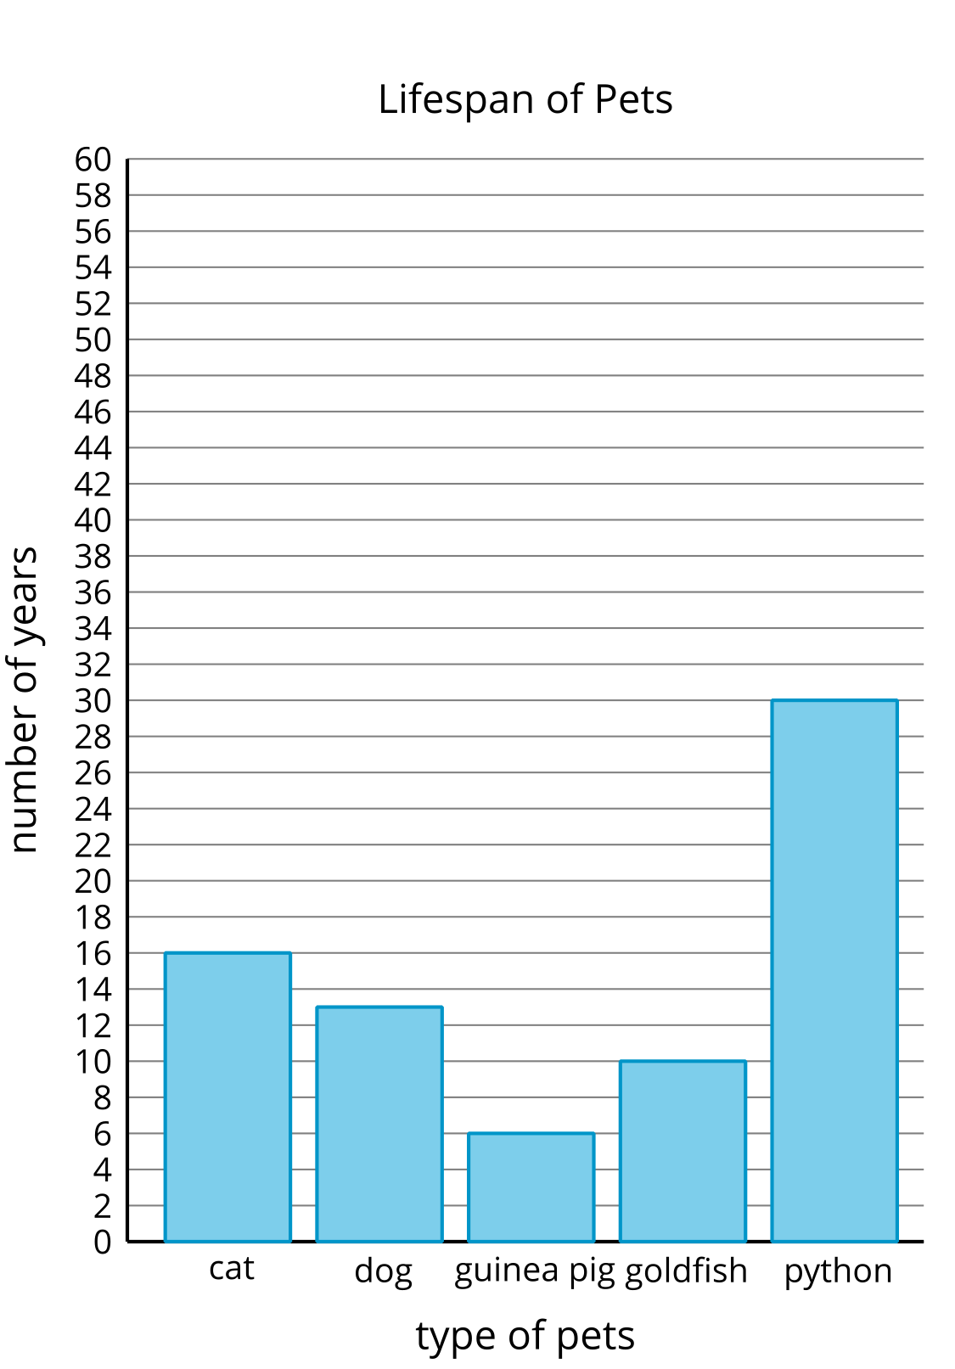
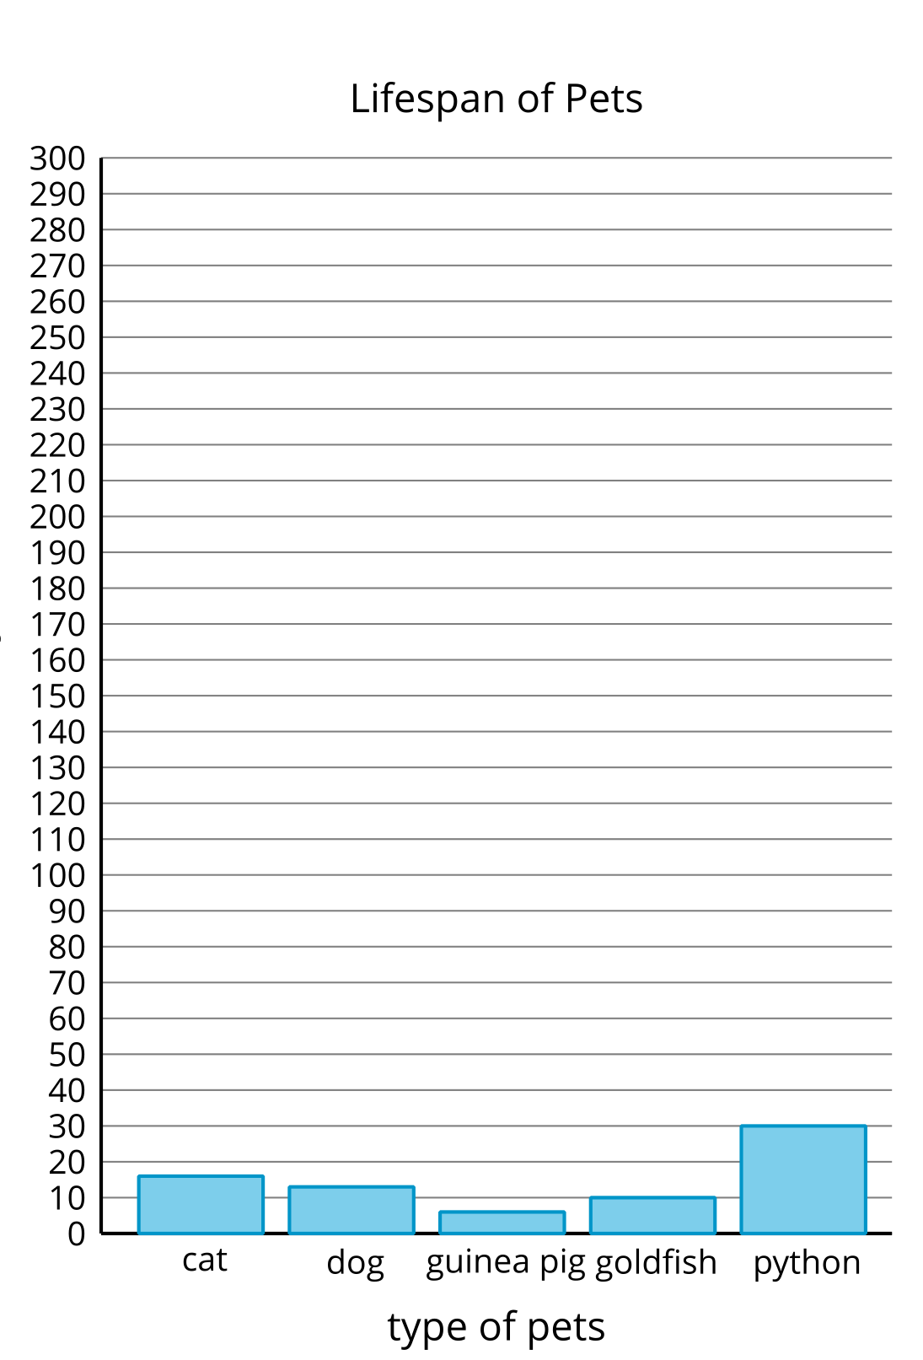

1 Represent Pattern Blocks

Student Task Statement
Here is a collection of pattern blocks.
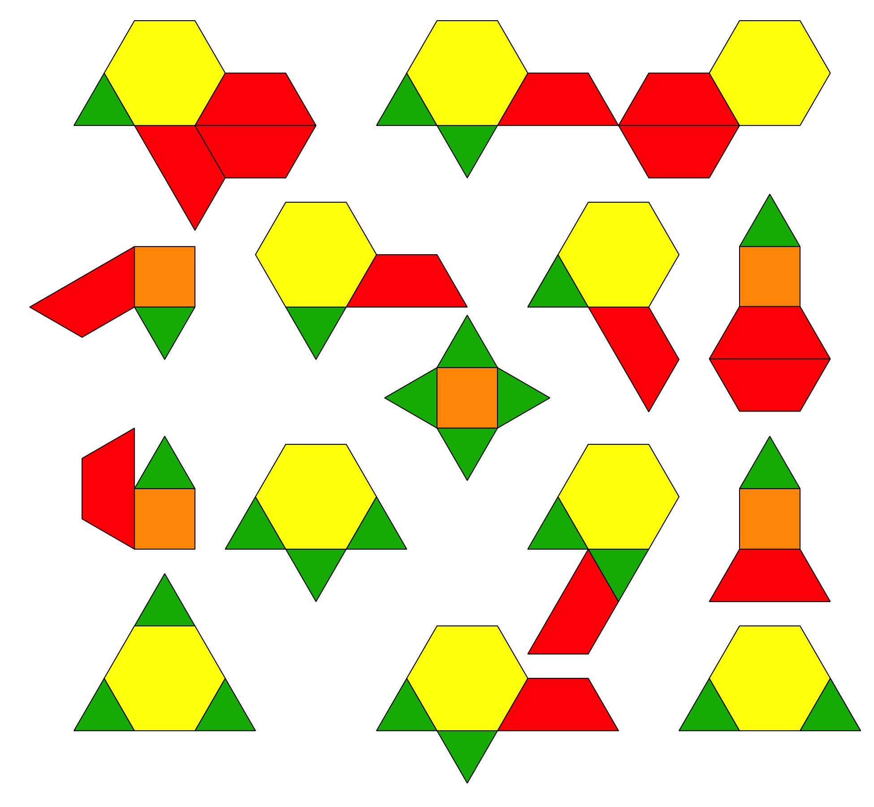
Mai, Noah, and Priya want to make a bar graph to represent the number of triangles, squares, trapezoids, and hexagons in the collection.
- Mai says the scale of the bar graph should be 2.
- Noah says the scale of the bar graph should be 5.
- Priya says the scale of the bar graph should be 10.
- Who do you agree with? Explain your reasoning.
- Use the scale that you chose to create a scaled bar graph to represent the collection of pattern blocks.
- 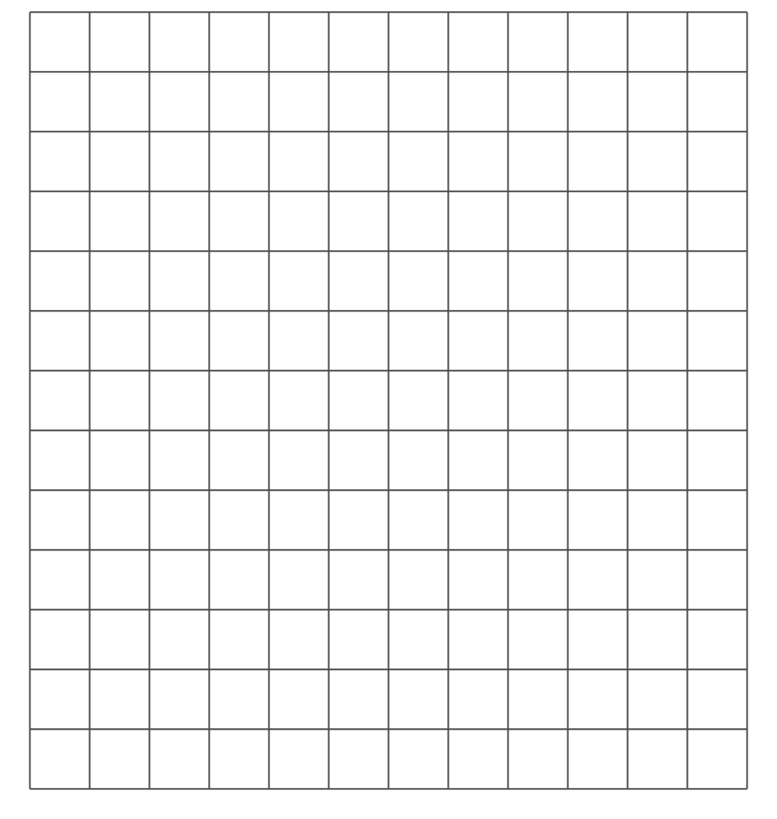

2 Represent More Data in a Scaled Bar Graph

Student Task Statement
All the third-grade students at school were asked, “What is your favorite time of the year?” Their responses are shown in this table:
favorite time of the year | number of students
winter | 24
spring | 13
summer | 40
fall | 22
Use the data from this table to create a scaled bar graph.
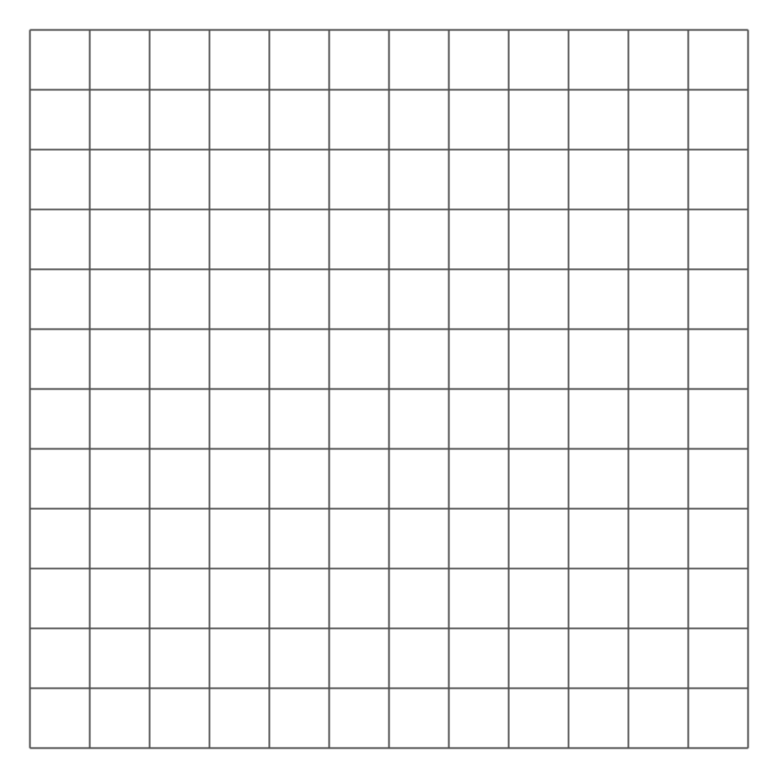
© CC BY 2021 Illustrative Mathematics®

