Unit 4 Lesson 7: One Hundred Percent

1 Notice and Wonder: Double Number Line (Warm up)

Student Task Statement
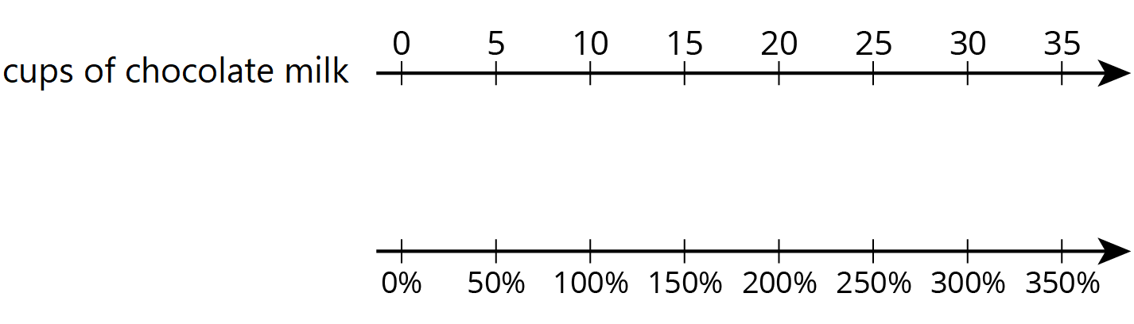
What do you notice? What do you wonder?

2 Double Number Lines

Student Task Statement
For each problem, complete the double number line diagram to show the percentages that correspond to the original amount and to the new amount.
- The gas tank in dad’s car holds 12 gallons. The gas tank in mom’s truck holds 50% more than that. How much gas does the truck’s tank hold?
- 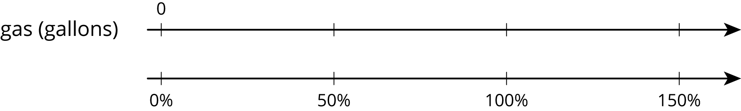
- At a movie theater, the size of popcorn bags decreased 20%. If the old bags held 15 cups of popcorn, how much do the new bags hold?
- 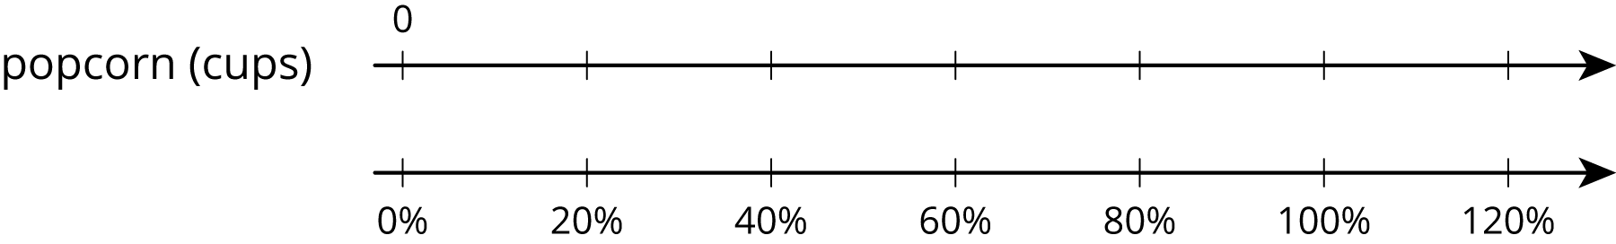
- A school had 1,200 students last year and only 1,080 students this year. What was the percentage decrease in the number of students?
- 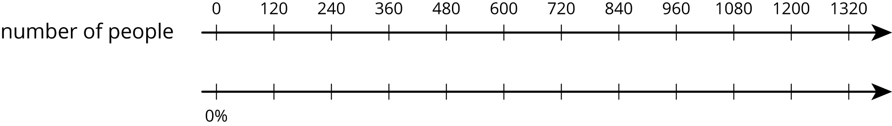
- One week gas was $1.25 per gallon. The next week gas was $1.50 per gallon. By what percentage did the price increase?
- 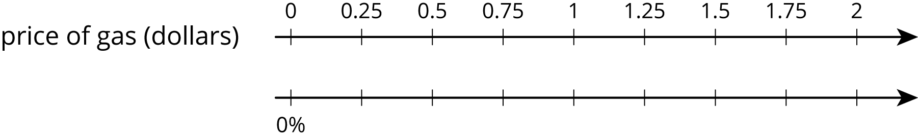
- After a 25% discount, the price of a T-shirt was $12. What was the price before the discount?
- 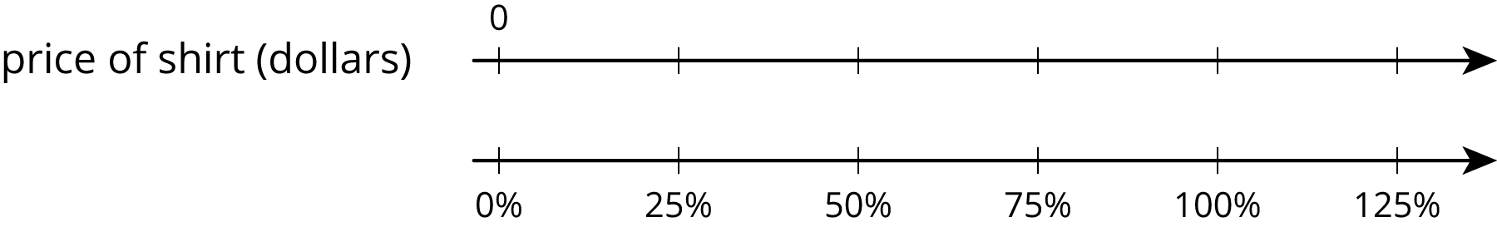
- Compared to last year, the population of Boom Town has increased 25%. The population is now 6,600. What was the population last year?
- 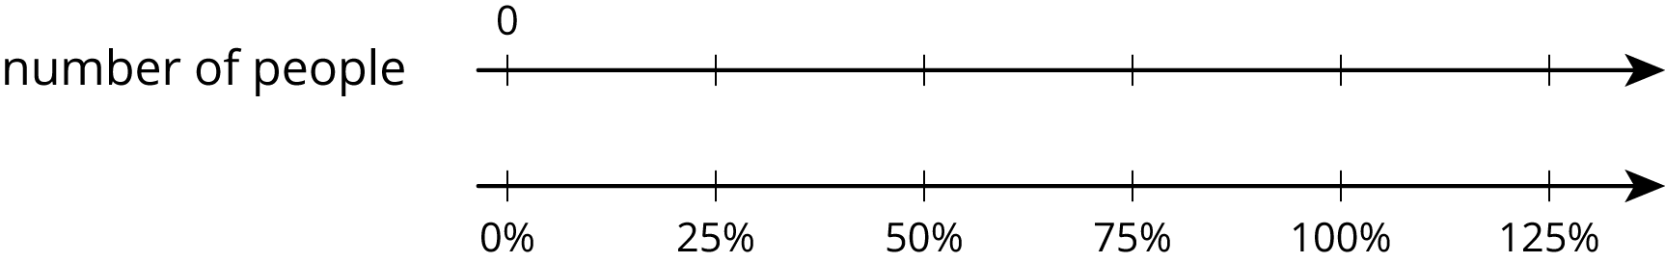

3 Representing More Juice

Student Task Statement
Two students are working on the same problem:
A juice box has 20% more juice in its new packaging. The original packaging held 12 fluid ounces. How much juice does the new packaging hold?
- Here is how Priya set up her double number line.
- 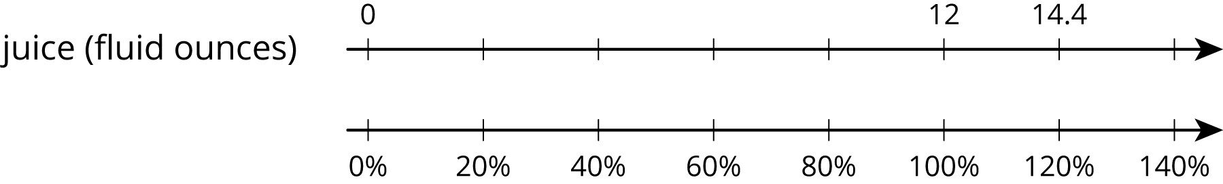
- Here is how Clare set up her double number line.
- 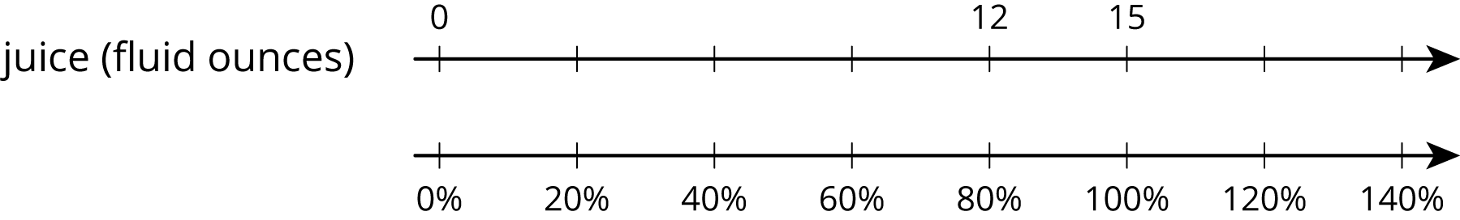
Do you agree with either of them? Explain or show your reasoning.

4 Protecting the Green Sea Turtle (Optional)

Student Task Statement
Green sea turtles live most of their lives in the ocean, but come ashore to lay their eggs. Some beaches where turtles often come ashore have been made into protected sanctuaries so the eggs will not be disturbed.
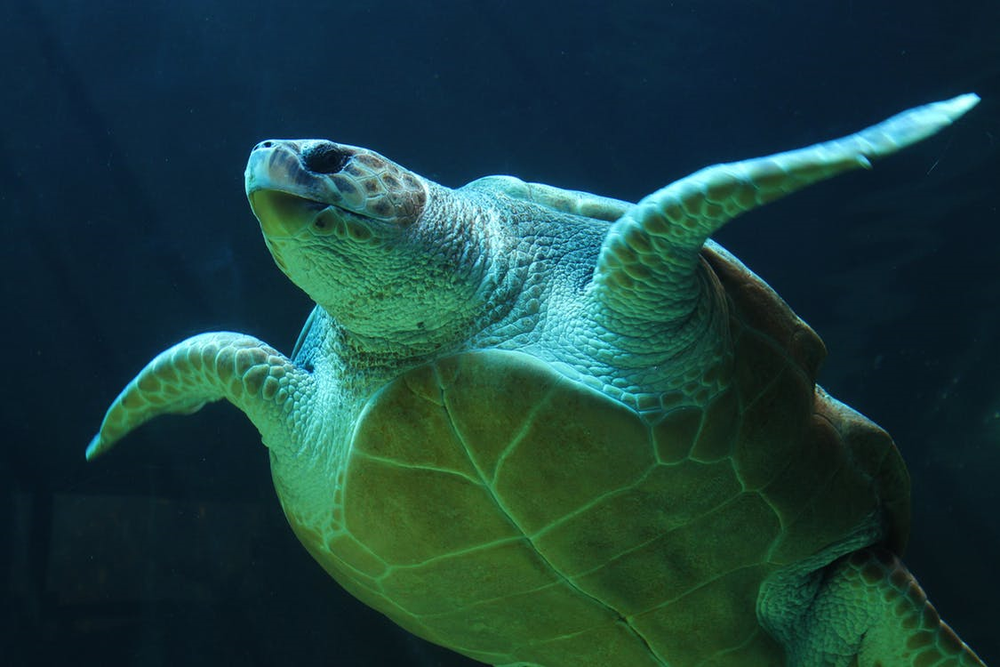
- One sanctuary had 180 green sea turtles come ashore to lay eggs last year. This year, the number of turtles increased by 10%. How many turtles came ashore to lay eggs in the sanctuary this year?
- At another sanctuary, the number of nesting turtles decreased by 10%. This year there were 234 nesting turtles. How many nesting turtles were at this sanctuary last year?
© CC BY Open Up Resources. Adaptations CC BY IM.

