Unit 8 Lesson 13 Cumulative Practice Problems
- Suppose 45% of all the students at Andre’s school brought in a can of food to contribute to a canned food drive. Andre picks a representative sample of 25 students from the school and determines the sample’s percentage.
- He expects the percentage for this sample will be 45%. Do you agree? Explain your reasoning.
- This is a dot plot of the scores on a video game for a population of 50 teenagers.
- 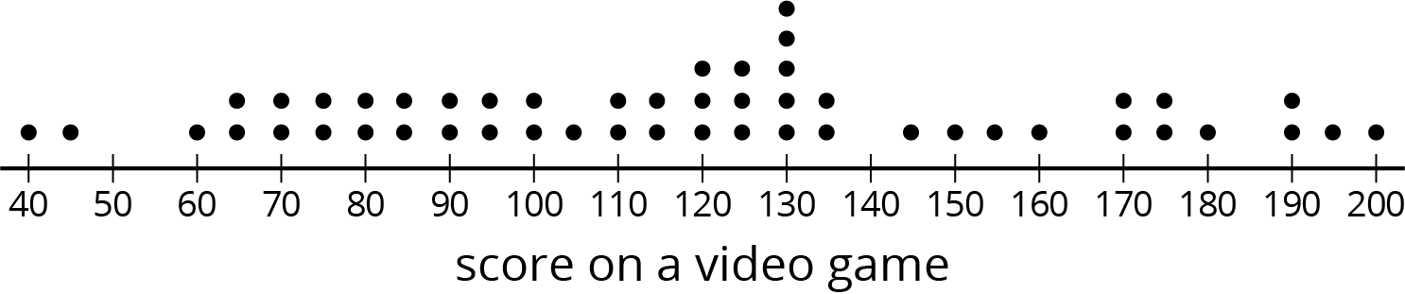
- The three dot plots together are the scores of teenagers in three samples from this population. Which of the three samples is most representative of the population? Explain how you know.
- 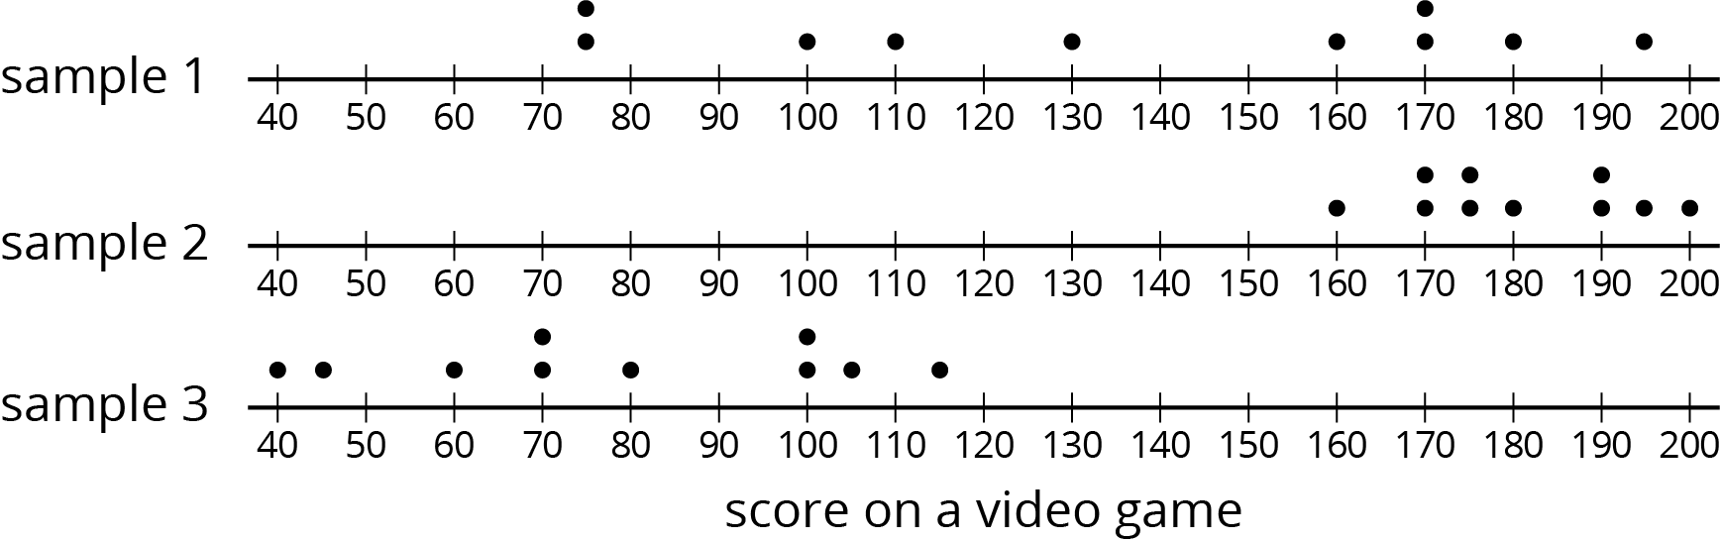
- This is a dot plot of the number of text messages sent one day for a sample of the students at a local high school. The sample consisted of 30 students and was selected to be representative of the population.
- 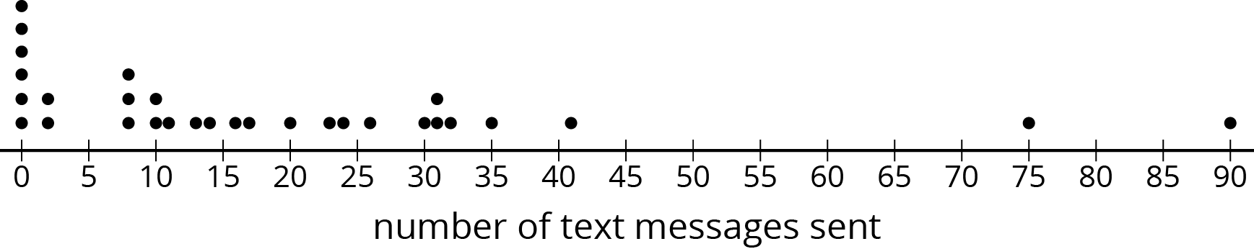
  - What do the six values of 0 in the dot plot represent?
  - Since this sample is representative of the population, describe what you think a dot plot for the entire population might look like.
- A doctor suspects you might have a certain strain of flu and wants to test your blood for the presence of markers for this strain of virus. Why would it be good for the doctor to take a sample of your blood rather than use the population?
- (From Unit 8, Lesson 12.)
- How many different outcomes are in each sample space? Explain your reasoning. (You do not need to write out the actual options, just provide the number and your reasoning.)
  - A letter of the English alphabet is followed by a digit from 0 to 9.
  - A baseball team’s cap is selected from 3 different colors, 2 different clasps, and 4 different locations for the team logo. A decision is made to include or not to include reflective piping.
  - A locker combination like 7-23-11 uses three numbers, each from 1 to 40. Numbers can be used more than once, like 7-23-7.
- (From Unit 8, Lesson 8.)
© CC BY Open Up Resources. Adaptations CC BY IM.

