Lesson 4: Situaciones acerca de la multiplicación de fracciones

Standards Alignments
Addressing | 5.NF.B.4.a
Building Towards | 5.NF.B.4.b

Teacher-facing Learning Goals
- Represent and solve problems involving multiplication of a unit fraction and a non-unit fraction.

Student-facing Learning Goals
- Resolvamos problemas acerca de la multiplicación de fracciones unitarias.

Lesson Purpose
The purpose of this lesson is for students to represent the product of a unit fraction and a non-unit fraction with a diagram.
In previous lessons, students used a diagram to visualize quantities, write a multiplication expression, and find the value of the product. This lesson uses the context of a park to encourage students to use an area diagram. After using the diagram to create an expression in the first activity, students work in the other direction in the second activity, finding which part of the park is represented by different expressions. Throughout the lesson, students observe that the methods that helped them find products of unit fractions also work when one of those fractions is not a unit fraction.
Because these problems are in context, the area diagrams do not have the side lengths labeled. This means that students are finding the fraction of the park, rather than the area of a given section. Although this difference is small, it is helpful for teachers to be consistent about the difference in what the diagram represents when it does not have labeled side lengths.

Access for:

Students with Disabilities
- Action and Expression (Activity 2)

English Learners
- MLR8 (Activity 1)

Instructional Routines
Number Talk (Warm-up)

Lesson Timeline
Warm-up | 10 min
Activity 1 | 20 min
Activity 2 | 15 min
Lesson Synthesis | 10 min
Cool-down | 5 min

Teacher Reflection Question
If you were to teach this lesson over again, what activity would you redo? How would your proposed changes support student learning?

Cool-down
(to be completed at the end of the lesson) 5min
Área del parque

Standards Alignments
Addressing | 5.NF.B.4.a

Student-facing Task Statement
- Este es un diagrama de un parque.
- 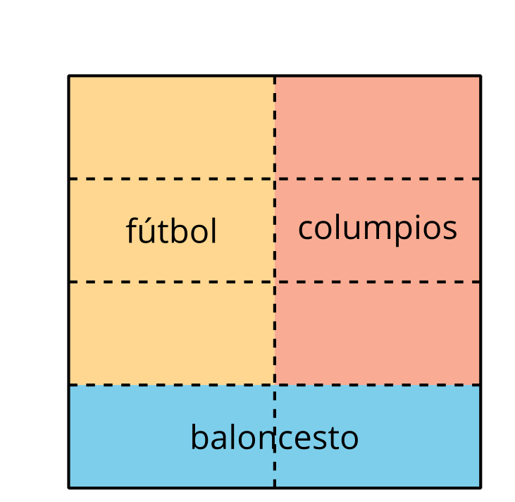
  - Escribe una expresión de multiplicación que represente la fracción del parque que se usa para fútbol.
  - ¿Cuánto del parque entero se usará para fútbol?

Student Responses

  - $\frac{3}{4}×\frac{1}{2}$ or $\frac{1}{2}×\frac{3}{4}$
  - $\frac{3}{8}$

