Lesson 11: Encuestas sobre una mascota para el curso

Standards Alignments
Addressing | 1.MD.C.4, 1.OA.B.4, 1.OA.C.5, 1.OA.C.6
Building Towards | 1.MD.C.4

Teacher-facing Learning Goals
- Determine whether statements about data are true or false.
- Write statements about data from a visual representation.

Student-facing Learning Goals
- Veamos qué nos dicen los datos.

Lesson Purpose
The purpose of this lesson is for students to write and evaluate statements based on data in a visual representation.
In a previous lesson, students created representations of survey data collected from their class. In this lesson, students interpret data represented with tally marks to consider whether statements about the data are true or false. Students then write their own statements about a different set of data, also represented with tally marks.

Access for:

Students with Disabilities
- Action and Expression (Activity 1)

English Learners
- MLR8 (Activity 1)

Instructional Routines
Notice and Wonder (Warm-up)

Materials to Gather
- Materials from previous centers: Activity 3

Lesson Timeline
Warm-up | 10 min
Activity 1 | 10 min
Activity 2 | 10 min
Activity 3 | 15 min
Lesson Synthesis | 10 min
Cool-down | 5 min

Teacher Reflection Question
What types of statements did students make about the data? What do these statements tell you about how prepared students are to answer “how many in each category” and “how many in all” questions in upcoming lessons?

Cool-down
(to be completed at the end of the lesson) 5min
Datos sobre una mascota para el curso

Standards Alignments
Addressing | 1.MD.C.4

Student-facing Task Statement
Otro curso respondió la pregunta: “¿Cuál animal sería la mejor mascota para el curso?”.
Sus respuestas se muestran a continuación.
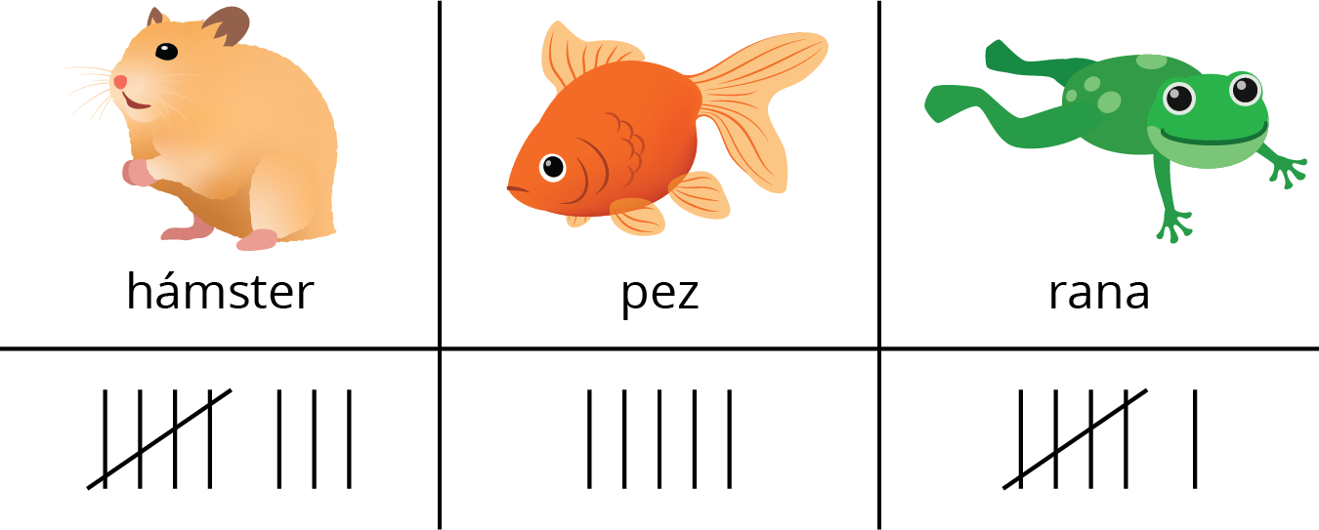
Escribe 1 afirmación sobre los datos que sea verdadera.

Student Responses
Sample responses:
- 8 students voted for hamster.
- 11 students voted for fish or frog.
- 19 students voted altogether.
- More students chose hamster than fish.

