Lesson 5: Two Equations for Each Relationship

5.1: Missing Figures
Here are the second and fourth figures in a pattern.
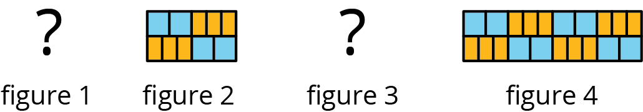
- What do you think the first and third figures in the pattern look like?
- Describe the 10th figure in the pattern.

5.2: Meters and Centimeters
There are 100 centimeters (cm) in every meter (m).
length (m) | length (cm)
1 | 100
0.94
1.67
57.24
$x$
length (cm) | length (m)
100 | 1
250
78.2
123.9
$y$
- Complete each of the tables.
- For each table, find the constant of proportionality.
- What is the relationship between these constants of proportionality?
- For each table, write an equation for the proportional relationship. Let $x$ represent a length measured in meters and $y$ represent the same length measured in centimeters.

Are you ready for more?
- How many cubic centimeters are there in a cubic meter?
- How do you convert cubic centimeters to cubic meters?
- How do you convert the other way?

5.3: Filling a Water Cooler
It took Priya 5 minutes to fill a cooler with 8 gallons of water from a faucet that was flowing at a steady rate. Let $w$ be the number of gallons of water in the cooler after $t$ minutes.
- Which of the following equations represent the relationship between $w$ and $t$? Select all that apply.
  - $w=1.6t$
  - $w=0.625t$
  - $t=1.6w$
  - $t=0.625w$
- What does 1.6 tell you about the situation?
- What does 0.625 tell you about the situation?
- Priya changed the rate at which water flowed through the faucet. Write an equation that represents the relationship of $w$ and $t$ when it takes 3 minutes to fill the cooler with 1 gallon of water.
- Was the cooler filling faster before or after Priya changed the rate of water flow? Explain how you know.

5.4: Feeding Shrimp
At an aquarium, a shrimp is fed $\frac{1}{5}$ gram of food each feeding and is fed 3 times each day.
- How much food does a shrimp get fed in one day?
- Complete the table to show how many grams of food the shrimp is fed over different numbers of days.
- number of days | - food in grams
- 1
- 7
- 30
- 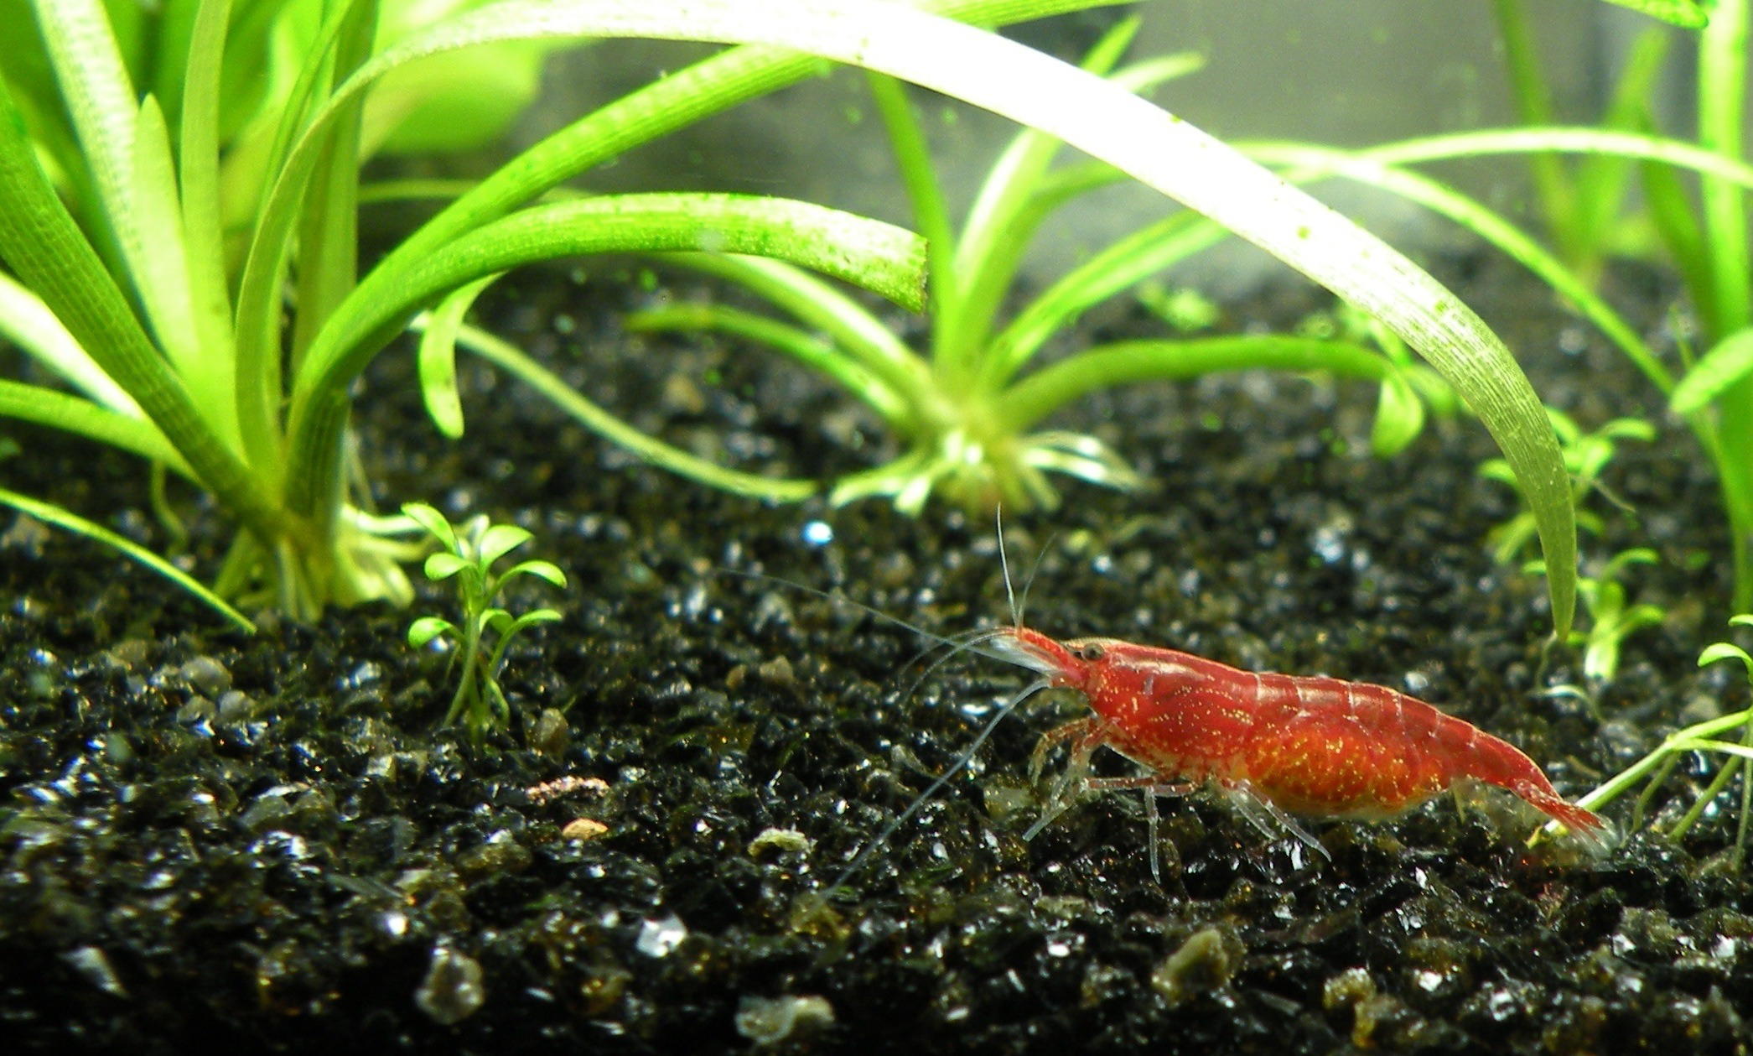
- What is the constant of proportionality? What does it tell us about the situation?
- If we switched the columns in the table, what would be the constant of proportionality? Explain your reasoning.
- Use $d$ for number of days and $f$ for amount of food in grams that a shrimp eats to write two equations that represent the relationship between $d$ and $f$.
- If a tank has 10 shrimp in it, how much food is added to the tank each day?
- If the aquarium manager has 300 grams of shrimp food for this tank of 10 shrimp, how many days will it last? Explain or show your reasoning.

Lesson 5 Summary
If Kiran rode his bike at a constant 10 miles per hour, his distance in miles, $d$, is proportional to the number of hours, $t$, that he rode. We can write the equation $d=10t$ With this equation, it is easy to find the distance Kiran rode when we know how long it took because we can just multiply the time by 10.
We can rewrite the equation:
$\begin{matrix}d & =10t \\ \left(\frac{1}{10}\right)d & =t \\ t & =\left(\frac{1}{10}\right)d\end{matrix}$
This version of the equation tells us that the amount of time he rode is proportional to the distance he traveled, and the constant of proportionality is $\frac{1}{10}$. That form is easier to use when we know his distance and want to find how long it took because we can just multiply the distance by $\frac{1}{10}$.
When two quantities $x$ and $y$ are in a proportional relationship, we can write the equation $y=kx$ and say, “$y$ is proportional to $x$.” In this case, the number $k$ is the corresponding constant of proportionality. We can also write the equation $x=\frac{1}{k}y$ and say, “$x$ is proportional to $y$.” In this case, the number $\frac{1}{k}$ is the corresponding constant of proportionality. Each one can be useful depending on the information we have and the quantity we are trying to figure out.
© CC BY Open Up Resources. Adaptations CC BY IM.

