Lesson 4: Características de los rectángulos, los rombos y los cuadrados

Standards Alignments
Addressing | 3.G.A.1

Teacher-facing Learning Goals
- Identify attributes of rhombuses, rectangles, and squares.

Student-facing Learning Goals
- Averigüemos qué hace que los rectángulos, los rombos y los cuadrados sean lo que son.

Lesson Purpose
The purpose of this lesson is for students to consider the geometric attributes a quadrilateral must have to be a rhombus, rectangle, or square.
In previous lessons, students learned how to compare and describe shapes using geometric attributes. In this lesson, students analyze examples and non-examples of rectangles, rhombuses, and squares in order to identify their defining attributes. As they discern and describe features that define these quadrilaterals, students practice looking for structure (MP7) and communicating with precision (MP6).
Throughout the lesson, offer rulers to students if needed to determine if sides have the same length.

Access for:

Students with Disabilities
- Engagement (Activity 1)

English Learners
- MLR8 (Activity 1)

Instructional Routines
Which One Doesn’t Belong? (Warm-up)

Lesson Timeline
Warm-up | 10 min
Activity 1 | 35 min
Lesson Synthesis | 10 min
Cool-down | 5 min

Teacher Reflection Question
Today students carefully analyzed attributes of specific quadrilaterals. How did this work prepare them to see a square as both a rhombus and a rectangle in future lessons?

Cool-down
(to be completed at the end of the lesson) 5min
Encuentra los rombos

Standards Alignments
Addressing | 3.G.A.1

Student-facing Task Statement
Selecciona todos los cuadriláteros que son rombos. Explica tu razonamiento.
A
B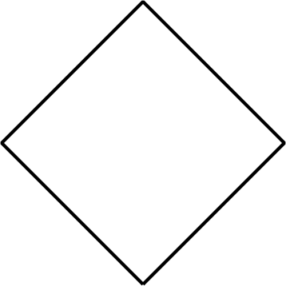
C
D
E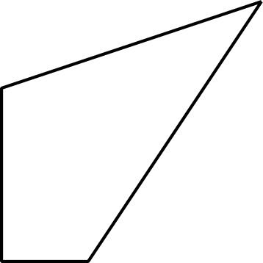

Student Responses
B and D, because they have 4 sides and all the sides are the same length.

