Lesson 3: Ubiquemos más puntos

Standards Alignments
Addressing | 5.G.A.1
Building Towards | 5.G.A.1

Teacher-facing Learning Goals
- Locate and name coordinates on a coordinate grid by reasoning about the structure of coordinate pairs.

Student-facing Learning Goals
- Ubiquemos y nombremos puntos en la cuadrícula de coordenadas.

Lesson Purpose
The purpose of this lesson is for students to plot points on the coordinate grid and recognize the importance of attending to precision when naming coordinates.
In previous lessons, students saw how coordinates are an effective tool for locating and describing points on the coordinate grid. In this lesson, they examine how points sharing the same vertical or horizontal coordinate are related. For example, the points $\left(3,1\right)$, $\left(5,1\right)$, and $\left(6,1\right)$ all have 1 as their second coordinate. Students see that they all lie on a horizontal line. Students study points that lie on the horizontal or vertical axes and see 0 as a possible value for a coordinate.
This lesson has a Student Section Summary.

Access for:

Students with Disabilities
- Action and Expression (Activity 1)

English Learners
- MLR8 (Activity 1)

Instructional Routines
Notice and Wonder (Warm-up)

Lesson Timeline
Warm-up | 10 min
Activity 1 | 20 min
Activity 2 | 15 min
Lesson Synthesis | 10 min
Cool-down | 5 min

Teacher Reflection Question
What questions did you ask to deepen student understanding of the structure of the coordinate plane?

Cool-down
(to be completed at the end of the lesson) 5min
Ubica coordenadas

Standards Alignments
Addressing | 5.G.A.1

Student-facing Task Statement
Este plano de coordenadas tiene algunos puntos marcados.
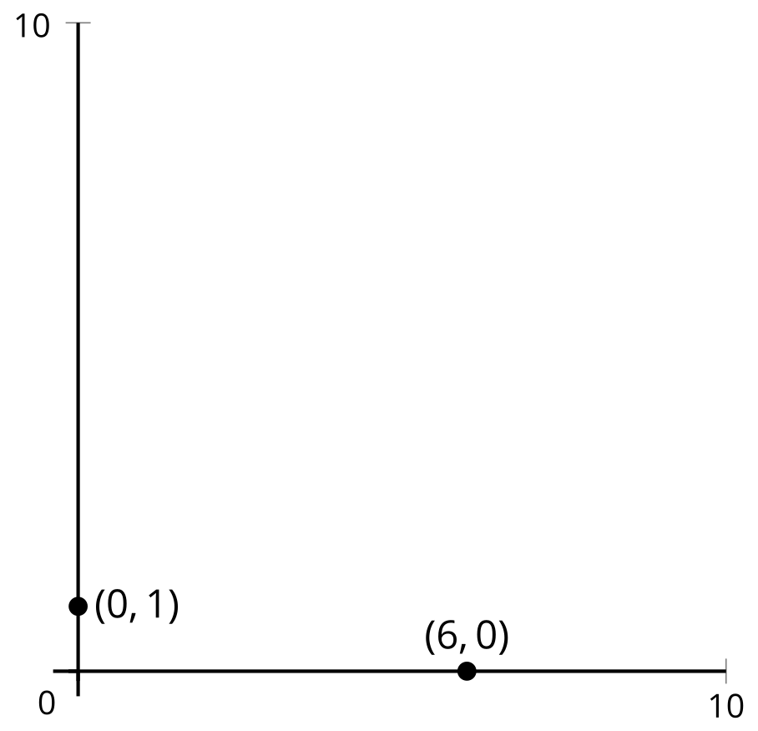
Ubica y marca los puntos $\left(3,0\right)$, $\left(0,2\right)$ y $\left(3,2\right)$. Explica o muestra cómo razonaste.

Student Responses
Sample responses: For $\left(3,0\right)$ I took half the distance to $\left(6,0\right)$ and for $\left(0,2\right)$ I took twice the distance to $\left(0,1\right)$. Then $\left(3,2\right)$ has horizontal coordinate 3 and vertical coordinate 2.
