Lesson 18 Practice Problems
- A function $g$ can be represented with a graph that contains $\left(\text{-}2,1\right)$ and $\left(1,\frac{1}{64}\right)$.
- Write an equation of the form $g\left(x\right)=a⋅b^{x}$ to define the function.
- 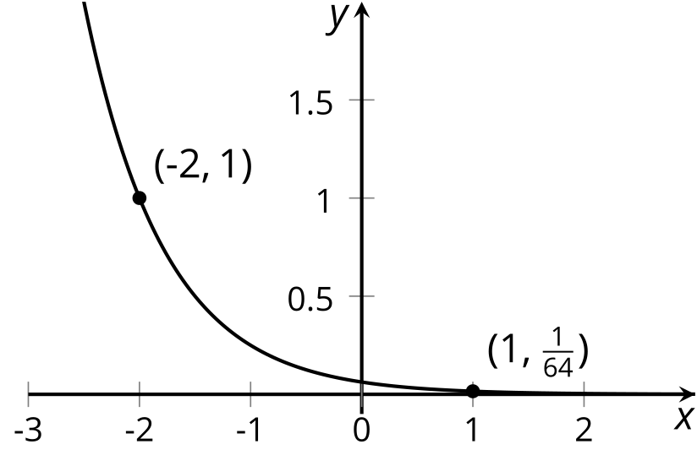
- (From Unit 4, Lesson 6.)
- Using the fact that $2^{10}=1024$, Tyler estimates that $2^{20}$ is about 1,000,000, and $\log_{2}\left(1,​000,​000\right)$ is about 20. Do you agree with Tyler?
- (From Unit 4, Lesson 10.)
- For each logarithmic equation, write an equivalent equation in exponential form.
  - $ln618=p$
  - $lnq=2$
  - $ln100=t$
  - $ln\left(e^{3}\right)=3$
- (From Unit 4, Lesson 14.)
- The function $f$ given by $f\left(t\right)=10e^{0.07t}$ models the balance in a bank account, in thousands of dollars, $t$ years after it was opened.
  - What was the opening balance?
  - About when does the account balance reach 1,000,000 dollars? Explain or show how you know.
- (From Unit 4, Lesson 15.)
- The function $f$ is given by $f\left(x\right)=20⋅e^{x}$.
  - Write an equation of an exponential function $g$ whose graph meets the graph of $f$ for a positive value of $x$.
  - Write an equation of an exponential function $h$ whose graph does not meet the graph of $f$ for any positive value of $x$.
- (From Unit 4, Lesson 16.)
- The area of a wall covered by mold is growing exponentially. Without treatment, the area doubles every month.
  - Complete the table.
  - Write a function, $f$, to represent the time in months as a function of the square feet of area covered by mold, $a$.
  - The wall is 240 square feet; about how many months will it take for the area to be completely covered by mold? Show your reasoning.
- area in  square feet | - time in  months
- 1 | - 0
- 2
- 16
- 20
- 32
- 64
- 100
- $a$
- (From Unit 4, Lesson 17.)
- A bank account had a balance of $100. Because of the interest accumulated over time, the balance doubles every decade. No withdrawals or other deposits are made.
  - To find out when the account will have a balance of $1,000, Diego wrote: $100⋅2^{t}=1,​000$ and Mai wrote: $t=\log_{2}\left(\frac{1,​000}{100}\right)$. Show that the equations are equivalent and have the same solution.
  - Use either of the strategies to find out when the account will have the following amounts. Show your reasoning.
    - $5,000
    - $12,000
  - Write an equation that shows when (at what value of $t$) the account will have $x$ dollars.
- (From Unit 4, Lesson 17.)
© CC BY 2019 by Illustrative Mathematics®

