Lesson 11: Extending the Domain of Trigonometric Functions
- Let’s think about the value of cosine and sine for all types of inputs.

11.1: Rewind to the Windmill
Priya is thinking about the windmill in an earlier lesson. That windmill had a point $P$ at $\left(1,0\right)$ at the end of the blade that starts at 0 radians pointing directly to the right. Priya says that if the blade rotates $\text{-}\frac{π}{2}$ radians, then $P$ will be at the lowest point in its circle of rotation.
What do you think Priya means by rotating $\text{-}\frac{π}{2}$ radians? Do you agree with Priya? Be prepared to explain your reasoning.

11.2: Math Talk: The Hour Hand
Here is a clock showing an hour hand at 3 p.m.
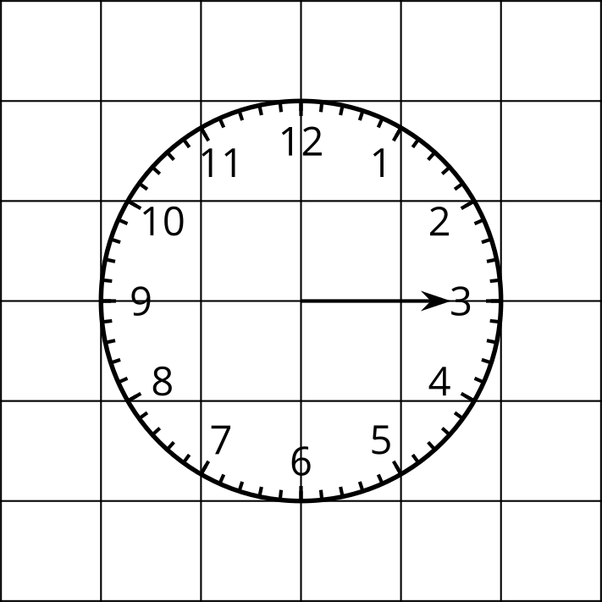
Your teacher will give you a time. Identify the radian angle measure that the hour hand rotates through if it starts at 3 p.m.

11.3: The Big Picture for Cosine and Sine
- Create a visual display for the following functions. Include a graph of the function from at least $\text{-}4π$ to $4π$ radians, the maximum and minimum value of the function, and the period of the function. Label any intersections the graph of the function has with the axes.
  - $y=cos\left(θ\right)$
  - $y=sin\left(θ\right)$
- The $y$-axis is a line of symmetry for one of the two graphs. Which one? Explain how you know.

Are you ready for more?
Recall that a symmetry is a rigid transformation that takes a figure onto itself (not counting a transformation that leaves every point where it is). For example, the graph of $y={\left(x−3\right)}^{2}$ has reflection symmetry across the line $x=3$.
- Find a reflection symmetry of the graph of $y=sin\left(θ\right)$.
- Find a rotation symmetry of the graph of $y=sin\left(θ\right)$.
- Find a translation symmetry of the graph of $y=sin\left(θ\right)$.

11.4: Cosine and Sine Together
Use graphing technology to graph the functions $y=cos\left(θ\right)$ and $y=sin\left(θ\right)$ on the same axes.
- Identify two points where the graphs intersect—one with a negative $θ$-coordinate, and one with a positive $θ$-coordinate. What is the exact $θ$-coordinate for each point? Explain or show how you know.
- What are the $y$-coordinates of the points of intersection? Explain or show how you know.
- What could be the value of $cos\left(θ\right)$ if $sin\left(θ\right)=0$? Explain your reasoning.

Lesson 11 Summary
The functions $cos\left(θ\right)$ and $sin\left(θ\right)$ are both periodic, meaning their values repeat at regular intervals. Since the period of cosine and sine is $2π$, the values of these functions repeat any time the input is changed by a multiple of $2π$. We can see this in the graph of $y=sin\left(θ\right)$ shown here.
Notice that between $\text{-}2π$ and $0$, and then between 0 and $2π$, the same wave pattern repeats. Both positive and negative values for $θ$ can be thought of through the lens of the unit circle with positive values indicating counterclockwise rotation and negative values indicating clockwise rotation. This means that different important features of the graph occur at regular intervals:
- The $θ$-intercepts of the graph are at all integer multiples of $π$.
- The relative maximums are at $\frac{π}{2}$ and any integer multiple of $2π$ from there.
- The relative minimums are at $\frac{3π}{2}$ and any integer multiple of $2π$ from there.
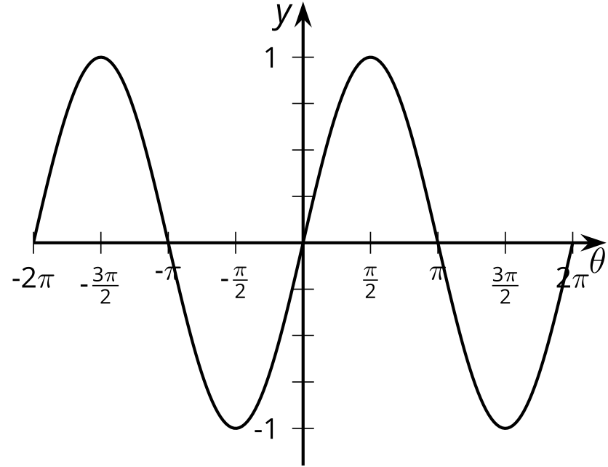
The graph of $y=cos\left(θ\right)$ is also periodic, repeating every time the input changes by a multiple of $2π$.
- The $θ$-intercepts are at $\frac{π}{2}$ and any integer multiple of $π$ from there.
- The relative maximums are at 0 and any integer multiple of $2π$ from there.
- The relative minimums are at $π$ and any integer multiple of $2π$ from there.
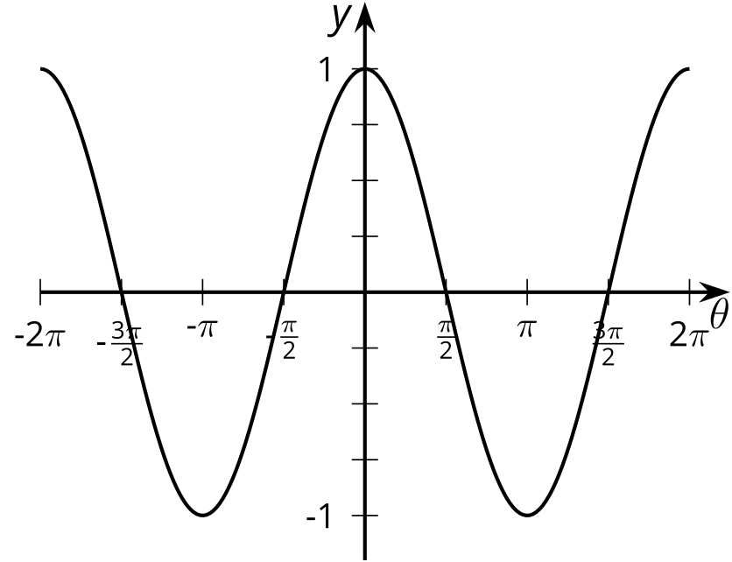
© CC BY 2019 by Illustrative Mathematics®

