Unit 2 Lesson 19: Solutions to Inequalities in One Variable

1 Find a Value, Any Value (Warm up)

Images for Launch

Student Task Statement
- Write some solutions to the inequality $y≤9.2$. Be prepared to explain what makes a value a solution to this inequality.
- Write one solution to the inequality $7(3−x)>14$. Be prepared to explain your reasoning.

2 Off to an Orchard

Student Task Statement
A teacher is choosing between two options for a class field trip to an orchard.
- At Orchard A, admission costs $9 per person and 3 chaperones are required.
- At Orchard B, the cost is $10 per person, but only 1 chaperone is required.
- At each orchard, the same price applies to both chaperones and students.
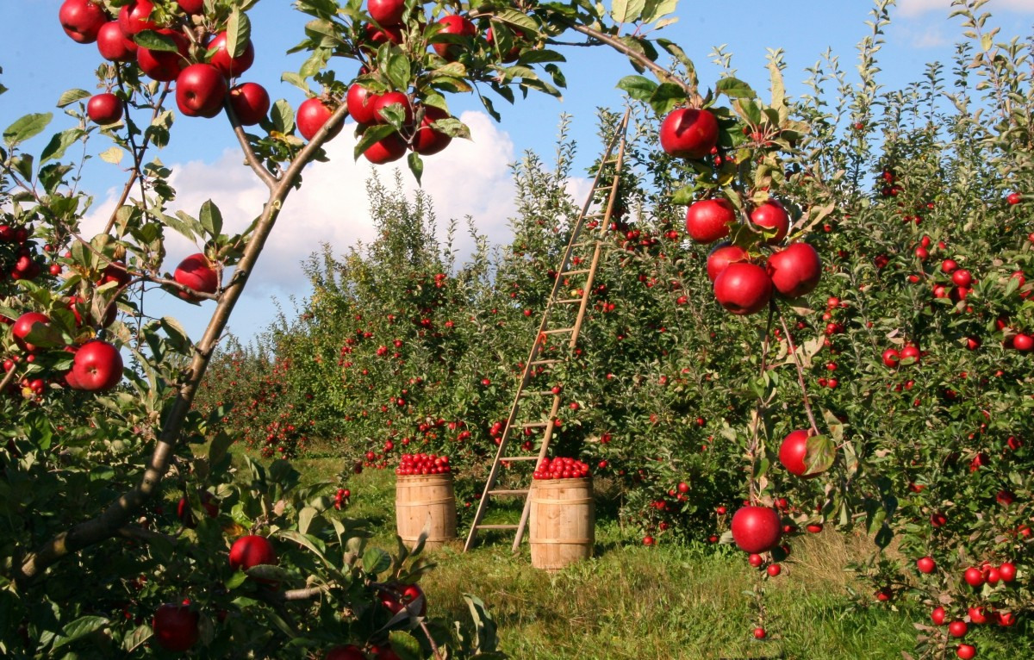
- Which orchard would be cheaper to visit if the class has:
  - 8 students?
  - 12 students?
  - 30 students?
- To help her compare the cost of her two options, the teacher first writes the equation $9(n+3)=10(n+1)$, and then she writes the inequality $9(n+3)<10(n+1)$.
  - What does $n$ represent in each statement?
  - In this situation, what does the equation $9(n+3)=10(n+1)$ mean?
  - What does the solution to the inequality $9(n+3)<10(n+1)$ tell us?
  - Graph the solution to the inequality on the number line. Be prepared to show or explain your reasoning.

3 Part-Time Work (Optional)

Student Task Statement
To help pay for his tuition, a college student plans to work in the evenings and on weekends. He has been offered two part-time jobs: working in the guest-services department at a hotel and waiting tables at a popular restaurant.
- The job at the hotel pays $18 an hour and offers $33 in transportation allowance per month.
- The job at the restaurant pays $7.50 an hour plus tips. The entire waitstaff typically collects about $50 in tips each hour. Tips are divided equally among the 4 waitstaff members who share a shift.
- The equation $7.50h+\frac{50}{4}h=18h+33$ represents a possible constraint about a situation.
  - Solve the equation and check your solution.
  - Here is a graph on a number line.
  - Put a scale on the number line so that the point marked with a circle represents the solution to the equation.
- Does one job pay better if:
  - The student works fewer hours than the solution you found earlier? If so, which job?
  - The student works more hours than the solution you found earlier? If so, which job?
- Be prepared to explain or show how you know.
- Here are two inequalities and two graphs that represent the solutions to the inequalities.
  - Inequality 1: $7.50h+\frac{50}{4}h<18h+33$
  - Inequality 2: $7.50h+\frac{50}{4}h>18h+33$

- A

- B
  - Put the same scale on each number line so that the circle represents the number of hours that you found earlier.
  - Match each inequality with a graph that shows its solution. Be prepared to explain or show how you know.

Activity Synthesis

4 Equality and Inequality

Student Task Statement
- Solve this equation and check your solution: $\text{-}\frac{4(x+3)}{5}=4x−12$.
- Consider the inequality: $\text{-}\frac{4(x+3)}{5}≤4x−12$.
  - Choose a couple of values less than 2 for $x$. Are they solutions to the inequality?
  - Choose a couple of values greater than 2 for $x$. Are they solutions to the inequality?
  - Choose 2 for $x$. Is it a solution?
  - Graph the solution to the inequality on the number line.

5 More or Less? (Optional)

Student Task Statement
Consider the inequality $\text{-}\frac{1}{2}x+6<4x−3$. Let's look at another way to find its solutions.
- Use graphing technology to graph $y=\text{-}\frac{1}{2}x+6$ and $y=4x−3$ on the same coordinate plane.
- Use your graphs to answer the following questions:
  - Find the values of $\text{-}\frac{1}{2}x+6$ and $4x−3$ when $x$ is 1.
  - What value of $x$ makes $\text{-}\frac{1}{2}x+6$ and $4x−3$ equal?
  - For what values of $x$ is $\text{-}\frac{1}{2}x+6$ less than $4x−3$?
  - For what values of $x$ is $\text{-}\frac{1}{2}x+6$ greater than $4x−3$?
- What is the solution to the inequality $\text{-}\frac{1}{2}x+6<4x−3$? Be prepared to explain how you know.
© CC BY 2019 by Illustrative Mathematics®

