Lesson 19: Which One Changes Faster?
Let's compare linear and exponential functions as they continue to increase.

19.1: Graph of Which Function?
Here is a graph.
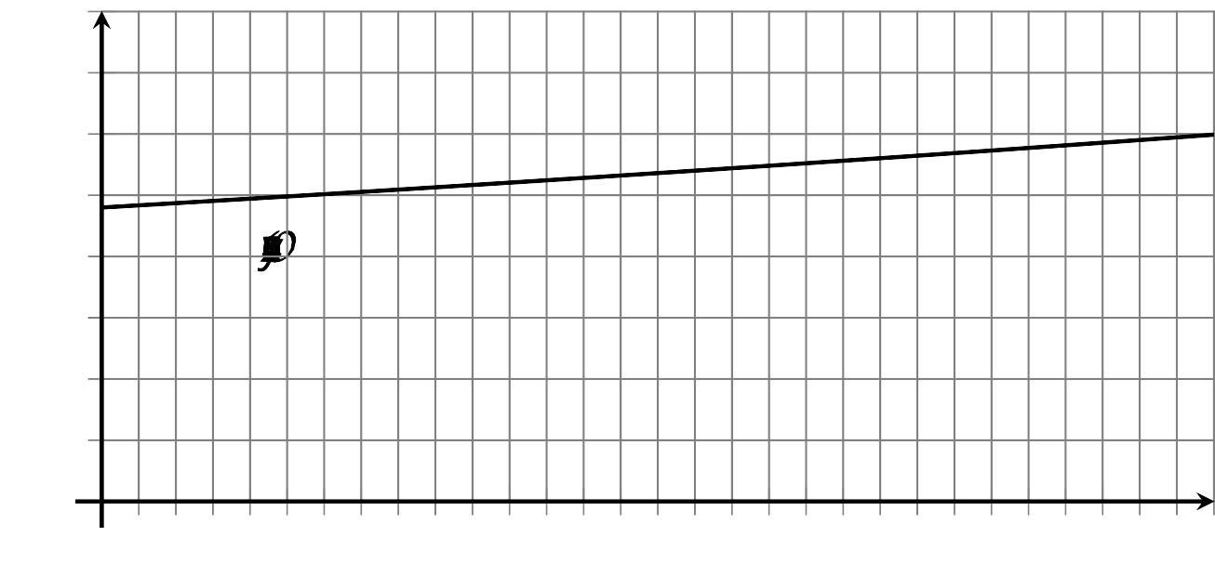
- Which equation do you think the graph represents? Use the graph to support your reasoning.
  - $y=120+(3.7)⋅x$
  - $y=120⋅(1.03)^{x}$
- What information might help you decide more easily whether the graph represents a linear or an exponential function?

19.2: Simple and Compound Interests
A family has $1,000 to invest and is considering two options: investing in government bonds that offer 2% simple interest, or investing in a savings account at a bank, which charges a $20 fee to open an account and pays 2% compound interest. Both options pay interest annually.
Here are two tables showing what they would earn in the first couple of years if they do not invest additional amounts or withdraw any money.
Bonds
years of investment | amount in dollars
0 | $1,000
1 | $1,020
2 | $1,040
Savings Account
years of investment | amount in dollars
0 | $980
1 | $999.60
2 | $1,019.59
- Bonds: How does the investment grow with simple interest?
- Savings account: How are the amounts $999.60 and $1,019.59 calculated?
- For each option, write an equation to represent the relationship between the amount of money and the number of years of investment.
- Which investment option should the family choose? Use your equations or calculations to support your answer.
- Use graphing technology to graph the two investment options and show how the money grows in each.

19.3: Reaching 2,000
- Complete the table of values for the functions $f$ and $g$.
- $x$ | - $f(x)$ | - $g(x)$
- 1
- 10
- 50
- 100
- 500
- Based on the table of values, which function do you think grows faster? Explain your reasoning.
- Which function do you think will reach a value of 2,000 first? Show your reasoning. If you get stuck, consider increasing $x$ by 100 a few times and record the function values in the table.

Are you ready for more?
Consider the functions $g(x)=x^{5}$ and $f(x)=5^{x}$. While it is true that $f(7)>g(7)$, for example, it is hard to check this using mental math. Find a value of $x$ for which properties of exponents allow you to conclude that $f(x)>g(x)$ without a calculator.

Lesson 19 Summary
Suppose that you won the top prize from a game show and are given two options. The first option is a cash gift of $10,000 and $1,000 per day for the next 7 days. The second option is a cash gift of 1 cent (or $0.01) that grows tenfold each day for 7 days. Which option would you choose?
In the first option, the amount of money increases by the same amount ($1,000) each day, so we can represent it with a linear function. In the second option, the money grows by multiples of 10, so we can represent it with an exponential function. Let $f$ represent the amount of money $x$ days after winning with the first option and let $g$ represent the amount of money $x$ days after winning with the second option.
Option 1: $f(x)=10,​000+1,​000x$
$f(1)=11,​000$
$f(2)=12,​000$
$f(3)=13,​000$
. . .
$f(6)=16,​000$
$f(7)=17,​000$
Option 2: $g(x)=(0.01)⋅{10}^{x}$
$g(1)=0.1$
$g(2)=1$
$g(3)=10$
. . .
$g(6)=10,​000$
$g(7)=100,​000$
For the first few days, the second option trails far behind the first. Because of the repeated multiplication by 10, however, after 7 days it surges past the amount in the first option.
What if the factor of growth is much smaller than 10? Suppose we have a third option, represented by a function $h$. The starting amount is still $0.01 and it grows by a factor of 1.5 times each day. If we graph the function $h(x)=(0.01)⋅(1.5)^{x}$, we see that it takes many, many more days before we see a rapid growth. But given time to continue growing, the amount in this exponential option will eventually also outpace that in the linear option.
© CC BY 2019 by Illustrative Mathematics®

