Unit 4 Lesson 8: Percent Increase and Decrease with Equations

1 Number Talk: From 100 to 106 (Warm up)

Student Task Statement
How do you get from one number to the next using multiplication or division?
From 100 to 106
From 100 to 90
From 90 to 100
From 106 to 100

2 Interest and Depreciation

Student Task Statement
- Money in a particular savings account increases by about 6% after a year. How much money will be in the account after one year if the initial amount is $100? $50? $200? $125? $x$ dollars? If you get stuck, consider using diagrams or a table to organize your work.
- The value of a new car decreases by about 15% in the first year. How much will a car be worth after one year if its initial value was $1,000? $5,000? $5,020? $x$ dollars? If you get stuck, consider using diagrams or a table to organize your work.
- 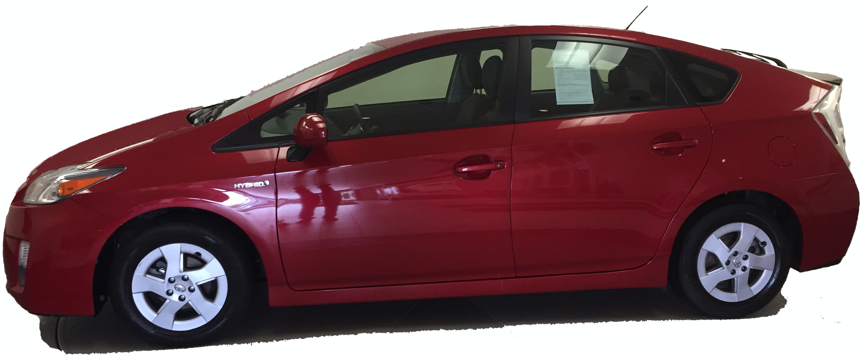
- 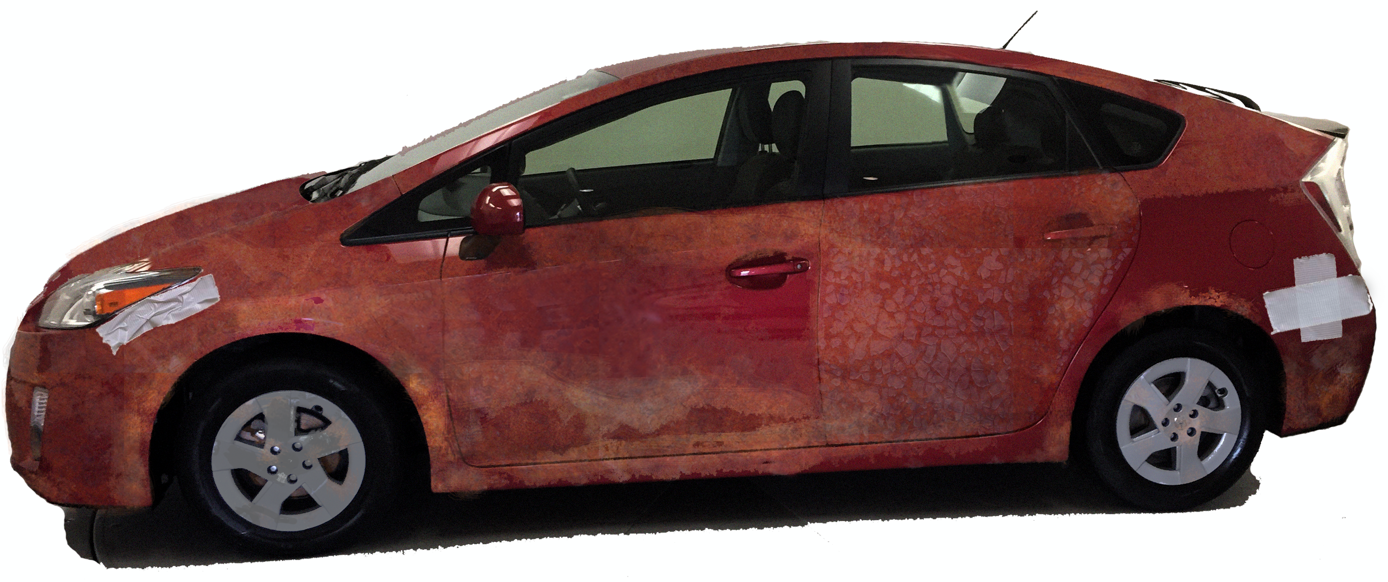

3 Matching Equations

Student Task Statement
Match an equation to each of these situations. Be prepared to share your reasoning.
- The water level in a reservoir is now 52 meters. If this was a 23% increase, what was the initial depth?
- The snow is now 52 inches deep. If this was a 77% decrease, what was the initial depth?
$0.23x=52$
$0.77x=52$
$1.23x=52$
$1.77x=52$

4 Representing Percent Increase and Decrease: Equations (Optional)

Images for Launch
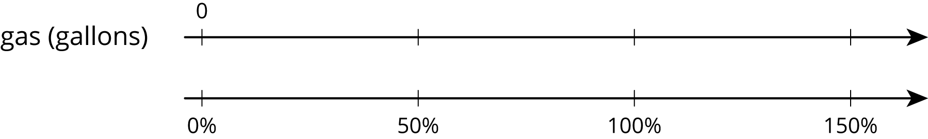

Student Task Statement
- The gas tank in dad’s car holds 12 gallons. The gas tank in mom’s truck holds 50% more than that. How much gas does the truck’s tank hold? Explain why this situation can be represented by the equation $\left(1.5\right)⋅12=t$. Make sure that you explain what $t$ represents.
- Write an equation to represent each of the following situations.
  - A movie theater decreased the size of its popcorn bags by 20%. If the old bags held 15 cups of popcorn, how much do the new bags hold?
  - After a 25% discount, the price of a T-shirt was $12. What was the price before the discount?
  - Compared to last year, the population of Boom Town has increased by 25%.The population is now 6,600. What was the population last year?
© CC BY Open Up Resources. Adaptations CC BY IM.

