Lesson 13 Practice Problems
- Select all the expressions that are equivalent to 64.
  - $2^{6}$
  - $2^{8}$
  - $4^{3}$
  - $8^{2}$
  - ${16}^{4}$
  - ${32}^{2}$
- Select all the expressions that equal $3^{4}$.
  - 7
  - $4^{3}$
  - 12
  - 81
  - 64
  - $9^{2}$
- $4^{5}$ is equal to 1,024. Evaluate each expression.
  - $4^{6}$
  - $4^{4}$
  - $4^{3}⋅4^{2}$
- $6^{3}=216$. Using exponents, write three more expressions whose value is 216.
- Find two different ways to rewrite $3xy+6yz$ using the distributive property.
- (From Unit 4, Lesson 10.)
- Solve each equation.
- $a−2.01=5.5$

- $b+2.01=5.5$
- $10c=13.71$

- $100d=13.71$
- (From Unit 4, Lesson 5.)
- Which expressions represent the total area of the large rectangle? Select all that apply.
- 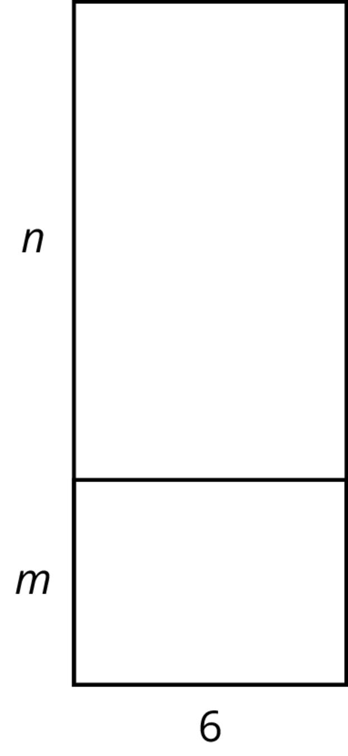
- ​​
  - $6\left(m+n\right)$
  - $6n+m$
  - $6n+6m$
  - $6mn$
  - $\left(n+m\right)6$
- (From Unit 4, Lesson 10.)
- Is each statement true or false? Explain your reasoning.
  - $\frac{45}{100}⋅72=\frac{45}{72}⋅100$
  - 16% of 250 is equal to 250% of 16
- (From Unit 2, Lesson 24.)
© CC BY Open Up Resources. Adaptations CC BY IM.

