Lesson 12 Practice Problems
- One thousand baseball fans were asked how far they would be willing to travel to watch a professional baseball game. From this population, 100 different samples of size 40 were selected. Here is a dot plot showing the mean of each sample.
- 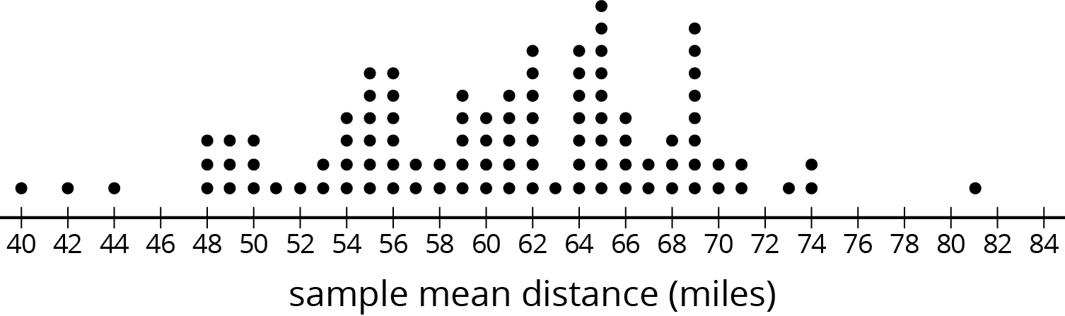
- Based on the distribution of sample means, what do you think is a reasonable estimate for the mean of the population?
- Last night, everyone at the school music concert wrote their age on a slip of paper and placed it in a box. Today, each of the students in a math class selected a random sample of size 10 from the box of papers. Here is a dot plot showing their sample means, rounded to the nearest year.
- 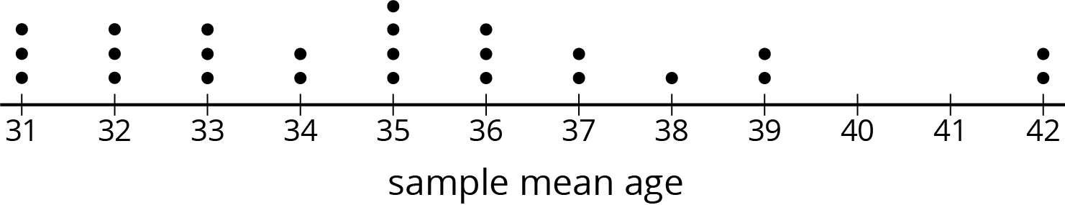
  - Does the number of dots on the dot plot tell you how many people were at the concert or how many students are in the math class?
  - The mean age for the population was 35 years. If Elena picks a new sample of size 10 from this population, should she expect her sample mean to be within 1 year of the population mean? Explain your reasoning.
  - What could Elena do to select a random sample that is more likely to have a sample mean within 1 year of the population mean?
- Andre would like to estimate the mean number of books the students at his school read over the summer break. He has a list of the names of all the students at the school, but he doesn’t have time to ask every student how many books they read.
- What should Andre do to estimate the mean number of books?
- (From Unit 8, Lesson 11.)
© CC BY Open Up Resources. Adaptations CC BY IM.

