Unit 4 Lesson 1: How Many Groups?

How Many Do You See: Apples (Warm up)

Student Task Statement
How many do you see? How do you see them?
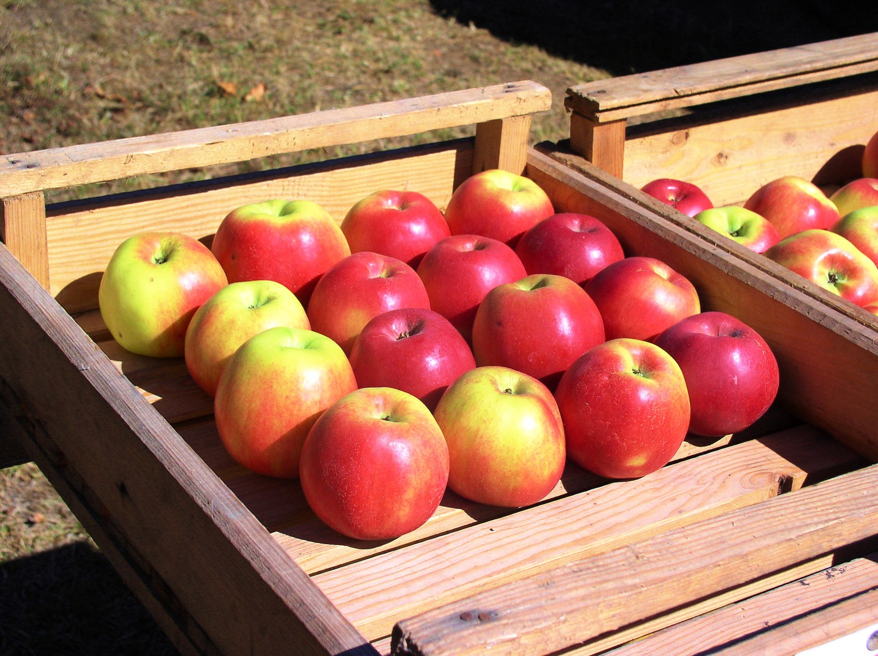

1 How Many Apples?

Student Task Statement
Solve each problem. Show your thinking using objects, a drawing, or a diagram.
- If 24 apples are put into boxes with 8 apples in each box, how many boxes are there?
- If 42 apples are put into boxes with 6 apples in each box, how many boxes are there?
- If 32 apples are put into boxes with 4 apples in each box, how many boxes are there?

2 Gallery Walk: Apples in Boxes

Student Task Statement
- Visit the posters around the room with your partner. Discuss what is the same and what is different about the thinking shown on each poster.
- Reflect on what you saw. Write down one thing that was the same and one thing that was different about the thinking shown on each poster.
© CC BY 2021 Illustrative Mathematics®

