Lesson 11 Practice Problems

  - Show that the two pentagons are congruent.
  - Find the side lengths of $ABCDE$ and the angle measures of $FGHIJ$.
- 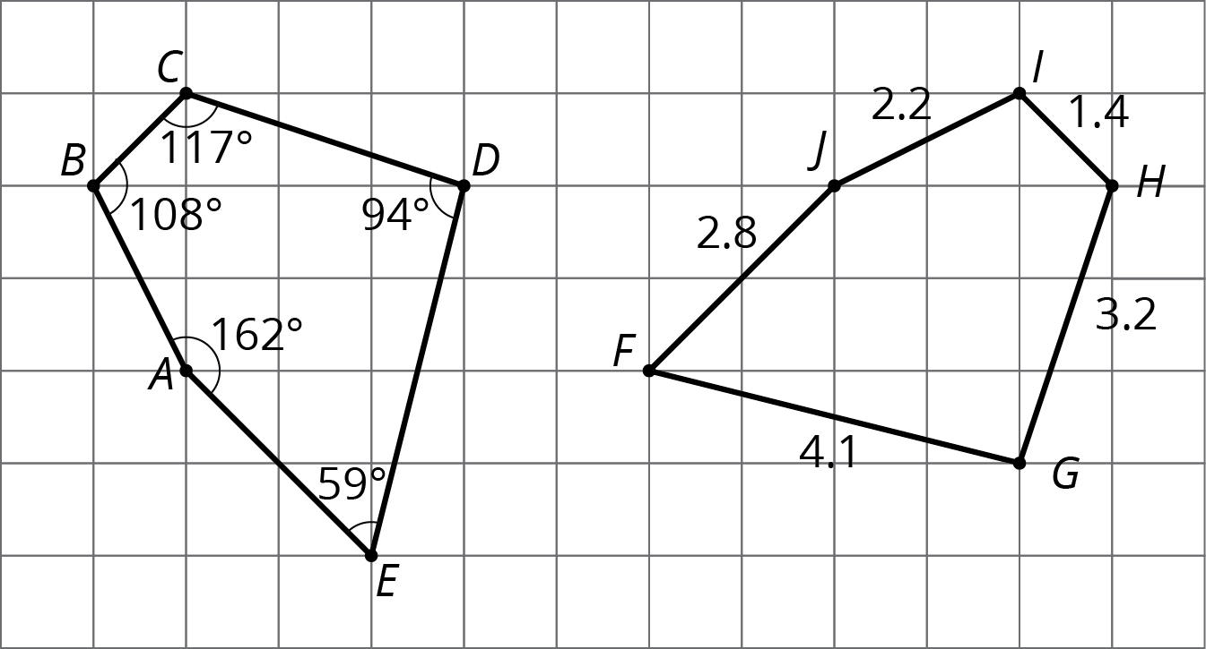
- These two figures are congruent, with corresponding points marked.
- 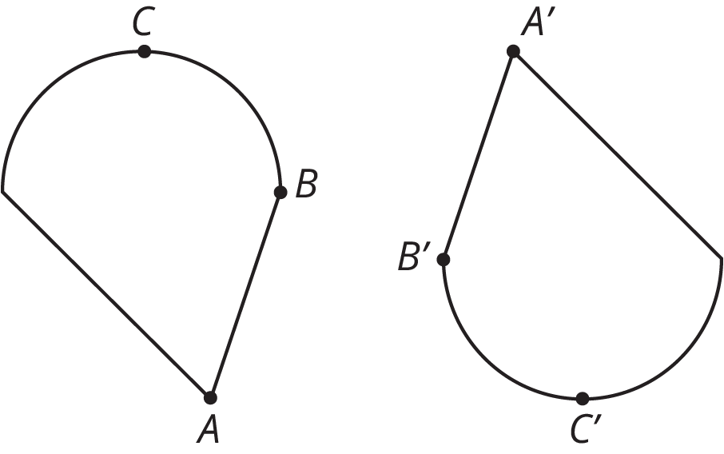
  - Are angles $ABC$ and $A^{′}B^{′}C^{′}$ congruent? Explain your reasoning.
  - Measure angles $ABC$ and $A^{′}B^{′}C^{′}$ to check your answer.
- For each pair of shapes, decide whether or not the two shapes are congruent. Explain your reasoning.

  - 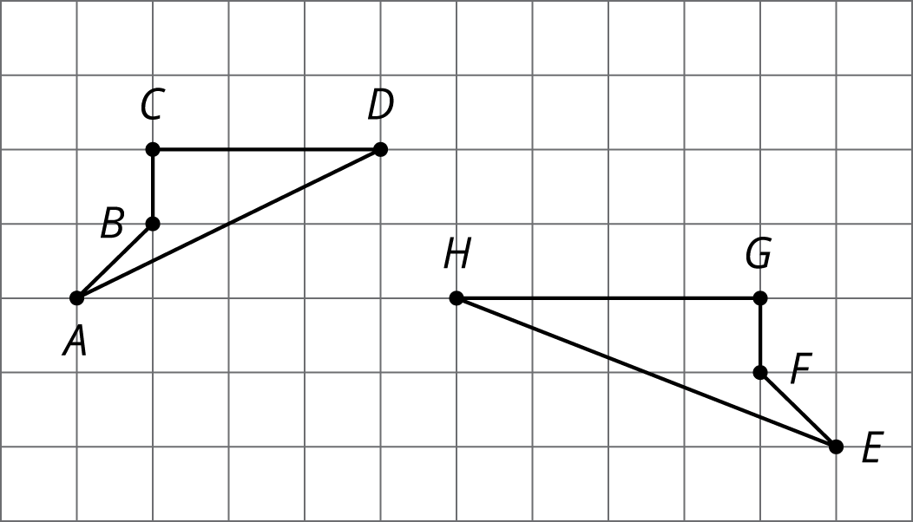

  - 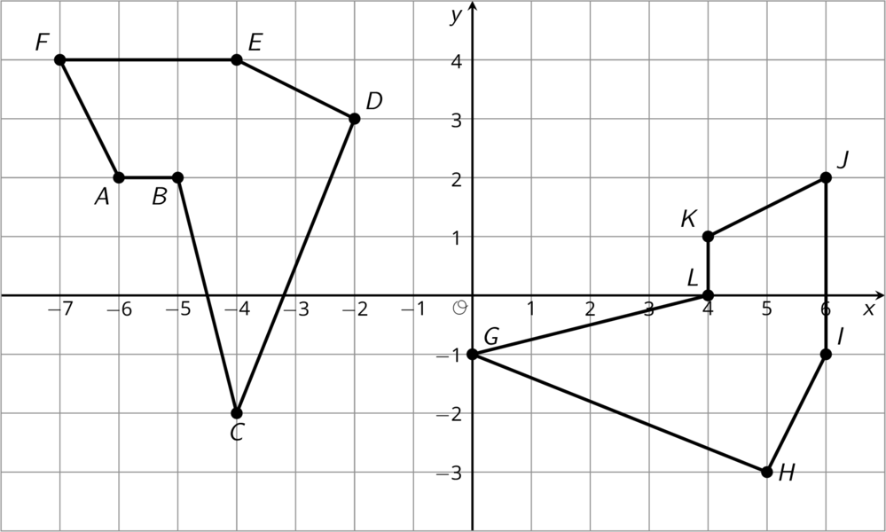

  - 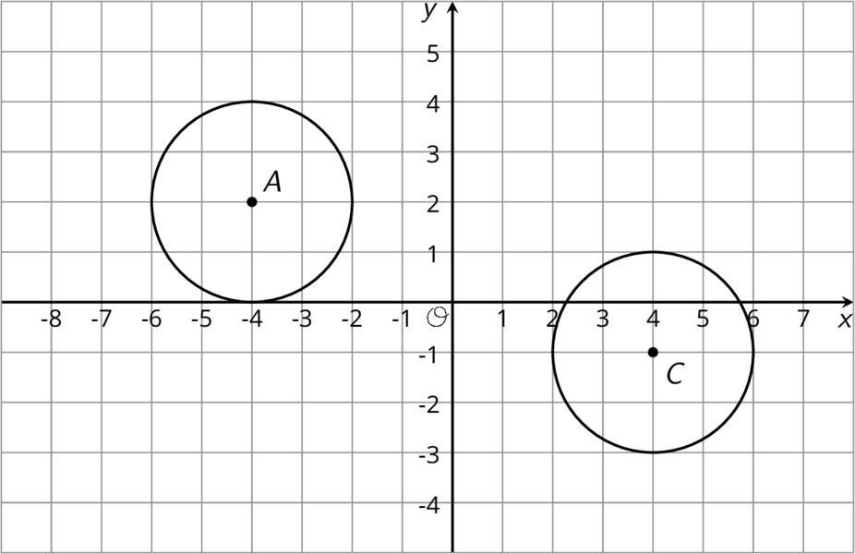
- Which of these four figures are congruent to the top figure?
- 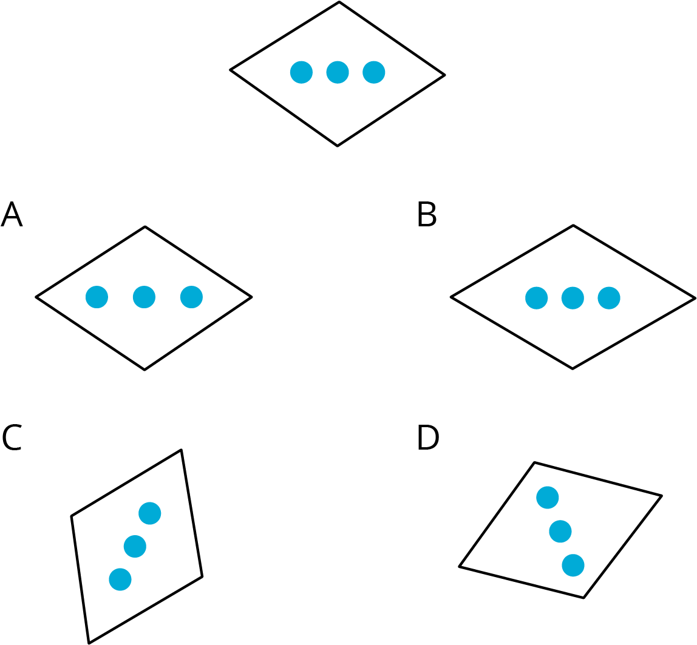
  - A
  - B
  - C
  - D
- Here are two figures.
- 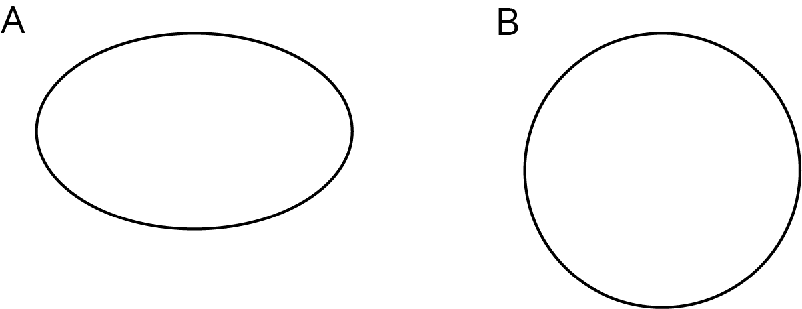
- Show, using measurement, that these two figures are not congruent.
© CC BY Open Up Resources. Adaptations CC BY IM.

