Lesson 15 Practice Problems
- The equation $p\left(h\right)=5,​000⋅2^{h}$ represents a bacteria population as a function of time in hours. Here is a graph of the function $p$.
- 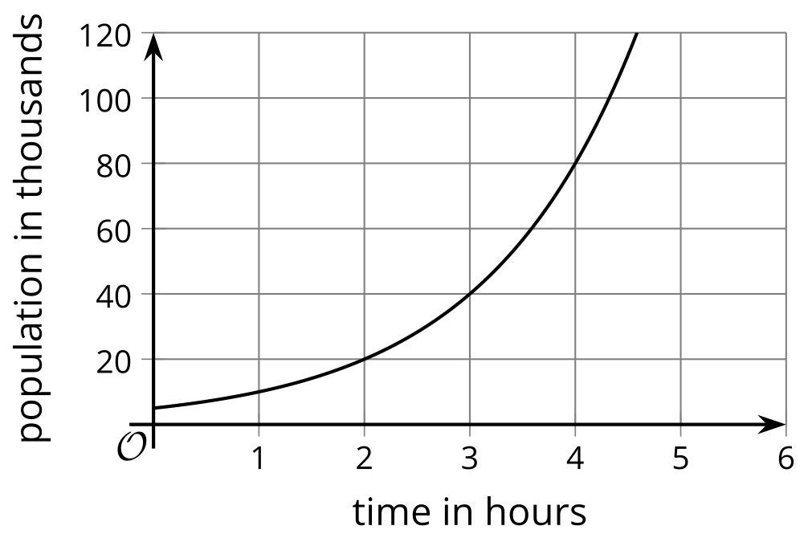
  - Use the graph to determine when the population will reach 100,000.
  - Explain why $\log_{2}20$ also tells us when the population will reach 100,000.
- Technology required. Population growth in the U.S. between 1800 and 1850, in millions, can be represented by the function $f$, defined by $f\left(t\right)=5⋅e^{\left(0.028t\right)}$.
  - What was the U.S. population in 1800?
  - Use graphing technology to graph the equations $y=f\left(t\right)$ and $y=20$. Adjust the graphing window to the following boundaries: $0<x<100$ and $0<y<40$.
  - What is the point of intersection of the two graphs, and what does it mean in this situation?
- The growth of a bacteria population is modeled by the equation $p\left(h\right)=1,​000e^{\left(0.4h\right)}$. For each question, explain or show how you know.
  - How long does it take for the population to double?
  - How long does it take for the population to reach 1,000,000?
- What value of $b$ makes each equation true?
  - $\log_{b}144=2$
  - $\log_{b}64=2$
  - $\log_{b}64=3$
  - $\log_{b}64=6$
  - $\log_{b}\frac{1}{9}=\text{-}2$
- (From Unit 4, Lesson 10.)
- Put the following expressions in order, from least to greatest.
- $\log_{2}11$ | - $\log_{3}5$ | - $\log_{5}25$ | - $\log_{10}1,​000$ | - $\log_{2}5$

- (From Unit 4, Lesson 11.)
- Solve $9⋅{10}^{\left(0.2t\right)}=900$. Show your reasoning.
- (From Unit 4, Lesson 14.)
- Explain why $ln4$ is greater than 1 but is less than 2.
- (From Unit 4, Lesson 14.)
© CC BY 2019 by Illustrative Mathematics®

